|  |
| --- |
| **Clinical Waste** |
| Revision Summary |
| Version 1, April 2016 |

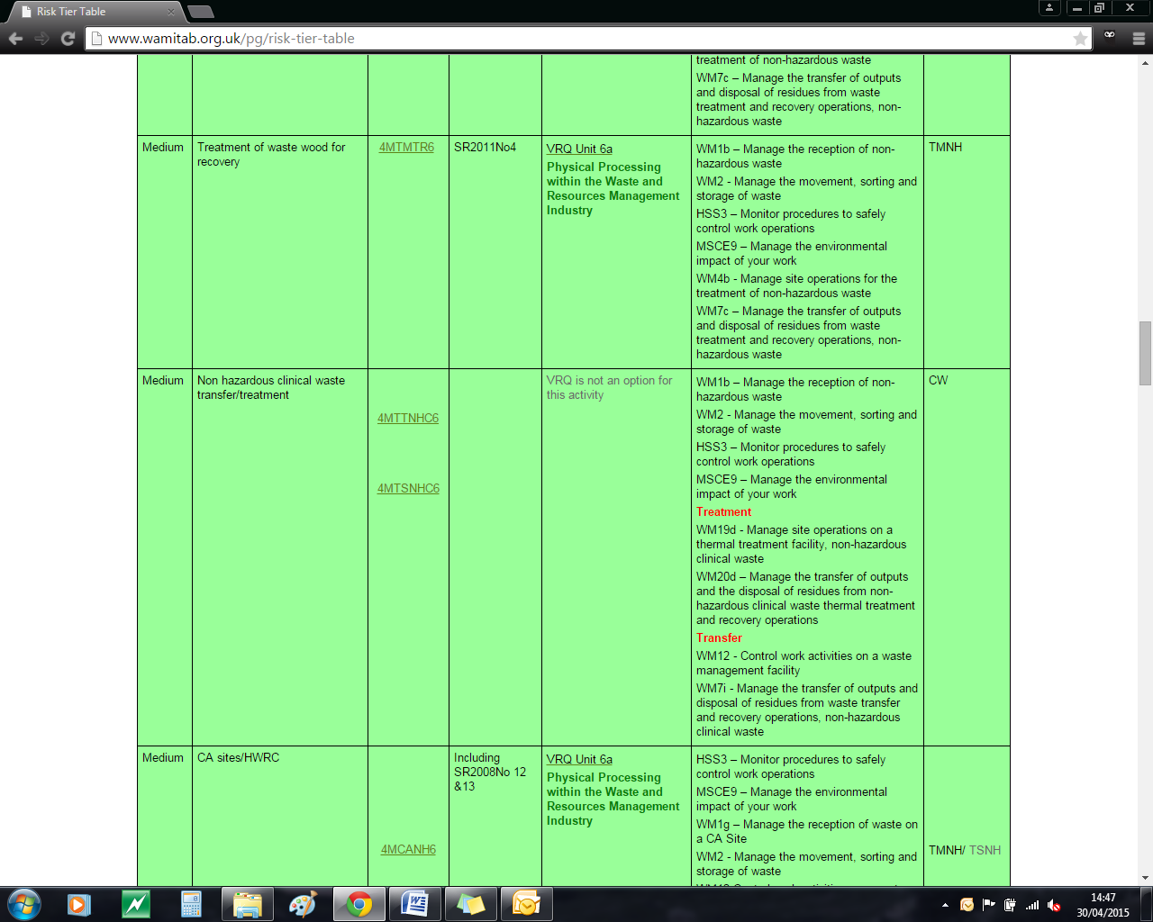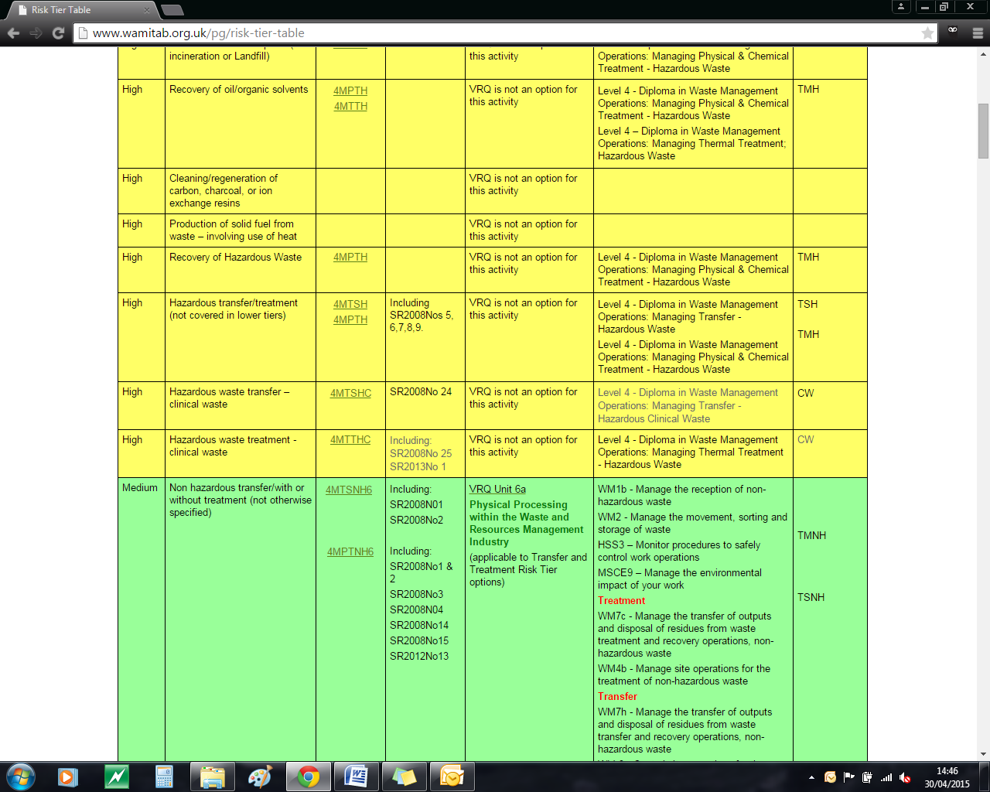http://ciwm-journal.co.uk/wordpress/wp-content/themes/ciwm-journal/hamish/CIWM_Journal_Logo.png

**CIWM/WAMITAB**

**Continuing Competence**

**Part of the CIWM/WAMITAB**

**Operator Competence Scheme**

Copyright ©2016 WAMITAB

Copyright in this document is owned by WAMITAB. Any person viewing, printing and distributing this document is subject to the following conditions:

* The document may be used for informational purposes only
* The document may be used for non-commercial purposes only (unless used by WAMITAB approved centres or partners)
* Anyone using information provided in this document should acknowledge WAMITAB

Changes are made periodically to the information contained within the document so for the latest version please refer to the website: [www.wamitab.org.uk](http://www.wamitab.org.uk).

For further information on Intellectual Property matters contact [info.admin@wamitab.org.uk](mailto:info.admin@wamitab.org.uk).

Please note that all word clouds are curtsey of Tagxedo.com and all images have been sourced from i-stock.

**Contents**

[Introduction 4](#_Toc448477024)

[About WAMITAB 4](#_Toc448477025)

[What is Continuing Competence? 4](#_Toc448477026)

[About this Revision Summary 4](#_Toc448477027)

[1. Storage and Packaging 5](#_Toc448477028)

[Learning Outcomes 5](file:///W:\Continuing%20Competence\Scheme%20review%20and%20amends%20April%202016\Revision%20Summaries\Clinical%20Waste%20Revision%20Summary%20%5bFree%5d.docx#_Toc448477029)

[Where do I find this information? 5](file:///W:\Continuing%20Competence\Scheme%20review%20and%20amends%20April%202016\Revision%20Summaries\Clinical%20Waste%20Revision%20Summary%20%5bFree%5d.docx#_Toc448477030)

[Notes 5](file:///W:\Continuing%20Competence\Scheme%20review%20and%20amends%20April%202016\Revision%20Summaries\Clinical%20Waste%20Revision%20Summary%20%5bFree%5d.docx#_Toc448477031)

[Notes 6](file:///W:\Continuing%20Competence\Scheme%20review%20and%20amends%20April%202016\Revision%20Summaries\Clinical%20Waste%20Revision%20Summary%20%5bFree%5d.docx#_Toc448477033)

[2. Classification of Wastes 7](#_Toc448477035)

[Learning Outcomes 7](file:///W:\Continuing%20Competence\Scheme%20review%20and%20amends%20April%202016\Revision%20Summaries\Clinical%20Waste%20Revision%20Summary%20%5bFree%5d.docx#_Toc448477034)

[Where do I find this information? 7](file:///W:\Continuing%20Competence\Scheme%20review%20and%20amends%20April%202016\Revision%20Summaries\Clinical%20Waste%20Revision%20Summary%20%5bFree%5d.docx#_Toc448477036)

[Notes 7](file:///W:\Continuing%20Competence\Scheme%20review%20and%20amends%20April%202016\Revision%20Summaries\Clinical%20Waste%20Revision%20Summary%20%5bFree%5d.docx#_Toc448477037)

[3. Consignment Procedures 8](#_Toc448477039)

[Learning Outcomes 8](file:///W:\Continuing%20Competence\Scheme%20review%20and%20amends%20April%202016\Revision%20Summaries\Clinical%20Waste%20Revision%20Summary%20%5bFree%5d.docx#_Toc448477038)

[Where do I find this information? 8](file:///W:\Continuing%20Competence\Scheme%20review%20and%20amends%20April%202016\Revision%20Summaries\Clinical%20Waste%20Revision%20Summary%20%5bFree%5d.docx#_Toc448477040)

[Notes 8](file:///W:\Continuing%20Competence\Scheme%20review%20and%20amends%20April%202016\Revision%20Summaries\Clinical%20Waste%20Revision%20Summary%20%5bFree%5d.docx#_Toc448477041)

[4. Waste Acceptance Procedures 9](#_Toc448477043)

[Learning Outcomes 9](file:///W:\Continuing%20Competence\Scheme%20review%20and%20amends%20April%202016\Revision%20Summaries\Clinical%20Waste%20Revision%20Summary%20%5bFree%5d.docx#_Toc448477042)

[Where do I find this information? 9](file:///W:\Continuing%20Competence\Scheme%20review%20and%20amends%20April%202016\Revision%20Summaries\Clinical%20Waste%20Revision%20Summary%20%5bFree%5d.docx#_Toc448477044)

[Notes 9](file:///W:\Continuing%20Competence\Scheme%20review%20and%20amends%20April%202016\Revision%20Summaries\Clinical%20Waste%20Revision%20Summary%20%5bFree%5d.docx#_Toc448477045)

[5. Treatment and Disposal Options for Clinical Waste 10](#_Toc448477047)

[Learning Outcomes 10](file:///W:\Continuing%20Competence\Scheme%20review%20and%20amends%20April%202016\Revision%20Summaries\Clinical%20Waste%20Revision%20Summary%20%5bFree%5d.docx#_Toc448477046)

[Where do I find this information? 10](W:\\Continuing Competence\\Scheme review and amends April 2016\\Revision Summaries\\Clinical Waste Revision Summary [Free].docx" \l "_Toc448477048)

[Notes 10](file:///W:\Continuing%20Competence\Scheme%20review%20and%20amends%20April%202016\Revision%20Summaries\Clinical%20Waste%20Revision%20Summary%20%5bFree%5d.docx#_Toc448477049)

[Additional Sources 11](#_Toc448477050)

# Introduction

## About WAMITAB

WAMITAB is an awarding organisation and charity that develops qualifications for those working in cleaning; street cleansing; facilities management; resource management and recycling and parking from operative through to management level.

Since it was formed in 1989, WAMITAB has evolved in line with the convergence between the sectors with a clear focus on promoting and supporting environmental sustainability.  With over 120 qualification pathways and 70 quality assured centres, WAMITAB offers an unrivalled specialist network to support staff development.

## What is Continuing Competence?

The CIWM/WAMITAB continuing competence scheme is designed to ensure that the technically competent person (holds a certificate of technical competence, units or a qualification that is part of the CIWM/WAMITAB Operator Competence Scheme) on a waste site has knowledge and skills that keep pace with changes made across the waste management industry, such as the introduction of new legislation, technologies and techniques.

The CIWM/WAMITAB continuing competence scheme requires technically competent people in England and Wales to pass an assessment that demonstrates individuals have kept their competence up to date.

Keeping competence up to date is becoming increasingly important across the UK as society starts to recognise the crucial role waste and resource management industry professionals play in ensuring that the 434 million tonnes of waste generated every year can be treated, reused and recycled to produce a product that will contribute to further economic growth.

## About this Revision Summary

WAMITAB recognise the diverse needs of learners within the sectors we represent. To support those individuals undertaking their Continuing Competence test, we have developed this revision summary.

This revision summary is designed to support you preparation by linking the learning outcomes with the areas that may come up during the Continuing Competence test.

# 1. Storage and Packaging C:\Users\Helen\AppData\Local\Microsoft\Windows\Temporary Internet Files\Content.IE5\FJ1S42NY\MC900432680[1].png

## Learning Outcomes

* 1. Know the type of container required for fully and partially discharged ‘sharps’ used to administer pharmaceuticals.
  2. Know the type of container required for ‘sharps’ that are infectious but have not been used to administer pharmaceuticals i.e. taking blood/ dissecting blades.
  3. Know the type of container for waste contaminated with cytotoxic/cytostatic medicinal products.
  4. Know the type of container for waste medicinal products that are non- cytotoxic/ cytostatic.
  5. Know the type of packaging used for infectious healthcare wastes.
  6. Know the UN marks on packaging that can be used for different types of wastes.
  7. Know how waste containers on site should be labelled.
  8. Know the ‘appropriate measures’ for safe storage of waste onsite.
  9. Know the ‘appropriate measures’ that should be taken when cleaning storage areas and containers.
  10. Know the ‘appropriate measures’ for managing clinical waste to avoid problems with odour, litter and vermin.



## Where do I find this information?

[Health Technical Memorandum 07-01: Safe Management of Healthcare Waste (2013)](https://www.gov.uk/government/uploads/system/uploads/attachment_data/file/167976/HTM_07-01_Final.pdf)

[HSE Guidance: Management of Healthcare Waste](http://www.hse.gov.uk/healthservices/healthcare-waste.htm)

[Environment Agency - How to comply with your environmental permit: additional guidance for clinical waste (EPR 5.07) (Version 1.1, January 2011)](http://a0768b4a8a31e106d8b0-50dc802554eb38a24458b98ff72d550b.r19.cf3.rackcdn.com/geho0710bsvi-e-e.pdf)

## Notes

|  |
| --- |
|  |
|  |
|  |
|  |
|  |
|  |
|  |
|  |
|  |
|  |
|  |
|  |
|  |
|  |
|  |
|  |
|  |
|  |
|  |
|  |
|  |
|  |
|  |
|  |
|  |
|  |
|  |
|  |
|  |
|  |
|  |
|  |
|  |
|  |
|  |
|  |
|  |
|  |

# 

## Notes

|  |
| --- |
|  |
|  |
|  |
|  |
|  |
|  |
|  |
|  |
|  |
|  |
|  |
|  |
|  |
|  |
|  |
|  |
|  |
|  |
|  |
|  |
|  |
|  |
|  |
|  |
|  |
|  |
|  |
|  |
|  |
|  |
|  |
|  |
|  |
|  |
|  |
|  |
|  |
|  |

# 2. C:\Users\Helen\AppData\Local\Microsoft\Windows\Temporary Internet Files\Content.IE5\FJ1S42NY\MC900432680[1].pngClassification of Wastes

## Learning Outcomes

2.1 Know which wastes are hazardous.

2.2 Know which wastes are non-hazardous.



## Where do I find this information?

[Technical Guidance WM3 – Guidance on the Classification and Assessment of waste (1st edition, 2015)](http://a0768b4a8a31e106d8b0-50dc802554eb38a24458b98ff72d550b.r19.cf3.rackcdn.com/LIT_5426_acd22f.pdf)

[Health Technical Memorandum 07-01: Safe Management of Healthcare Waste (2013)](https://www.gov.uk/government/uploads/system/uploads/attachment_data/file/167976/HTM_07-01_Final.pdf)

## Notes

|  |
| --- |
|  |
|  |
|  |
|  |
|  |
|  |
|  |
|  |
|  |
|  |
|  |
|  |
|  |
|  |
|  |
|  |
|  |
|  |
|  |
|  |
|  |
|  |
|  |
|  |

# 3. C:\Users\Helen\AppData\Local\Microsoft\Windows\Temporary Internet Files\Content.IE5\FJ1S42NY\MC900432680[1].pngConsignment Procedures

## Learning Outcomes

3.1 Know the paperwork is required when accepting consignments of hazardous and non-hazardous waste.

3.2 Know the frequency of returns to the Regulator made by a consignee of hazardous waste.



## Where do I find this information?

[GOV.UK –hazardous waste](http://www.environment-agency.gov.uk/business/topics/waste/32196.aspx)

[GOV.UK – Receive and dispose of hazardous waste](https://www.gov.uk/dispose-hazardous-waste/consignees)

[GOV.UK - Your waste – your responsibility (Duty of Care)](https://www.gov.uk/managing-your-waste-an-overview/duty-of-care)

[Electronic Duty of Care](http://edoconline.co.uk/%20edoc)

## Notes

|  |
| --- |
|  |
|  |
|  |
|  |
|  |
|  |
|  |
|  |
|  |
|  |
|  |
|  |
|  |
|  |
|  |
|  |
|  |
|  |
|  |
|  |
|  |
|  |
|  |
|  |

# 4. Waste Acceptance Procedures

## Learning Outcomes

4.1 Know the requirements for pre-acceptance of clinical waste.

4.2 Know the requirements for onsite waste acceptance procedures and checks.

4.3 Know the requirements of a policy for the storage and disposal of rejected waste.

4.4 Know the actions required when non-conforming wastes are identified.

4.5 Know what information should be recorded on the site waste tracking system.



## Where do I find this information?

[Environment Agency - How to comply with your environmental permit: additional guidance for clinical waste (EPR 5.07)(Version 1.1, January 2011)](http://www.wamitab.org.uk/useruploads/files/waste/waste_resources/ea_documents/additional_guidance_for_clinical_waste_%5bepr_5.07%5d.pdf)

## Notes

|  |
| --- |
|  |
|  |
|  |
|  |
|  |
|  |
|  |
|  |
|  |
|  |
|  |
|  |
|  |
|  |
|  |
|  |
|  |
|  |
|  |
|  |
|  |
|  |
|  |
|  |

# 5. C:\Users\Helen\AppData\Local\Microsoft\Windows\Temporary Internet Files\Content.IE5\FJ1S42NY\MC900432680[1].pngTreatment and Disposal Options for Clinical Waste

## Learning Outcomes

5.1 Know the correct disposal routes for infectious wastes and sharps containers.

5.2 Know what ‘rendered safe’ means for wastes going to landfill.

5.3 Know when waste should not be macerated.

5.4 Know which technologies are described as ‘high temperature’ and ‘non-burn/low temperature.’

5.5 Know the requirements for Validation and Efficiency testing of treatment plants.



## Where do I find this information?

[Health Technical Memorandum 07-01: Safe Management of Healthcare Waste (2013)](https://www.gov.uk/government/uploads/system/uploads/attachment_data/file/167976/HTM_07-01_Final.pdf)

[Environment Agency - How to comply with your environmental permit: additional guidance for clinical waste (EPR 5.07)(Version 1.1, January 2011)](http://a0768b4a8a31e106d8b0-50dc802554eb38a24458b98ff72d550b.r19.cf3.rackcdn.com/geho0710bsvi-e-e.pdf)

## Notes

|  |
| --- |
|  |
|  |
|  |
|  |
|  |
|  |
|  |
|  |
|  |
|  |
|  |
|  |
|  |
|  |
|  |
|  |
|  |
|  |
|  |
|  |
|  |
|  |
|  |
|  |

# Additional Sources

CIWM guidance: <http://www.ciwm-journal.co.uk/downloads/Healthcare-Waste-WEB.pdf>

HSE guidance: <https://www.gov.uk/government/publications/carriage-of-dangerous-goods-guidance-other-than-class-7>

RCN guidance: <http://www.rcn.org.uk/__data/assets/pdf_file/0006/585447/004187_health_care_waste.pdf>





WAMITAB

Peterbridge House

3 The Lakes

Northampton

NN4 7HE

Tel: 01604 231950

Email: [info.admin@wamitab.org.uk](mailto:info.admin@wamitab.org.uk)

Web: [www.wamitab.org.uk](http://www.wamitab.org.uk)

[](https://twitter.com/WAMITAB) [](http://www.linkedin.com/company/wamitab) [](https://www.facebook.com/pages/WAMITAB/218830928149483)