|  |
| --- |
| **End of Life Vehicles (ELV)** |
| Revision Summary |
| Version 1, April 2016 |

http://ciwm-journal.co.uk/wordpress/wp-content/themes/ciwm-journal/hamish/CIWM_Journal_Logo.png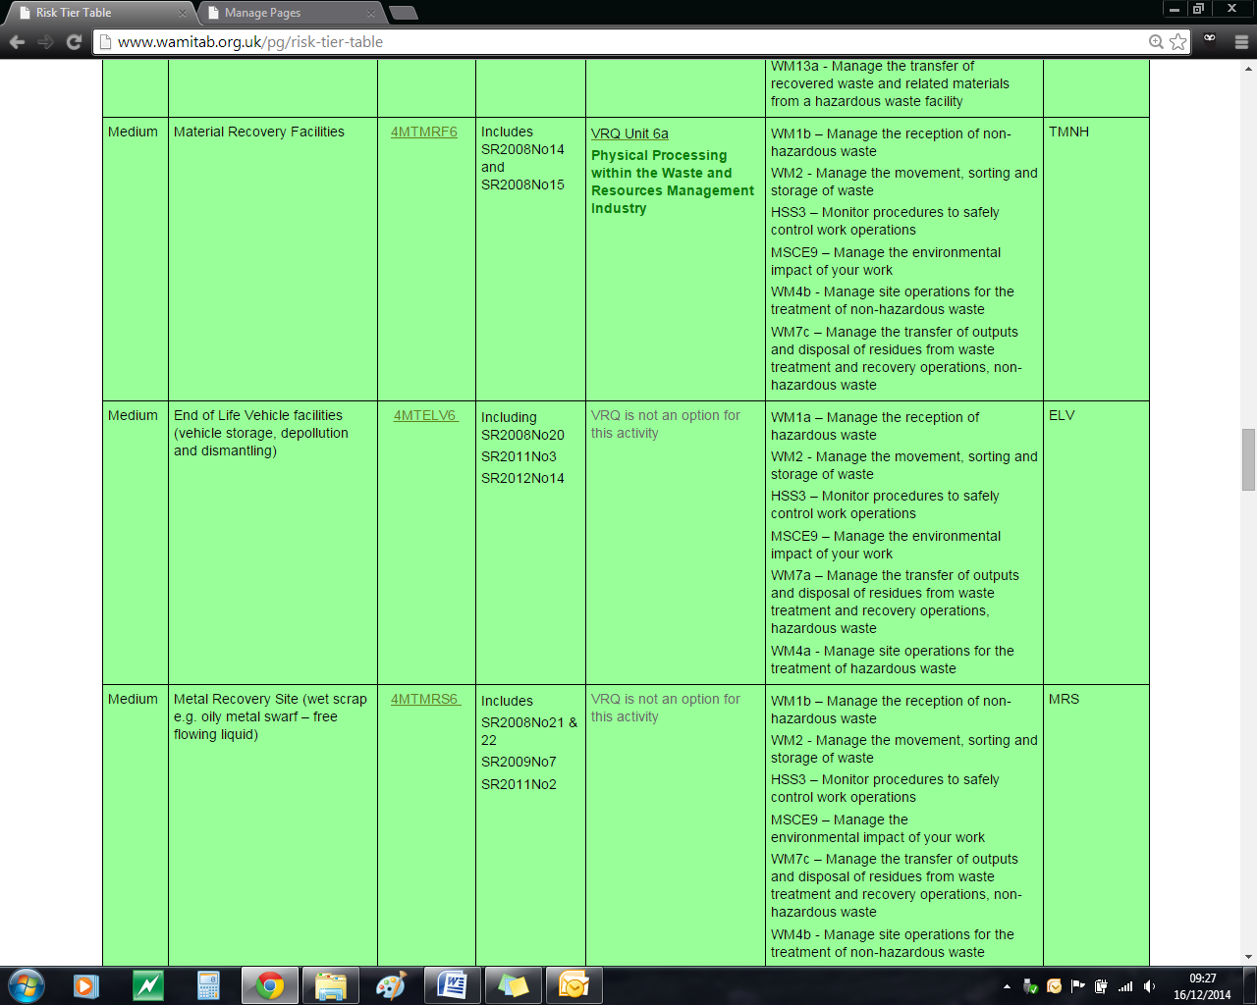

**CIWM/WAMITAB**

**Continuing Competence**

**Part of the CIWM/WAMITAB**

**Operator Competence Scheme**

Copyright ©2016 WAMITAB

Copyright in this document is owned by WAMITAB. Any person viewing, printing and distributing this document is subject to the following conditions:

* The document may be used for informational purposes only
* The document may be used for non-commercial purposes only (unless used by WAMITAB approved centres or partners)
* Anyone using information provided in this document should acknowledge WAMITAB

Changes are made periodically to the information contained within the document so for the latest version please refer to the website: [www.wamitab.org.uk](http://www.wamitab.org.uk).

For further information on Intellectual Property matters contact [info.admin@wamitab.org.uk](mailto:info.admin@wamitab.org.uk).

Please note that all word clouds are curtsey of Tagxedo.com and all images have been sourced from i-stock.

**Contents**

Introduction 5

About WAMITAB 5

What is Continuing Competence? 5

About this Revision Summary 5

1. Scrap Metal Dealers Act 2013 6

Learning Outcomes 6

Where do I find this information? 6

Notes 6

2. Certificates of Destruction 8

Learning Outcomes 8

Where do I find this information? 8

Notes 8

3. Handling Petrol 9

Learning Outcomes 9

Where do I find this information? 9

Notes 9

4. Depollution 10

Learning Outcomes 10

Where do I find this information? 10

Notes 10

5. Site Infrastructure/ Storage Areas 12

Learning Outcomes 12

Where do I find this information? 12

Notes 12

6. Hazardous Waste 14

Learning Outcomes 14

Where do I find this information? 14

Notes 14

7. Exporting Waste 15

Learning Outcomes 15

Where do I find this information? 15

Notes 15

Additional Sources 16

# Introduction

## About WAMITAB

WAMITAB is an awarding organisation and charity that develops qualifications for those working in cleaning; street cleansing; facilities management; resource management and recycling and parking from operative through to management level.

Since it was formed in 1989, WAMITAB has evolved in line with the convergence between the sectors with a clear focus on promoting and supporting environmental sustainability.  With over 120 qualification pathways and 70 quality assured centres, WAMITAB offers an unrivalled specialist network to support staff development.

## What is Continuing Competence?

The CIWM/WAMITAB continuing competence scheme is designed to ensure that the technically competent person (holds a certificate of technical competence, units or a qualification that is part of the CIWM/WAMITAB Operator Competence Scheme) on a waste site has knowledge and skills that keep pace with changes made across the waste management industry, such as the introduction of new legislation, technologies and techniques.

The CIWM/WAMITAB continuing competence scheme requires technically competent people in England and Wales to pass an assessment that demonstrates individuals have kept their competence up to date.

Keeping competence up to date is becoming increasingly important across the UK as society starts to recognise the crucial role waste and resource management industry professionals play in ensuring that the 434 million tonnes of waste generated every year can be treated, reused and recycled to produce a product that will contribute to further economic growth.

## About this Revision Summary

WAMITAB recognise the diverse needs of learners within the sectors we represent. To support those individuals undertaking their Continuing Competence test, we have developed this revision summary.

This revision summary is designed to support you preparation by linking the learning outcomes with the areas that may come up during the Continuing Competence test.

# C:\Users\Helen\AppData\Local\Microsoft\Windows\Temporary Internet Files\Content.IE5\FJ1S42NY\MC900432680[1].png1. Scrap Metal Dealers Act 2013

## Learning Outcomes

1.1 Know who is responsible for issuing scrap metal licences.

1.2 Know the difference between a site licence and a collectors licence.

1.3 Know the definition of a ‘suitable person’ in terms of applying for a site licence.

1.4 Know how long a licence is valid for.

1.5 Know the circumstances under which a licence can be revoked or conditions imposed.

1.6 Know the conditions that may be imposed on a licence.

1.7 Know the information required for the Register of Licences.

1.8 Know who to notify when a licence is no longer required, and by when.

1.9 Know where site licences and collectors licences must be displayed.

1.10 Know what information is required to verify a supplier’s identity.

1.11 Know what forms of payment are acceptable when paying for end of life vehicles.

1.12 Know what records must be kept when receiving and disposing of end of life vehicles.

1.13 Know how long records for receipt/disposal of end of life vehicles should be kept for.

1.14 Know the offences under the Scrap Metal Dealers Act 2013.



## Where do I find this information?

[Scrap Metal Dealers Act 2013](http://www.legislation.gov.uk/ukpga/2013/10/contents/enacted)

[Scrap Metal Dealers Act 2013 – Explanatory Notes](http://www.legislation.gov.uk/ukpga/2013/10/pdfs/ukpgaen_20130010_en.pdf)

[Scrap Metal Dealers Act 2013 supplementary guidance](https://www.gov.uk/government/publications/scrap-metal-dealers-act-2013-supplementary-guidance)

[Scrap Metal Dealers Register](http://epr.environment-agency.gov.uk/ePRInternet/searchregisters.aspx)

## Notes

|  |
| --- |
|  |
|  |
|  |
|  |
|  |
|  |
|  |
|  |

# 

## Notes

|  |
| --- |
|  |
|  |
|  |
|  |
|  |
|  |
|  |
|  |
|  |
|  |
|  |
|  |
|  |
|  |
|  |
|  |
|  |
|  |
|  |
|  |
|  |
|  |
|  |
|  |
|  |
|  |
|  |
|  |
|  |
|  |
|  |
|  |
|  |
|  |
|  |

# 2. Certificates of DestructionC:\Users\Helen\AppData\Local\Microsoft\Windows\Temporary Internet Files\Content.IE5\FJ1S42NY\MC900432680[1].png

## Learning Outcomes

2.1 Know what information is required about the holder/owner of the vehicle when completing a Certificate of Destruction.

2.2 Know what information is required about the vehicle when completing a Certificate of Destruction.



## Where do I find this information?

[The End of Life Vehicles Regulations 2003](http://www.legislation.gov.uk/uksi/2003/2635/pdfs/uksi_20032635_en.pdf)

[The End of Life Vehicles Regulations 2003 – schedule 3 minimum requirements for destruction](http://www.legislation.gov.uk/uksi/2003/2635/schedule/3/made#f00015)

[GOV.UK End of Life Vehicles: guidance for waste sites](https://www.gov.uk/guidance/end-of-life-vehicles-elvs-guidance-for-waste-sites)

## Notes

|  |
| --- |
|  |
|  |
|  |
|  |
|  |
|  |
|  |
|  |
|  |
|  |
|  |
|  |
|  |
|  |
|  |
|  |
|  |
|  |
|  |
|  |
|  |
|  |
|  |
|  |

# 3. Handling PetrolC:\Users\Helen\AppData\Local\Microsoft\Windows\Temporary Internet Files\Content.IE5\FJ1S42NY\MC900432680[1].png

## Learning Outcomes

3.1 Know the procedure for removing fuel from a fuel tank.

3.2 Know why the battery is removed before the fuel tank is depolluted.

3.3 Know the health and safety requirements for assessing the risk of fire and explosion when storing or handling petrol.

3.4 Know how to ensure safe working in areas designated as ‘hazard areas’ in accordance with DSEAR.

3.5 Know how to exclude ignition sources from a hazard area.



## Notes

|  |
| --- |
|  |
|  |
|  |
|  |
|  |
|  |
|  |
|  |
|  |
|  |
|  |
|  |
|  |
|  |
|  |
|  |
|  |
|  |
|  |
|  |
|  |
|  |
|  |
|  |

## Where do I find this information?

[GOV.UK - Depolluting End of Life Vehicles (Cars and Light Goods Vehicles): Guidance for Authorised Treatment Facilities (March 2011)](https://www.gov.uk/government/uploads/system/uploads/attachment_data/file/31736/11-528-depolluting-end-of-life-vehicles-guidance.pdf)

[HSE – The safe recovery of petrol from end of life vehicle (published 07/15)](http://www.hse.gov.uk/pubns/waste10.pdf)

# 4. DepollutionC:\Users\Helen\AppData\Local\Microsoft\Windows\Temporary Internet Files\Content.IE5\FJ1S42NY\MC900432680[1].png

## Learning Outcomes

4.1 Know the depollution sequence outlined in the Depollution Guidance for Authorised Treatment Facilities.

4.2 Know the time delays, procedures and safety measures for airbag detonation.

4.3 Know the procedures for:

* Draining and removal of engine oil.
* Draining gearbox transmission oil.
* Removing brake and screen waste fluid.
* Removing antifreeze and air conditioning refrigerants.

4.4 Know where transmission and hydraulic oils are located.

4.5 Know how to deal with shock absorbers and catalytic converters.

4.6 Know the procedures an ATF should follow when removing LPG tanks.

4.7 Know the requirements for dealing with F Gas when disposing of air conditioning units from vehicles.

De

## Notes

|  |
| --- |
|  |
|  |
|  |
|  |
|  |
|  |
|  |
|  |
|  |
|  |
|  |
|  |
|  |
|  |
|  |
|  |
|  |
|  |
|  |
|  |
|  |
|  |
|  |
|  |

## Where do I find this information?

[GOV.UK - Depolluting End of Life Vehicles (Cars and Light Goods Vehicles): Guidance for Authorised Treatment Facilities (March 2011)](https://www.gov.uk/government/uploads/system/uploads/attachment_data/file/31736/11-528-depolluting-end-of-life-vehicles-guidance.pdf)

[GOV.UK End of Life Vehicles: guidance for waste sites](https://www.gov.uk/guidance/end-of-life-vehicles-elvs-guidance-for-waste-sites)

[GOV.UK F Gas requirements for air conditioners in cars and other vehicles](https://www.gov.uk/guidance/f-gas-requirements-for-air-conditioners-in-cars-and-other-vehicles)

[BIS – Removal of LPG Tanks: Guidance(April 2011)](https://www.gov.uk/government/publications/removal-of-lpg-tanks-guidance)

## Notes

|  |
| --- |
|  |
|  |
|  |
|  |
|  |
|  |
|  |
|  |
|  |
|  |
|  |
|  |
|  |
|  |
|  |
|  |
|  |
|  |
|  |
|  |
|  |
|  |
|  |
|  |
|  |
|  |
|  |
|  |
|  |
|  |
|  |
|  |
|  |
|  |
|  |

# 5. Site Infrastructure/ Storage AreasC:\Users\Helen\AppData\Local\Microsoft\Windows\Temporary Internet Files\Content.IE5\FJ1S42NY\MC900432680[1].png

## Learning Outcomes

5.1 Know the surface and drainage requirements for storing:

* Liquids.
* Contaminated materials.
* Hazardous waste.

5.2 Know the storage conditions for lead-acid batteries.

5.3 Know the storage conditions for un-depolluted vehicles.

5.4 Know the minimum requirements for the separate storage of fluids removed from end of life vehicles.

5.5 Know the minimum requirements for the storage of uncontaminated:

* Plastics.
* Glass.
* Ferrous.
* Non-ferrous metal waste.

5.6 Know the minimum requirements for checking, storing and maintaining containers of polluting liquids.

De



## Where do I find this information?

[Environment Agency – Standard Rules Permit SR2008No20_75kte: Vehicle Storage, Depollution and dismantling (authorised treatment) facility(June 2012, V5.0)](http://a0768b4a8a31e106d8b0-50dc802554eb38a24458b98ff72d550b.r19.cf3.rackcdn.com/geho0512bwki-e-e.pdf)

[Environment Agency – Standard Rules Permit SR2011No3: Vehicle Storage, Depollution and dismantling (authorised treatment) facility( June 2013 V3.0)](http://a0768b4a8a31e106d8b0-50dc802554eb38a24458b98ff72d550b.r19.cf3.rackcdn.com/LIT_6963_faccc8.pdf)

[Environment Agency – Standard Rules Permit SR2012 No14 Metal recycling, vehicle storage depollution and dismantling facility.](https://www.gov.uk/government/publications/sr2012-no14-metal-recycling-vehicle-storage-depollution-and-dismantling-facility)

[Environmental Permitting Regulations – Schedule 11 Waste Motor Vehicles](http://www.legislation.gov.uk/uksi/2010/675/schedule/11/made)

[GOV.UK - Depolluting End of Life Vehicles (Cars and Light Goods Vehicles): Guidance for Authorised Treatment Facilities(March 2011)](https://www.gov.uk/government/uploads/system/uploads/attachment_data/file/31736/11-528-depolluting-end-of-life-vehicles-guidance.pdf)

[How to Comply with your Environmental Permit](https://www.gov.uk/government/publications/how-to-comply-with-your-environmental-permit)

## Notes

|  |
| --- |
|  |
|  |
|  |
|  |
|  |
|  |
|  |
|  |
|  |
|  |
|  |
|  |
|  |
|  |
|  |
|  |
|  |
|  |
|  |
|  |
|  |
|  |
|  |
|  |

## Notes

|  |
| --- |
|  |
|  |
|  |
|  |
|  |
|  |
|  |
|  |
|  |
|  |
|  |
|  |
|  |
|  |
|  |
|  |
|  |
|  |
|  |
|  |
|  |
|  |
|  |
|  |
|  |
|  |
|  |
|  |
|  |
|  |
|  |
|  |
|  |
|  |
|  |

# 6. Hazardous WasteC:\Users\Helen\AppData\Local\Microsoft\Windows\Temporary Internet Files\Content.IE5\FJ1S42NY\MC900432680[1].png

## Learning Outcomes

6.1 Know the wastes classified as hazardous from end of life vehicle treatment.

6.2 Know how to identify a hazardous wastes from the correct List of Wastes (EWC) codes.

6.3 Know how to use guidance to identify the hazardous properties of waste.

6.4 Know how long to keep hazardous wastes consignment notes.

6.5 Know the paperwork needed for the disposal of hazardous waste.

6.6 Know the frequency of returns to the Regulator made by a consignee of hazardous waste.

De

## Notes

|  |
| --- |
|  |
|  |
|  |
|  |
|  |
|  |
|  |
|  |
|  |
|  |
|  |
|  |
|  |
|  |
|  |
|  |
|  |
|  |
|  |
|  |
|  |
|  |
|  |
|  |

## Where do I find this information?

[Environment Agency – Technical Guidance WM3: Hazardous Waste(1st edition, 2015)](http://a0768b4a8a31e106d8b0-50dc802554eb38a24458b98ff72d550b.r19.cf3.rackcdn.com/LIT_5426_acd22f.pdf)

[Environment Agency – Move hazardous waste](http://www.environment-agency.gov.uk/business/topics/waste/32196.aspx)

[Environment Agency – Hazardous Waste – Producers and Holders](https://www.gov.uk/dispose-hazardous-waste/producers-and-holders)

[Environment Agency – Technical Guidance WM3: Hazardous Waste(1st edition, 2015)](http://a0768b4a8a31e106d8b0-50dc802554eb38a24458b98ff72d550b.r19.cf3.rackcdn.com/LIT_5426_acd22f.pdf)

# 7. Exporting WasteC:\Users\Helen\AppData\Local\Microsoft\Windows\Temporary Internet Files\Content.IE5\FJ1S42NY\MC900432680[1].png

## Learning Outcomes

7.1 Know the restrictions and controls relating to export of end of life vehicle waste outside of the UK.

De



## Where do I find this information?

[Gov.UK Waste: Import and Export](https://www.gov.uk/guidance/importing-and-exporting-waste)

## Notes

|  |
| --- |
|  |
|  |
|  |
|  |
|  |
|  |
|  |
|  |
|  |
|  |
|  |
|  |
|  |
|  |
|  |
|  |
|  |
|  |
|  |
|  |
|  |
|  |
|  |

# Additional Sources

The Motor Vehicle Dismantlers Association (MVDA): [www.mvda.org.uk](http://www.mvda.org.uk)

British Metals Recycling Association (BMRA):[www.recyclemetals.org](http://www.recyclemetals.org)

British Vehicle Salvage Federation (BVSF):[www.bvsf.org.uk](http://www.bvsf.org.uk)



WAMITAB

Peterbridge House

3 The Lakes

Northampton

NN4 7HE

Tel: 01604 231950

Email: [info.admin@wamitab.org.uk](mailto:info.admin@wamitab.org.uk)

Web: [www.wamitab.org.uk](http://www.wamitab.org.uk)

[](https://twitter.com/WAMITAB) [](http://www.linkedin.com/company/wamitab) [](https://www.facebook.com/pages/WAMITAB/218830928149483)