|  |
| --- |
| **Generic Environmental Protection** |
| Revision Summary |
| Version 1, April 2016 |

http://ciwm-journal.co.uk/wordpress/wp-content/themes/ciwm-journal/hamish/CIWM_Journal_Logo.png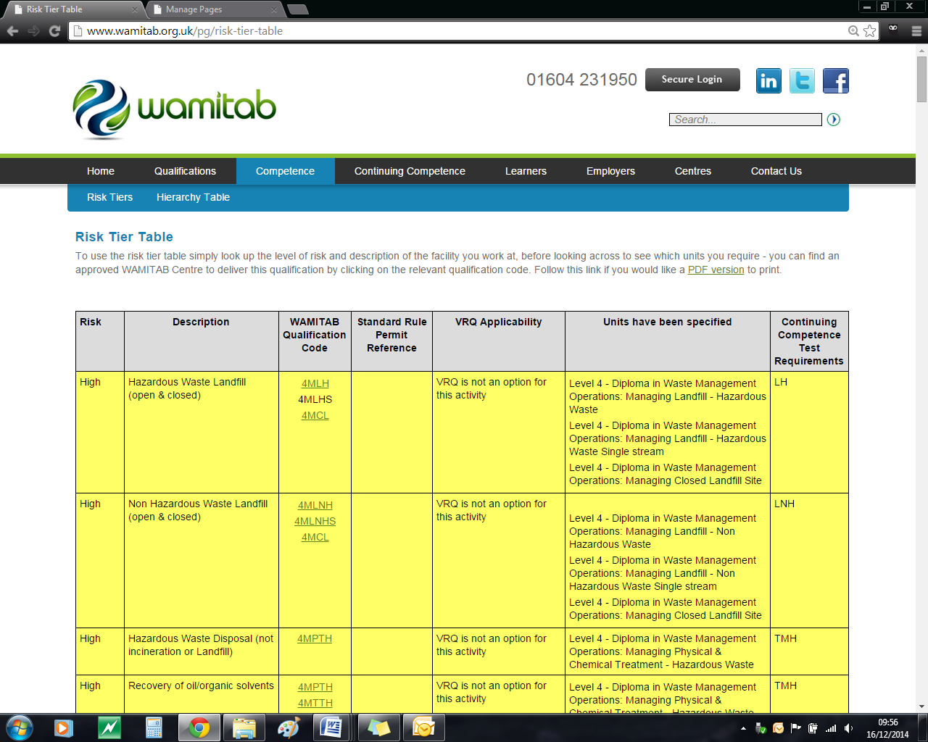

**CIWM/WAMITAB**

**Continuing Competence**

**Part of the CIWM/WAMITAB**

**Operator Competence Scheme**

Copyright ©2016 WAMITAB

Copyright in this document is owned by WAMITAB. Any person viewing, printing and distributing this document is subject to the following conditions:

* The document may be used for informational purposes only
* The document may be used for non-commercial purposes only (unless used by WAMITAB approved centres or partners)
* Anyone using information provided in this document should acknowledge WAMITAB

Changes are made periodically to the information contained within the document so for the latest version please refer to the website: [www.wamitab.org.uk](http://www.wamitab.org.uk).

For further information on Intellectual Property matters contact [info.admin@wamitab.org.uk](mailto:info.admin@wamitab.org.uk).

Please note that all word clouds are curtsey of Tagxedo.com and all images have been sourced from i-stock.

**Contents**

Introduction 4

About WAMITAB 4

What is Continuing Competence? 4

About this Revision Summary 4

1. Environmental Risks 5

Learning Outcomes 5

Where do I find this information? 5

Notes 5

2. Controlling Emissions 6

Learning Outcomes 6

Where do I find this information? 6

Notes 6

3. Containment and Storage on Site 7

Learning Outcomes 7

Where do I find this information? 7

Notes 7

4. Fires 8

Learning Outcomes 8

Where do I find this information? 8

Notes 8

5. Environmental Incidents/Spillages on Site 9

Learning Outcomes 9

Where do I find this information? 9

Notes 9

# Introduction

## About WAMITAB

WAMITAB is an awarding organisation and charity that develops qualifications for those working in cleaning; street cleansing; facilities management; resource management and recycling and parking from operative through to management level.

Since it was formed in 1989, WAMITAB has evolved in line with the convergence between the sectors with a clear focus on promoting and supporting environmental sustainability.  With over 120 qualification pathways and 70 quality assured centres, WAMITAB offers an unrivalled specialist network to support staff development.

## What is Continuing Competence?

The CIWM/WAMITAB continuing competence scheme is designed to ensure that the technically competent person (holds a certificate of technical competence, units or a qualification that is part of the CIWM/WAMITAB Operator Competence Scheme) on a waste site has knowledge and skills that keep pace with changes made across the waste management industry, such as the introduction of new legislation, technologies and techniques.

The CIWM/WAMITAB continuing competence scheme requires technically competent people in England and Wales to pass an assessment that demonstrates individuals have kept their competence up to date.

Keeping competence up to date is becoming increasingly important across the UK as society starts to recognise the crucial role waste and resource management industry professionals play in ensuring that the 434 million tonnes of waste generated every year can be treated, reused and recycled to produce a product that will contribute to further economic growth.

## About this Revision Summary

WAMITAB recognise the diverse needs of learners within the sectors we represent. To support those individuals undertaking their Continuing Competence test, we have developed this revision summary.

This revision summary is designed to support you preparation by linking the learning outcomes with the areas that may come up during the Continuing Competence test.

# 1. Environmental RisksC:\Users\Helen\AppData\Local\Microsoft\Windows\Temporary Internet Files\Content.IE5\FJ1S42NY\MC900432680[1].png

## Learning Outcomes

* 1. Know the key criteria of a site environmental risk assessments
  2. Know the difference between a risk and a hazard
  3. Know the ‘appropriate measures’ used in relation to managing environmental risks
  4. Know how to ensure a written management system enables compliance with permit and relevant Risk Assessments



## Where do I find this information?

* [Incident Response Planning: PPG 21 (March 2009)](https://www.gov.uk/government/collections/pollution-prevention-guidance-ppg)
* [PPG1: General Guide to the Prevention of Pollution – July 2013](http://publications.environment-agency.gov.uk/PDF/PMHO0501BFOX-E-E.pdf)
* [H1 Environmental Risks Assessment](http://www.environment-agency.gov.uk/business/topics/permitting/36414.aspx)
* [H1 Annex A – Amenity & accident risk from installations and waste activities](http://publications.environment-agency.gov.uk/PDF/GEHO0410BSIG-E-E.pdf)
* [How to comply with your environmental permit v.6 June 2013 (EA Guidance)](http://a0768b4a8a31e106d8b0-50dc802554eb38a24458b98ff72d550b.r19.cf3.rackcdn.com/LIT_7123_79744e.pdf)

## Notes

|  |
| --- |
|  |
|  |
|  |
|  |
|  |
|  |
|  |
|  |
|  |
|  |
|  |
|  |
|  |
|  |
|  |
|  |
|  |
|  |
|  |
|  |
|  |
|  |
|  |
|  |

# 2. C:\Users\Helen\AppData\Local\Microsoft\Windows\Temporary Internet Files\Content.IE5\FJ1S42NY\MC900432680[1].pngControlling Emissions

## Learning Outcomes

* 1. Know the difference between a point source and fugitive emissions
  2. Know the ‘appropriate measures’ used to control nuisance to neighbours, including:
* Mud,
* Dust,
* Litter
* Pests
  1. Know the ‘appropriate measures’ used to prevent noise nuisance from the site
  2. Know how to record the measures used in written management systems
  3. Know who to apply to discharge surface water and liquids from a site to:
* a watercourse
* ground
* sewer
  1. Know the requirements of an emissions management plan
  2. Know the requirements of an odour management plan
  3. Know the requirements of a noise and vibration management plan



## Where do I find this information?

* [How to comply with your environmental permit v.6 June 2013 (EA Guidance)](http://a0768b4a8a31e106d8b0-50dc802554eb38a24458b98ff72d550b.r19.cf3.rackcdn.com/LIT_7123_79744e.pdf)
* [H1 Annex A - Amenity and accident risks from installations and waste activities](https://www.gov.uk/government/uploads/system/uploads/attachment_data/file/298235/geho0410bsig-e-e.pdf)
* [Environmental Permitting: H3 Part 2 noise assessment and control](https://www.gov.uk/government/publications/environmental-permitting-h3-part-2-noise-assessment-and-control)
* [Noise impact assessment: information requirements](https://www.gov.uk/government/publications/noise-impact-assessment-information-requirements)
* [Environmental permitting for discharges to surface water and groundwater - Environment Agency](http://www.environment-agency.gov.uk/business/regulation/32038.aspx)

# 

## Notes

|  |
| --- |
|  |
|  |
|  |
|  |
|  |
|  |
|  |
|  |
|  |
|  |
|  |
|  |
|  |
|  |
|  |
|  |
|  |
|  |
|  |
|  |
|  |
|  |
|  |
|  |

# 3. C:\Users\Helen\AppData\Local\Microsoft\Windows\Temporary Internet Files\Content.IE5\FJ1S42NY\MC900432680[1].pngContainment and Storage on Site

## Learning Outcomes

* 1. Know the definition of the term ‘secondary containment’
  2. Know the required checks for a sealed on-site drainage system and bunded areas
  3. Know the effect of using detergents for washing in an area served by an oil interceptor
  4. Know the difference between ‘hard standing’ and an impermeable pavement/ impervious surface
  5. Know the key characteristics of a sealed drainage system
  6. Know the infrastructure requirements for the operational areas on a site including potential quarantined waste areas
  7. Know the requirements for safely storing oil, other polluting liquids
  8. Know the maintenance checks required to maintain site infrastructure and prevent pollution
  9. Know how to manage and store combustible materials safely in accordance with the site Fire Prevention Plan



## Where do I find this information?

* [Above Ground Oil Storage Tanks: PPG 2 – August 2011 – Environment Agency](http://a0768b4a8a31e106d8b0-50dc802554eb38a24458b98ff72d550b.r19.cf3.rackcdn.com/pmho0811bucr-e-e.pdf)
* [PPG3 Use and design of oil separators in surface water drainage systems – 2006 - Environment Agency](http://publications.environment-agency.gov.uk/PDF/PMHO0406BIYL-E-E.pdf)
* [How to comply with your environmental permit v.6 June 2013 (EA Guidance)](http://a0768b4a8a31e106d8b0-50dc802554eb38a24458b98ff72d550b.r19.cf3.rackcdn.com/LIT_7123_79744e.pdf)
* <https://www.ciria.org/Resources/Free_publications/c736.aspx>
* [Understanding permeable and impermeable surfaces: Technical report on surfacing options and cost benefit analysis](http://webarchive.nationalarchives.gov.uk/20091105143948/http:/www.communities.gov.uk/publications/planningandbuilding/permeablesufacesreport)
* Fire Prevention Plans Guidance: <https://www.gov.uk/government/publications/permitted-sites-fire-prevention-plans>
* [WISH28: Reducing Fire Risk at Waste Management Sites](http://www.ciwm.co.uk/web/FILES/WISH/WASTE_28_Reducing_fire_risk_at_waste_management_sites_issue_1_-_Oct_2014.pdf)

## Notes

|  |
| --- |
|  |
|  |
|  |
|  |
|  |
|  |
|  |
|  |
|  |
|  |
|  |
|  |
|  |
|  |
|  |
|  |
|  |
|  |
|  |
|  |
|  |
|  |
|  |
|  |

# 4. C:\Users\Helen\AppData\Local\Microsoft\Windows\Temporary Internet Files\Content.IE5\FJ1S42NY\MC900432680[1].pngFires

## Learning Outcomes

* 1. Know the measures used to prevent fires and minimise their impact on a waste facility
  2. Know when a Fire Prevention Plan is needed
  3. Know the key criteria of a Fire Prevention plan and how it should be implemented
  4. Know the information that should be made available about a waste facility to emergency services in case of fire



## Where do I find this information?

* Fire Prevention Plans Guidance: <https://www.gov.uk/government/publications/permitted-sites-fire-prevention-plans>
* [WISH28: Reducing Fire Risk at Waste Management Sites](http://www.ciwm.co.uk/web/FILES/WISH/WASTE_28_Reducing_fire_risk_at_waste_management_sites_issue_1_-_Oct_2014.pdf)

## Notes

|  |
| --- |
|  |
|  |
|  |
|  |
|  |
|  |
|  |
|  |
|  |
|  |
|  |
|  |
|  |
|  |
|  |
|  |
|  |
|  |
|  |
|  |
|  |
|  |
|  |
|  |

# 5. C:\Users\Helen\AppData\Local\Microsoft\Windows\Temporary Internet Files\Content.IE5\FJ1S42NY\MC900432680[1].pngEnvironmental Incidents/Spillages on Site

## Learning Outcomes

* 1. Know the actions to take in the event of a spillage or other accident which causes or could potentially cause environmental damage
  2. Know the records, reports and notifications required in order to comply with permits
  3. Know how to check if a facility is liable to flood in order to ensure appropriate measures are included in the written management system for the site to minimise environmental harm

* 1. Know the colour the Regulator recommends for foul water and surface water drain covers
  2. Know the factors taken into account by the courts under the Sentencing Guidelines when deciding on penalties for environmental pollution/ non-compliance with permits



## Where do I find this information?

* [Pollution Prevention Pays](https://www.gov.uk/government/publications/preventing-industrial-and-commercial-pollution-pollution-prevention-pays)
* [Incident Response Planning: PPG 21 (March 2009)](https://www.gov.uk/government/collections/pollution-prevention-guidance-ppg)
* [How to comply with your environmental permit v.6 June 2013 (EA Guidance)](http://a0768b4a8a31e106d8b0-50dc802554eb38a24458b98ff72d550b.r19.cf3.rackcdn.com/LIT_7123_79744e.pdf)
* [Regulatory Guidance Series No 11: Enforcement powers](https://www.gov.uk/government/publications/rgn-11-enforcement-powers)
* [PPG2: Dealing with Spills – April 2011 Environment Agency](https://www.gov.uk/government/collections/pollution-prevention-guidance-ppg)
* [Environmental Offences: Sentencing Guidelines](https://www.sentencingcouncil.org.uk/publications/item/environmental-offences-definitive-guideline/)
* [Environment Agency – Check flood warnings and river levels.](https://www.gov.uk/check-if-youre-at-risk-of-flooding)

## Notes

|  |
| --- |
|  |
|  |
|  |
|  |
|  |
|  |
|  |
|  |
|  |
|  |
|  |
|  |
|  |
|  |
|  |
|  |
|  |
|  |
|  |
|  |
|  |
|  |
|  |
|  |



WAMITAB

Peterbridge House

3 The Lakes

Northampton

NN4 7HE

Tel: 01604 231950

Email: [info.admin@wamitab.org.uk](mailto:info.admin@wamitab.org.uk)

Web: [www.wamitab.org.uk](http://www.wamitab.org.uk)

[](https://twitter.com/WAMITAB) [](http://www.linkedin.com/company/wamitab) [](https://www.facebook.com/pages/WAMITAB/218830928149483)