|  |
| --- |
| **Generic Health and Safety** |
| Revision Summary |
| Version 1, April 2016 |

http://ciwm-journal.co.uk/wordpress/wp-content/themes/ciwm-journal/hamish/CIWM_Journal_Logo.png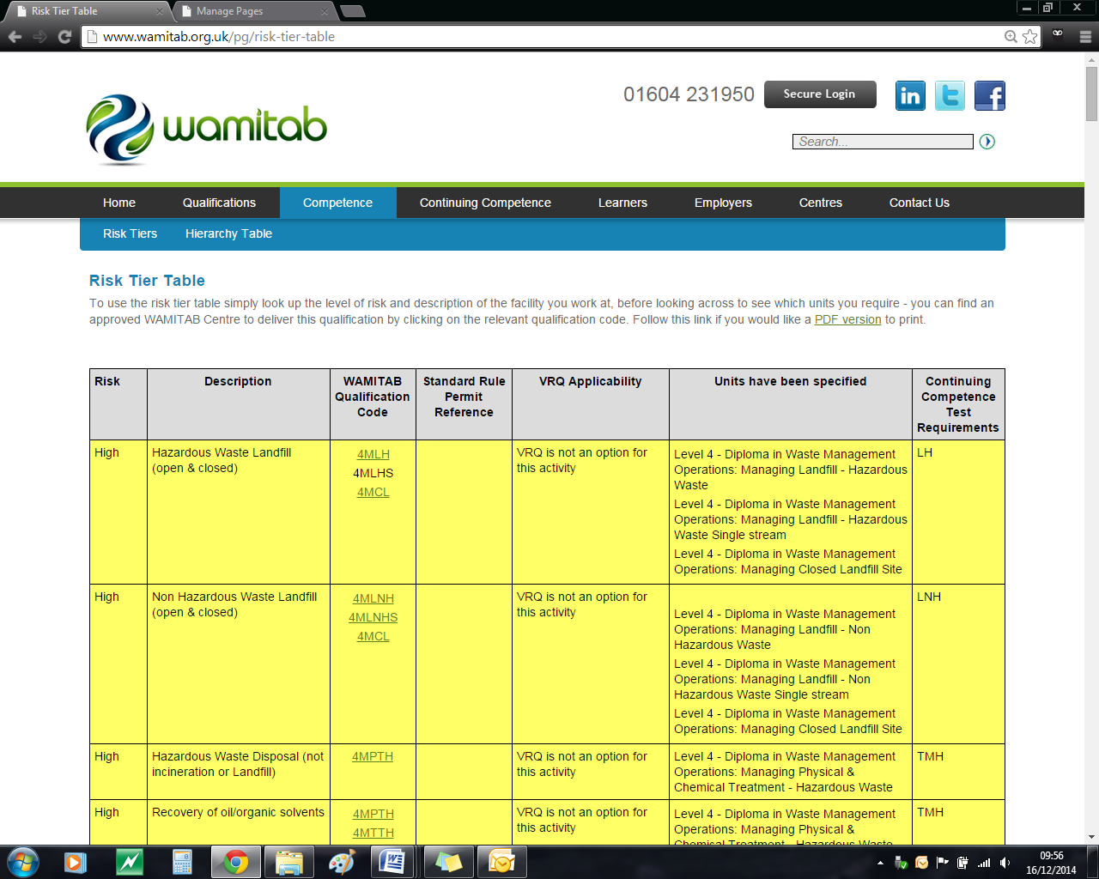

**CIWM/WAMITAB**

**Continuing Competence**

**Part of the CIWM/WAMITAB**

**Operator Competence Scheme**

Copyright ©2016 WAMITAB

Copyright in this document is owned by WAMITAB. Any person viewing, printing and distributing this document is subject to the following conditions:

* The document may be used for informational purposes only
* The document may be used for non-commercial purposes only (unless used by WAMITAB approved centres or partners)
* Anyone using information provided in this document should acknowledge WAMITAB

Changes are made periodically to the information contained within the document so for the latest version please refer to the website: [www.wamitab.org.uk](http://www.wamitab.org.uk).

For further information on Intellectual Property matters contact [info.admin@wamitab.org.uk](mailto:info.admin@wamitab.org.uk).

Please note that all word clouds are curtsey of Tagxedo.com and all images have been sourced from i-stock.

**Contents**

Introduction 4

About WAMITAB 4

What is Continuing Competence? 4

About this Revision Summary 4

1. Health and Safety Legislation 5

Learning Outcomes 5

Where do I find this information? 5

Notes 5

2. Noise, vibration and asbestos 6

Learning Outcomes 6

Where do I find this information? 6

Notes 6

3. Risk Assessment 7

Learning Outcomes 7

Where do I find this information? 7

Notes 7

4. People on Site (Staff and Non-Staff) 8

Learning Outcomes 8

Where do I find this information? 8

Notes 8

5. Permits to Work 9

Learning Outcomes 9

Where do I find this information? 9

Notes 9

6. Requirements of Using Equipment 10

Learning Outcomes 10

Where do I find this information? 10

Notes 10

7. Manual Handling 11

Learning Outcomes 11

Where do I find this information? 11

Notes 11

# Introduction

## About WAMITAB

WAMITAB is an awarding organisation and charity that develops qualifications for those working in cleaning; street cleansing; facilities management; resource management and recycling and parking from operative through to management level.

Since it was formed in 1989, WAMITAB has evolved in line with the convergence between the sectors with a clear focus on promoting and supporting environmental sustainability.  With over 120 qualification pathways and 70 quality assured centres, WAMITAB offers an unrivalled specialist network to support staff development.

## What is Continuing Competence?

The CIWM/WAMITAB continuing competence scheme is designed to ensure that the technically competent person (holds a certificate of technical competence, units or a qualification that is part of the CIWM/WAMITAB Operator Competence Scheme) on a waste site has knowledge and skills that keep pace with changes made across the waste management industry, such as the introduction of new legislation, technologies and techniques.

The CIWM/WAMITAB continuing competence scheme requires technically competent people in England and Wales to pass an assessment that demonstrates individuals have kept their competence up to date.

Keeping competence up to date is becoming increasingly important across the UK as society starts to recognise the crucial role waste and resource management industry professionals play in ensuring that the 434 million tonnes of waste generated every year can be treated, reused and recycled to produce a product that will contribute to further economic growth.

## About this Revision Summary

WAMITAB recognise the diverse needs of learners within the sectors we represent. To support those individuals undertaking their Continuing Competence test, we have developed this revision summary.

This revision summary is designed to support you preparation by linking the learning outcomes with the areas that may come up during the Continuing Competence test.

# 1. Health and Safety Legislation C:\Users\Helen\AppData\Local\Microsoft\Windows\Temporary Internet Files\Content.IE5\FJ1S42NY\MC900432680[1].png

## Learning Outcomes

* 1. Know the responsibilities of employers and employees under the Health and Safety at Work Act 1974
  2. Know what is meant by the term ‘reasonably practicable’
  3. Know why procedural compliance with health and safety legislation is monitored
  4. Know what accidents require reporting to the Health and Safety Executive under RIDDOR
  5. Know the main features and legal requirements of COSHH (including COSHH assessments)
  6. Know how to recognise hazardous substances that may require COSHH assessments



## Where do I find this information?

* [HSE – Waste Management and recycling](http://www.hse.gov.uk/waste/)
* [HSE - HSG65: Managing for Health and Safety (3rd edition, published 2013)](http://www.hse.gov.uk/pubns/books/hsg65.pdf)
* [HSE - Reporting accidents and incidents at work – a brief guide to RIDDOR 2013 (published 10/13)](http://www.hse.gov.uk/pubns/indg453.pdf)
* [Health and Safety at Work etc. Act 1974](http://www.hse.gov.uk/legislation/hswa.htm)
* [Control of Substances Hazardous to Health Regulations 2002](http://www.legislation.gov.uk/uksi/2002/2677/contents/made)
* [HSE Guidance - COSHH](http://www.hse.gov.uk/coshh/)
* [HSE - What is a ‘substance hazardous to health’?](http://www.hse.gov.uk/coshh/basics/substance.htm)
* [HSE – Health and safety training in waste management and recycling](http://www.hse.gov.uk/pubns/waste21.pdf)

## Notes

|  |
| --- |
|  |
|  |
|  |
|  |
|  |
|  |
|  |
|  |
|  |
|  |
|  |
|  |
|  |
|  |
|  |
|  |
|  |
|  |
|  |
|  |
|  |
|  |
|  |
|  |
|  |
|  |
|  |
|  |
|  |
|  |
|  |
|  |
|  |
|  |

# 2. C:\Users\Helen\AppData\Local\Microsoft\Windows\Temporary Internet Files\Content.IE5\FJ1S42NY\MC900432680[1].pngNoise, vibration and asbestos

## Learning Outcomes

* 1. Know the noise action ‘trigger’ levels
  2. Know how to manage and mitigate noise levels caused by permitted activities on site
  3. Know when exposure to hand-arm vibration and whole body vibration may occur
  4. Know the requirements for controlling and preventing the effects of vibration at work
  5. Know where to go for more information on controlling and preventing the effects of vibration at work
  6. Know an operator’s responsibilities regarding potential exposure to Asbestos and other harmful substances when managing waste



## Where do I find this information?

* [HSE – Noise at Work (published 11/12)](http://www.hse.gov.uk/pubns/indg362.pdf)
* [HSE – Noise FAQs](http://www.hse.gov.uk/noise/faq.htm#q1)
* [HSE – Vibration at Work](http://www.hse.gov.uk/vibration/index.htm)
* [HSE – Asbestos](http://www.hse.gov.uk/asbestos/index.htm)

## Notes

|  |
| --- |
|  |
|  |
|  |
|  |
|  |
|  |
|  |
|  |
|  |
|  |
|  |
|  |
|  |
|  |
|  |
|  |
|  |
|  |
|  |
|  |
|  |
|  |
|  |
|  |
|  |
|  |
|  |
|  |
|  |
|  |
|  |
|  |
|  |
|  |

# 3. Risk Assessment C:\Users\Helen\AppData\Local\Microsoft\Windows\Temporary Internet Files\Content.IE5\FJ1S42NY\MC900432680[1].png

## Learning Outcomes

* 1. Know the difference between a hazard and risk
  2. Know the purpose of risk assessment
  3. Know the first stage of risk control
  4. Know why Personal Protective Equipment (PPE) is the last stage in risk control
  5. Know the requirements for monitoring and ensuring staff practices comply with health and safety procedures



## Where do I find this information?

* [HSE – Controlling Risks in the workplace](http://www.hse.gov.uk/risk/controlling-risks.htm)
* [HSE – Risk Assessment - A Brief Guide to Controlling Risks in the Workplace](http://www.hse.gov.uk/pubns/indg163.pdf)
* [HSE - Risk Management – Frequently Asked Questions](http://www.hse.gov.uk/risk/faq.htm)
* [HSE - Personal Protective Equipment at Work (2nd Edition)](http://www.hse.gov.uk/pubns/priced/l25.pdf)
* [HSE – The Health and Safety Toolbox: Personal Protective Equipment](http://www.hse.gov.uk/toolbox/ppe.htm)

## Notes

|  |
| --- |
|  |
|  |
|  |
|  |
|  |
|  |
|  |
|  |
|  |
|  |
|  |
|  |
|  |
|  |
|  |
|  |
|  |
|  |
|  |
|  |
|  |
|  |
|  |
|  |
|  |
|  |
|  |
|  |
|  |
|  |
|  |
|  |
|  |
|  |

# 4. C:\Users\Helen\AppData\Local\Microsoft\Windows\Temporary Internet Files\Content.IE5\FJ1S42NY\MC900432680[1].pngPeople on Site (Staff and Non-Staff)

## Learning Outcomes

* 1. Know the purpose and main features of a Traffic Management Plan
  2. Know the control measures used to minimise the risk posed by vehicles reversing on site
  3. Know the responsibilities for onsite contractors with regards to health and safety
  4. Know the different health and safety signs used on site
  5. Know the safety information that should be given to anyone visiting the site



## Where do I find this information?

* [HSE - HSG136: Workplace transport safety (2nd edition, published 2005)](http://www.hse.gov.uk/pubns/priced/hsg136.pdf)
* [Health and Safety at Work etc. Act 1974](http://www.hse.gov.uk/legislation/hswa.htm)
* [HSE – Safety Signs and Signals: Guidance on Regulations (3rdnd edition, published 2015)](http://www.hse.gov.uk/pubns/priced/l64.pdf)
* [HSE – HSG159: Managing Contractors – A Guide for Employers (2nd edition, published 2011)](http://www.hse.gov.uk/pubns/priced/hsg159.pdf)
* [HSE - Reversing](http://www.hse.gov.uk/workplacetransport/information/reversing.htm)
* [HSE – Waste Management and recycling](http://www.hse.gov.uk/waste/)

## Notes

|  |
| --- |
|  |
|  |
|  |
|  |
|  |
|  |
|  |
|  |
|  |
|  |
|  |
|  |
|  |
|  |
|  |
|  |
|  |
|  |
|  |
|  |
|  |
|  |
|  |
|  |
|  |
|  |
|  |
|  |
|  |
|  |
|  |
|  |
|  |
|  |

# 5. C:\Users\Helen\AppData\Local\Microsoft\Windows\Temporary Internet Files\Content.IE5\FJ1S42NY\MC900432680[1].pngPermits to Work

## Learning Outcomes

* 1. Know what a Permit to Work is
  2. Know when a Permit to Work is required
  3. Know what is meant by the terms:
* an explosive atmosphere
* oxygen deficient areas (confined space)
  1. Know the tests required before entering a confined space
  2. Know who is permitted to enter a confined space once tests have been carried out
  3. Know how to control the risk of falling from a height



## Where do I find this information?

* [HSE – Confined Spaces](http://www.hse.gov.uk/confinedspace/index.htm)
* [HSE – Safe Work in Confined Spaces (3rd edition, published 2014)](http://www.hse.gov.uk/pubns/priced/l101.pdf)
* [HSE Guidance – Dangerous Substances and Explosive Atmospheres Regulations 2002](http://www.hse.gov.uk/fireandexplosion/dsear.htm)
* [HSE – Dangerous substances and explosive atmospheres (2nd edition, published 2013)](http://www.hse.gov.uk/pubns/priced/l138.pdf)
* [HSE – Guidance – Confined Spaces](http://www.hse.gov.uk/confinedspace/)
* [HSE – Confined Spaces: a brief guide to working safely (published 01/13)](http://www.hse.gov.uk/pubns/indg258.pdf)[HSE – The Health and Safety Toolbox: Working at height.](http://www.hse.gov.uk/toolbox/height.htm)
* [HSE – The Work at Height Regulations 2005: a brief guide (revised 01/14)](http://www.hse.gov.uk/pubns/indg401.pdf)
* [HSE – Waste Management and recycling](http://www.hse.gov.uk/waste/)
* [The Health and safety toolbox: How to control risks at work](http://www.hse.gov.uk/toolbox/index.htm)

## Notes

|  |
| --- |
|  |
|  |
|  |
|  |
|  |
|  |
|  |
|  |
|  |
|  |
|  |
|  |
|  |
|  |
|  |
|  |
|  |
|  |
|  |
|  |
|  |
|  |
|  |
|  |
|  |
|  |
|  |
|  |
|  |
|  |
|  |
|  |
|  |
|  |

# C:\Users\Helen\AppData\Local\Microsoft\Windows\Temporary Internet Files\Content.IE5\FJ1S42NY\MC900432680[1].png6. Requirements of Using Equipment

## Learning Outcomes

* 1. Know the main features and legal requirements of:
* LOLER
* PUWER

6.2 Know the inspection frequencies for lifting equipment

6.3 Know what is meant by the terms:

* ‘roll-over-protection’
* S.W.L.

6.4 Know the routine maintenance required on:

* plant
* equipment

6.5 Know who can carry out maintenance on plant and equipment



## Where do I find this information?

* [HSE – Lifting Equipment at Work: a brief guide (published 03/13)](http://www.hse.gov.uk/pubns/indg290.pdf)
* [HSE – LOLER Guidance](http://www.hse.gov.uk/work-equipment-machinery/loler.htm)
* [HSE – Providing and using Work Equipment Safely (published 03/13)](http://www.hse.gov.uk/pubns/indg291.pdf)
* [HSE - Safe Use of Work Equipment: PUWER guidance (4th edition, published 2014)](http://www.hse.gov.uk/pubns/priced/l22.pdf)
* [HSE – Waste Management and recycling](http://www.hse.gov.uk/waste/)
* [HSE – Maintenance – vehicles and machinery](http://www.hse.gov.uk/agriculture/topics/maintenance.htm)

## Notes

|  |
| --- |
|  |
|  |
|  |
|  |
|  |
|  |
|  |
|  |
|  |
|  |
|  |
|  |
|  |
|  |
|  |
|  |
|  |
|  |
|  |
|  |
|  |
|  |
|  |
|  |
|  |
|  |
|  |
|  |
|  |
|  |
|  |
|  |
|  |
|  |

# C:\Users\Helen\AppData\Local\Microsoft\Windows\Temporary Internet Files\Content.IE5\FJ1S42NY\MC900432680[1].png7. Manual Handling

## Learning Outcomes

7.1 Know how to undertake a manual handling assessment

7.2 Know the steps for safe manual handling

7.3 Know the alternatives to manual lifting

7.4 Know what is meant by the term ‘team lifting’



## Where do I find this information?

* [HSE – Manual Handling](http://www.hse.gov.uk/msd/manualhandling.htm)
* [HSE – Manual Handling at Work: a brief guide (published 11/12)](http://www.hse.gov.uk/pubns/indg143.pdf)
* [HSE – FAQs: Manual Handling](http://www.hse.gov.uk/msd/faq-manhand.htm)
* [HSE – Team handling](http://www.hse.gov.uk/msd/mac/assess03.htm)
* [HSE - Guidance for team handling tasks](http://www.hse.gov.uk/msd/mac/guidance03a.htm)
* [ROSPA – What is Manual Handling?](http://rospaworkplacesafety.com/2013/02/18/manual-handling-definition/)

## Notes

|  |
| --- |
|  |
|  |
|  |
|  |
|  |
|  |
|  |
|  |
|  |
|  |
|  |
|  |
|  |
|  |
|  |
|  |
|  |
|  |
|  |
|  |
|  |
|  |
|  |
|  |
|  |
|  |
|  |
|  |
|  |
|  |
|  |
|  |
|  |
|  |



WAMITAB

Peterbridge House

3 The Lakes

Northampton

NN4 7HE

Tel: 01604 231950

Email: [info.admin@wamitab.org.uk](mailto:info.admin@wamitab.org.uk)

Web: [www.wamitab.org.uk](http://www.wamitab.org.uk)

[](https://twitter.com/WAMITAB) [](http://www.linkedin.com/company/wamitab) [](https://www.facebook.com/pages/WAMITAB/218830928149483)