|  |
| --- |
| **Generic Legislation** |
| Revision Summary |
| Version 1, April 2016 |

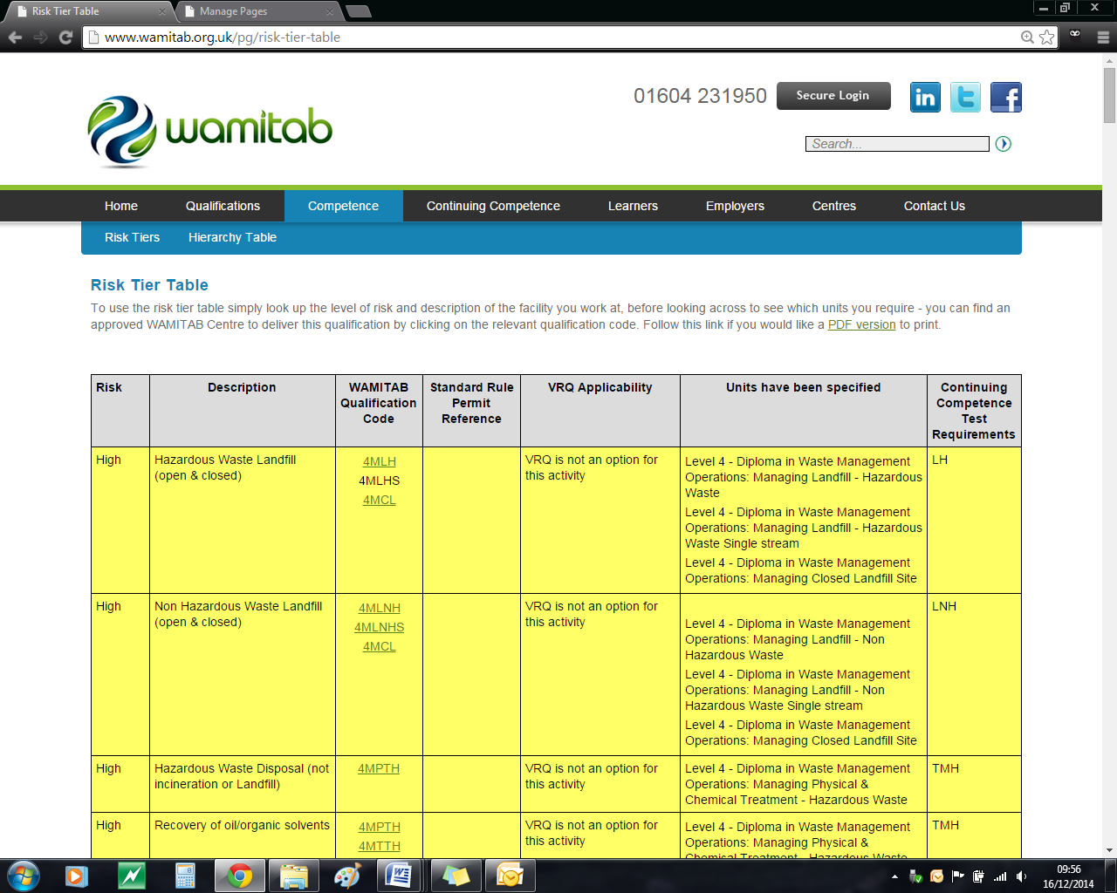http://ciwm-journal.co.uk/wordpress/wp-content/themes/ciwm-journal/hamish/CIWM_Journal_Logo.png

**CIWM/WAMITAB**

**Continuing Competence**

**Part of the CIWM/WAMITAB**

**Operator Competence Scheme**

Copyright ©2016 WAMITAB

Copyright in this document is owned by WAMITAB. Any person viewing, printing and distributing this document is subject to the following conditions:

* The document may be used for informational purposes only
* The document may be used for non-commercial purposes only (unless used by WAMITAB approved centres or partners)
* Anyone using information provided in this document should acknowledge WAMITAB

Changes are made periodically to the information contained within the document so for the latest version please refer to the website: [www.wamitab.org.uk](http://www.wamitab.org.uk).

For further information on Intellectual Property matters contact [info.admin@wamitab.org.uk](mailto:info.admin@wamitab.org.uk).

Please note that all word clouds are curtsey of Tagxedo.com and all images have been sourced from i-stock.

**Contents**

Introduction 4

About WAMITAB 4

What is Continuing Competence? 4

About this Revision Summary 4

1. Classification 5

Learning Outcomes 5

Where do I find this information? 5

Notes 5

2. Duty of Care 6

Learning Outcomes 6

Where do I find this information? 6

Notes 6

3. Hazardous Waste 7

Learning Outcomes 7

Where do I find this information? 7

Notes 7

4. Environmental Permitting Regulations 8

Learning Outcomes 8

Where do I find this information? 8

Notes 9

# Introduction

## About WAMITAB

WAMITAB is an awarding organisation and charity that develops qualifications for those working in cleaning; street cleansing; facilities management; resource management and recycling and parking from operative through to management level.

Since it was formed in 1989, WAMITAB has evolved in line with the convergence between the sectors with a clear focus on promoting and supporting environmental sustainability.  With over 120 qualification pathways and 70 quality assured centres, WAMITAB offers an unrivalled specialist network to support staff development.

## What is Continuing Competence?

The CIWM/WAMITAB continuing competence scheme is designed to ensure that the technically competent person (holds a certificate of technical competence, units or a qualification that is part of the CIWM/WAMITAB Operator Competence Scheme) on a waste site has knowledge and skills that keep pace with changes made across the waste management industry, such as the introduction of new legislation, technologies and techniques.

The CIWM/WAMITAB continuing competence scheme requires technically competent people in England and Wales to pass an assessment that demonstrates individuals have kept their competence up to date.

Keeping competence up to date is becoming increasingly important across the UK as society starts to recognise the crucial role waste and resource management industry professionals play in ensuring that the 434 million tonnes of waste generated every year can be treated, reused and recycled to produce a product that will contribute to further economic growth.

## About this Revision Summary

WAMITAB recognise the diverse needs of learners within the sectors we represent. To support those individuals undertaking their Continuing Competence test, we have developed this revision summary.

This revision summary is designed to support you preparation by linking the learning outcomes with the areas that may come up during the Continuing Competence test.

# 1. C:\Users\Helen\AppData\Local\Microsoft\Windows\Temporary Internet Files\Content.IE5\FJ1S42NY\MC900432680[1].pngClassification

## Learning Outcomes

* 1. Know how to classify different types of waste
  2. Know how to use the Consolidated List of Wastes (EWC) to identify the correct codes for waste
  3. Know the Waste Acceptance Criteria for landfill
  4. Know how the waste hierarchy works and why it should be used when deciding what to do with a waste
  5. Know how to apply the Waste Hierarchy to waste in order to comply with the Hierarchy Declaration



## Where do I find this information?

* [Environment Agency – How to Classify different types of waste.](https://www.gov.uk/how-to-classify-different-types-of-waste)
* [Waste Classification Technical Guidance - WM3 1st Edition 2015](https://www.gov.uk/government/uploads/system/uploads/attachment_data/file/427077/LIT_10121.pdf)
* [Waste Hierarchy Guidance – DEFRA June 2011](https://www.gov.uk/government/uploads/system/uploads/attachment_data/file/69403/pb13530-waste-hierarchy-guidance.pdf)
* [Environment Agency – Waste Acceptance at Landfills](https://www.gov.uk/government/publications/waste-acceptance-at-landfills)
* [Waste (England and Wales) Regulations 2011](http://www.legislation.gov.uk/uksi/2011/988/pdfs/uksi_20110988_en.pdf)

## Notes

|  |
| --- |
|  |
|  |
|  |
|  |
|  |
|  |
|  |
|  |
|  |
|  |
|  |
|  |
|  |
|  |
|  |
|  |
|  |
|  |
|  |
|  |
|  |
|  |
|  |
|  |

# 2. C:\Users\Helen\AppData\Local\Microsoft\Windows\Temporary Internet Files\Content.IE5\FJ1S42NY\MC900432680[1].pngDuty of Care

## Learning Outcomes

* 1. Know what is meant by the term ‘duty of care’
  2. Know the responsibilities of all those who handle waste in terms of duty of care
  3. Know the duty of care requirements for waste storage in order to prevent escape when transferring or receiving waste
  4. Know the documentation required when receiving or sending waste for disposal or treatment (including the use of electronic transfer notes)
  5. Know the written information required when transferring or receiving waste
  6. Know the procedures for checking certifications and permissions before accepting or passing on any waste



## Where do I find this information?

* [Environment Agency – Business and Commercial Waste](https://www.gov.uk/managing-your-waste-an-overview/overview)
* [GOV.UK - Transfer Notes](https://www.gov.uk/how-to-dispose-of-nonhazardous-waste)
* Duty of Code of Practice – <http://webarchive.nationalarchives.gov.uk/20130402151656/http:/archive.defra.gov.uk/environment/waste/controls/documents/waste-man-duty-code.pdf>
* [Electronic Duty of Care – edoc](http://edoconline.co.uk/)
* [Check if a waste carrier is registered – GOV.UK](https://www.gov.uk/find-registered-waste-carrier)
* [Environment Agency - Moving Waste](https://www.gov.uk/managing-your-waste-an-overview/moving-waste)
* [Waste (England and Wales) Regulations 2011](http://www.legislation.gov.uk/uksi/2011/988/pdfs/uksi_20110988_en.pdf)
* [Waste (England and Wales) (Amendment) Regulations 2014](http://www.legislation.gov.uk/uksi/2014/656/regulation/6/made)
* [Use of Consolidated list of waste (EWC) – appendix A of Waste Classification Technical Guidance (WM3)](https://www.gov.uk/government/uploads/system/uploads/attachment_data/file/427077/LIT_10121.pdf)

## Notes

|  |
| --- |
|  |
|  |
|  |
|  |
|  |
|  |
|  |
|  |
|  |
|  |
|  |
|  |
|  |
|  |
|  |
|  |
|  |
|  |
|  |
|  |
|  |
|  |
|  |
|  |

# 3. Hazardous WasteC:\Users\Helen\AppData\Local\Microsoft\Windows\Temporary Internet Files\Content.IE5\FJ1S42NY\MC900432680[1].png

## Learning Outcomes

3.1 Know the common types of hazardous wastes

3.2 Know how to determine if a waste is hazardous or non-hazardous

3.3 Know the consignment procedure for hazardous waste

# C:\Users\Helen\AppData\Local\Microsoft\Windows\Temporary Internet Files\Content.IE5\QBGJHOOM\MC900433793[1].png

## Notes

|  |
| --- |
|  |
|  |
|  |
|  |
|  |
|  |
|  |
|  |
|  |
|  |
|  |
|  |
|  |
|  |
|  |
|  |
|  |
|  |
|  |
|  |
|  |
|  |
|  |
|  |

## Where do I find this information?

* [Hazardous Waste Overview – GOV.UK](https://www.gov.uk/dispose-hazardous-waste/overview)
* [Waste Classification Technical Guidance - WM3 1st Edition 2015](https://www.gov.uk/government/uploads/system/uploads/attachment_data/file/427077/LIT_10121.pdf)
* [Hazardous Waste Consignment Notes – GOV.UK](https://www.gov.uk/dispose-hazardous-waste/consignment-notes)

# 4. C:\Users\Helen\AppData\Local\Microsoft\Windows\Temporary Internet Files\Content.IE5\FJ1S42NY\MC900432680[1].pngEnvironmental Permitting Regulations

## Learning Outcomes

* 1. Know the purpose of an Environmental Permit
  2. Know who can apply for an Environmental Permit
  3. Know the consequences of not complying with an Environmental Permit and the enforcement options available to the Regulators

* 1. Know the offences are and the penalties under the Environmental Permitting Regulations
  2. Know the criteria within the Sentencing Guidelines used for determining penalties
  3. Know what to do if:
  + Your Environmental Permit is changed
  + You need to transfer an Environmental Permit to somebody else
  + You want to cancel an Environmental Permit
  1. Know where to find details of exemptions and how to comply
  2. Know the requirements for maintaining Operator Competence
  3. Know why an Environmental Management System (EMS) is essential to a site and how to ensure everyone complies with it



## Where do I find this information?

* [Environment Agency – RGN 1 Understanding the meaning of operator (April 2010, V4)](http://a0768b4a8a31e106d8b0-50dc802554eb38a24458b98ff72d550b.r19.cf3.rackcdn.com/LIT_8293_48fed5.pdf)
* [Environmental Permitting (England and Wales) Regulations 2010](http://www.legislation.gov.uk/uksi/2010/675/contents/made)
* [The Environmental Permitting (England and Wales) (Amendment) Regulations 2012](http://www.legislation.gov.uk/uksi/2012/630/contents/made)
* [The Environmental Permitting (England and Wales) Amendment Regulations 2013](http://www.legislation.gov.uk/uksi/2013/390/contents/made)
* [The Environmental Permitting (England and Wales) (Amendment) Regulations 2015](http://www.legislation.gov.uk/uksi/2015/918/contents/made)
* [The Environmental Permitting (England and Wales) (Amendment) (No. 3) Regulations 2015](http://www.legislation.gov.uk/uksi/2015/1756/contents/made)
* [Environment Agency enforcement, sanctions and offences – GOV. UK](https://www.gov.uk/government/publications/environment-agency-enforcement-and-sanctions-statement)
* [Environmental Offences – Sentencing Guidelines](http://www.sentencingcouncil.org.uk/wp-content/uploads/Final_Environmental_Offences_Definitive_Guideline_web1.pdf)
* [Check if you need an environmental permit](https://www.gov.uk/environmental-permit-check-if-you-need-one/overview)
* [Application for an Environmental Permit Part A (version 9, Dec 2014)](https://www.gov.uk/government/uploads/system/uploads/attachment_data/file/415296/LIT_6771.pdf)
* [Application for an Environmental Permit Part D2 (version 8, Dec 2013) – Transfer.](https://www.gov.uk/government/uploads/system/uploads/attachment_data/file/305464/LIT_6789.pdf)
* [Transfer your permit](http://www.environment-agency.gov.uk/business/topics/permitting/117665.aspx)
* [Change (vary) an existing permit](http://www.environment-agency.gov.uk/business/topics/permitting/117648.aspx)
* [Cancel your permit](http://www.environment-agency.gov.uk/business/topics/permitting/117672.aspx)
* [Environment Agency – Waste operations covered by exemptions](http://www.wamitab.org.uk/pg/continuing-competence)
* [RGN5 Operator Competence](http://www.wamitab.org.uk/pg/continuing-competence)
* [Continuing Competence – CIWM/WAMITAB Operator Competence Scheme](http://www.wamitab.org.uk/pg/continuing-competence)

# 

## Notes

|  |
| --- |
|  |
|  |
|  |
|  |
|  |
|  |
|  |
|  |
|  |
|  |
|  |
|  |
|  |
|  |
|  |
|  |
|  |
|  |
|  |
|  |
|  |
|  |
|  |
|  |
|  |
|  |
|  |
|  |
|  |
|  |
|  |
|  |
|  |
|  |
|  |
|  |
|  |
|  |
|  |
|  |
|  |
|  |
|  |
|  |
|  |



WAMITAB

Peterbridge House

3 The Lakes

Northampton

NN4 7HE

Tel: 01604 231950

Email: [info.admin@wamitab.org.uk](mailto:info.admin@wamitab.org.uk)

Web: [www.wamitab.org.uk](http://www.wamitab.org.uk)

[](https://twitter.com/WAMITAB) [](http://www.linkedin.com/company/wamitab) [](https://www.facebook.com/pages/WAMITAB/218830928149483)