|  |
| --- |
| **Landfill Closed** |
| Revision Summary |
| Version 1, April 2016 |

http://ciwm-journal.co.uk/wordpress/wp-content/themes/ciwm-journal/hamish/CIWM_Journal_Logo.png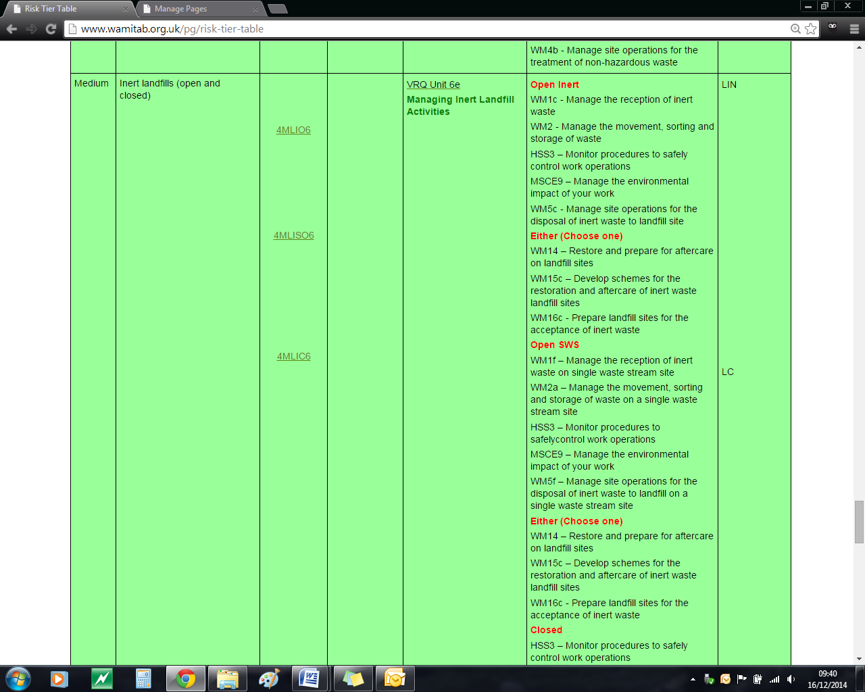

**CIWM/WAMITAB**

**Continuing Competence**

**Part of the CIWM/WAMITAB**

**Operator Competence Scheme**

Copyright ©2016 WAMITAB

Copyright in this document is owned by WAMITAB. Any person viewing, printing and distributing this document is subject to the following conditions:

* The document may be used for informational purposes only
* The document may be used for non-commercial purposes only (unless used by WAMITAB approved centres or partners)
* Anyone using information provided in this document should acknowledge WAMITAB

Changes are made periodically to the information contained within the document so for the latest version please refer to the website: [www.wamitab.org.uk](http://www.wamitab.org.uk).

For further information on Intellectual Property matters contact [info.admin@wamitab.org.uk](mailto:info.admin@wamitab.org.uk).

Please note that all word clouds are curtsey of Tagxedo.com and all images have been sourced from i-stock.

**Contents**

Introduction 4

About WAMITAB 4

What is Continuing Competence? 4

About this Revision Summary 4

1. Background and Legislation 5

Learning Outcomes 5

Where do I find this information? 5

Notes 5

2. Site Engineering 6

Learning Outcomes 6

Where do I find this information? 6

Notes 6

3. Landfill Gas 7

Learning Outcomes 7

Where do I find this information? 7

Notes 7

4. Leachate 8

Learning Outcomes 8

Where do I find this information? 8

Notes 8

5. Aftercare Monitoring 10

Learning Outcomes 10

Where do I find this information? 10

Notes 10

6. Records and Reports 11

Learning Outcomes 11

Where do I find this information? 11

Notes 11

7. Permit Surrender 12

Learning Outcomes 12

Where do I find this information? 12

Notes 12

# Introduction

## About WAMITAB

WAMITAB is an awarding organisation and charity that develops qualifications for those working in cleaning; street cleansing; facilities management; resource management and recycling and parking from operative through to management level.

Since it was formed in 1989, WAMITAB has evolved in line with the convergence between the sectors with a clear focus on promoting and supporting environmental sustainability.  With over 120 qualification pathways and 70 quality assured centres, WAMITAB offers an unrivalled specialist network to support staff development.

## What is Continuing Competence?

The CIWM/WAMITAB continuing competence scheme is designed to ensure that the technically competent person (holds a certificate of technical competence, units or a qualification that is part of the CIWM/WAMITAB Operator Competence Scheme) on a waste site has knowledge and skills that keep pace with changes made across the waste management industry, such as the introduction of new legislation, technologies and techniques.

The CIWM/WAMITAB continuing competence scheme requires technically competent people in England and Wales to pass an assessment that demonstrates individuals have kept their competence up to date.

Keeping competence up to date is becoming increasingly important across the UK as society starts to recognise the crucial role waste and resource management industry professionals play in ensuring that the 434 million tonnes of waste generated every year can be treated, reused and recycled to produce a product that will contribute to further economic growth.

## About this Revision Summary

WAMITAB recognise the diverse needs of learners within the sectors we represent. To support those individuals undertaking their Continuing Competence test, we have developed this revision summary.

This revision summary is designed to support you preparation by linking the learning outcomes with the areas that may come up during the Continuing Competence test.

# 1. Background and Legislation C:\Users\Helen\AppData\Local\Microsoft\Windows\Temporary Internet Files\Content.IE5\FJ1S42NY\MC900432680[1].png

## Learning Outcomes

1.1 Know the legislation relevant to landfill management during aftercare for sites that closed;

* Prior to July 2001.
* After July 2001.

1.2 Know the importance and content of a site specific, written management system.

1.3 Know the principles of financial provisions for landfill and how it applies during aftercare.



## Where do I find this information?

[Environment Agency – Guidance for monitoring trace components in landfill gas (v3.0, 2010)](http://www.wamitab.org.uk/useruploads/files/waste/waste_resources/ea_documents/guidance_for_monitoring_trace_components_in_landfill_gas.pdf)

[Environment Agency – Guidance on the management of landfill gas (2004)](http://www.wamitab.org.uk/useruploads/files/waste/waste_resources/ea_documents/guidance_on_the_management_of_landfill_gas.pdf)

## Notes

|  |
| --- |
|  |
|  |
|  |
|  |
|  |
|  |
|  |
|  |
|  |
|  |
|  |
|  |
|  |
|  |
|  |
|  |
|  |
|  |
|  |

# 2. C:\Users\Helen\AppData\Local\Microsoft\Windows\Temporary Internet Files\Content.IE5\FJ1S42NY\MC900432680[1].pngSite Engineering

## Learning Outcomes

2.1 Know the principles of ‘containment’.

2.2 Know the principle elements of any capping system and how to maintain it.

2.3 Know the elements of site construction that require Regulator approval.



## Where do I find this information?

[Environment Agency – TGN02 Monitoring landfill leachate, groundwater and surface water](http://www.wamitab.org.uk/useruploads/files/waste/waste_resources/ea_documents/tgn02_monitoring_landfill_leachate,_groundwater_and_surface_water.pdf)

## Notes

|  |
| --- |
|  |
|  |
|  |
|  |
|  |
|  |
|  |
|  |
|  |
|  |
|  |
|  |
|  |
|  |
|  |
|  |
|  |
|  |
|  |
|  |
|  |
|  |
|  |
|  |

# 3. C:\Users\Helen\AppData\Local\Microsoft\Windows\Temporary Internet Files\Content.IE5\FJ1S42NY\MC900432680[1].pngLandfill Gas

## Learning Outcomes

3.1 Know why landfill gas management is important during aftercare.

3.2 Know the actions to take if a perimeter borehole contains methane above a compliance limit.

3.3 Know what data should be recorded for each gas monitoring point.

3.4 Know why landfill gas must be utilised.



## Where do I find this information?

[GOV.UK - LFTGNo3: Guidance on the management of landfill gas](https://www.gov.uk/government/publications/management-of-landfill-gas-lftgn-03)

[GOV.UK – LFTGNo4: Guidance on the monitoring of trace components in landfill gas](https://www.gov.uk/government/publications/monitoring-trace-components-in-landfill-gas-lftgn-04)

## Notes

|  |
| --- |
|  |
|  |
|  |
|  |
|  |
|  |
|  |
|  |
|  |
|  |
|  |
|  |
|  |
|  |
|  |
|  |
|  |
|  |
|  |
|  |
|  |
|  |
|  |
|  |

# 4. Leachate

## Learning Outcomes

4.1 Know why leachate levels must be maintained below a limit.

4.2 Know the actions to take if the site has:

* Leachate above control levels.
* If a breach of compliance limit occurs.

4.3 Know the principles of leachate treatment and the associated pollution risks.

4.4 Know what a leachate re-circulation system needs to achieve.

4.5Know the infrastructure needed to support leachate re-circulation.

4.6 Know what precautions need to be taken to recirculate leachate.

4.7 Know the information required in a hydrogeological risk assessment.



## Where do I find this information?

[Environment Agency – TGN02 Monitoring landfill leachate, groundwater and surface water](http://www.environment-agency.gov.uk/static/documents/Business/report_1_533191.pdf)

[Gov.UK Horizontal Guidance Note H1 – Annex J3 – Hydrogeological risk assessment for landfills](https://www.gov.uk/government/uploads/system/uploads/attachment_data/file/298247/geho0212bulu-e-e.pdf)

[Landfill: How to comply with your environmental permit – additional guidance](https://www.gov.uk/government/publications/landfill-sector-technical-guidance)

[GOV.UK – LFTGN02: guidance on monitoring of landfill leachate, groundwater and surface water.](https://www.gov.uk/government/publications/monitoring-of-landfill-leachate-groundwater-and-surface-water-lftgn-02)

## Notes

|  |
| --- |
|  |
|  |
|  |
|  |
|  |
|  |
|  |
|  |
|  |
|  |
|  |
|  |
|  |
|  |
|  |
|  |
|  |
|  |
|  |
|  |
|  |
|  |
|  |
|  |

|  |
| --- |
|  |
|  |
|  |
|  |
|  |
|  |
|  |
|  |
|  |
|  |
|  |
|  |
|  |
|  |
|  |
|  |
|  |
|  |
|  |
|  |
|  |
|  |
|  |
|  |
|  |
|  |
|  |
|  |
|  |
|  |

# 5. C:\Users\Helen\AppData\Local\Microsoft\Windows\Temporary Internet Files\Content.IE5\FJ1S42NY\MC900432680[1].pngAftercare Monitoring

## Learning Outcomes

5.1 Know the implications of standing water on a capping system.

5.2 Know why it is important to keep an up to date site closure, aftercare plan and closure report.

5.3 Know why it is important to monitor in and around a closed landfill.

5.4 Know the difference between monitoring for compliance and operational performance.



## Where do I find this information?

[Gov.UK Horizontal Guidance Note H1 – Annex J3 – Hydrogeological risk assessment for landfills](https://www.gov.uk/government/uploads/system/uploads/attachment_data/file/298247/geho0212bulu-e-e.pdf)

[Environment Agency – Additional Guidance for Landfill (EPR 5.02) and other permanent deposits of waste: How to surrender your environmental permit (Version 2, issued 13/12/2012)](https://www.gov.uk/government/publications/landfill-epr-502-and-other-permanent-deposits-of-waste-how-to-surrender-your-environmental-permit)

[GOV.UK: Understanding the landfill Directive](https://www.gov.uk/government/publications/understanding-the-landfill-directive-lfd-1)

## Notes

|  |
| --- |
|  |
|  |
|  |
|  |
|  |
|  |
|  |
|  |
|  |
|  |
|  |
|  |
|  |
|  |
|  |
|  |
|  |
|  |
|  |
|  |
|  |
|  |
|  |
|  |

# 6. C:\Users\Helen\AppData\Local\Microsoft\Windows\Temporary Internet Files\Content.IE5\FJ1S42NY\MC900432680[1].pngRecords and Reports

## Learning Outcomes

6.1 Know what records must be kept and for how long.

6.2 Know what records need to be submitted to the regulator and at what frequency.

6.3 Know the ‘notifications’ requirement of permits.



## Where do I find this information?

[Landfill: How to comply with your environmental permit – additional guidance](https://www.gov.uk/government/publications/landfill-sector-technical-guidance)

## Notes

|  |
| --- |
|  |
|  |
|  |
|  |
|  |
|  |
|  |
|  |
|  |
|  |
|  |
|  |
|  |
|  |
|  |
|  |
|  |
|  |
|  |
|  |
|  |
|  |
|  |
|  |

# 7. C:\Users\Helen\AppData\Local\Microsoft\Windows\Temporary Internet Files\Content.IE5\FJ1S42NY\MC900432680[1].pngPermit Surrender

## Learning Outcomes

7.1 Know the permit surrender process and data requirements.



## Where do I find this information?

[Environment Agency – Additional Guidance for Landfill (EPR 5.02) and other permanent deposits of waste: How to surrender your environmental permit (Version 2, issued 13/12/2012)](https://www.gov.uk/government/publications/landfill-epr-502-and-other-permanent-deposits-of-waste-how-to-surrender-your-environmental-permit)

## Notes

|  |
| --- |
|  |
|  |
|  |
|  |
|  |
|  |
|  |
|  |
|  |
|  |
|  |
|  |
|  |
|  |
|  |
|  |
|  |
|  |
|  |
|  |
|  |
|  |
|  |
|  |





WAMITAB

Peterbridge House

3 The Lakes

Northampton

NN4 7HE

Tel: 01604 231950

Email: [info.admin@wamitab.org.uk](mailto:info.admin@wamitab.org.uk)

Web: [www.wamitab.org.uk](http://www.wamitab.org.uk)

[](https://twitter.com/WAMITAB) [](http://www.linkedin.com/company/wamitab) [](https://www.facebook.com/pages/WAMITAB/218830928149483)