|  |
| --- |
| **Landfill Inert** |
| Revision Summary |
| Version 1, April 2016 |

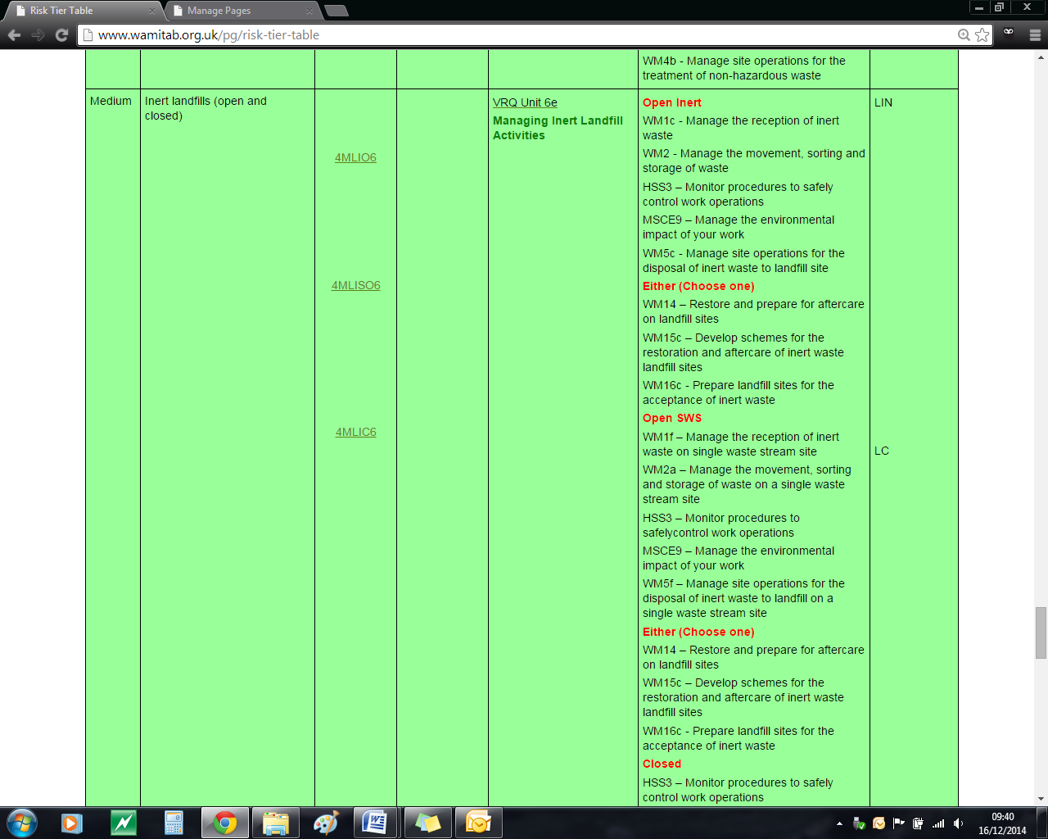http://ciwm-journal.co.uk/wordpress/wp-content/themes/ciwm-journal/hamish/CIWM_Journal_Logo.png

**CIWM/WAMITAB**

**Continuing Competence**

**Part of the CIWM/WAMITAB**

**Operator Competence Scheme**

Copyright ©2016 WAMITAB

Copyright in this document is owned by WAMITAB. Any person viewing, printing and distributing this document is subject to the following conditions:

* The document may be used for informational purposes only
* The document may be used for non-commercial purposes only (unless used by WAMITAB approved centres or partners)
* Anyone using information provided in this document should acknowledge WAMITAB

Changes are made periodically to the information contained within the document so for the latest version please refer to the website: [www.wamitab.org.uk](http://www.wamitab.org.uk).

For further information on Intellectual Property matters contact [info.admin@wamitab.org.uk](mailto:info.admin@wamitab.org.uk).

Please note that all word clouds are curtsey of Tagxedo.com and all images have been sourced from i-stock.

**Contents**

[Introduction 5](#_Toc448499127)

[About WAMITAB 5](#_Toc448499128)

[What is Continuing Competence? 5](#_Toc448499129)

[About this Revision Summary 5](#_Toc448499130)

[1. Background 6](#_Toc448499132)

[Learning Outcomes 6](file:///W:\Continuing%20Competence\Scheme%20review%20and%20amends%20April%202016\Revision%20Summaries\Old%20revision%20summaries\Landfill%20Inert%20Revision%20Summary%20%5bFree%5d.docx#_Toc448499131)

[Where do I find this information? 6](file:///W:\Continuing%20Competence\Scheme%20review%20and%20amends%20April%202016\Revision%20Summaries\Old%20revision%20summaries\Landfill%20Inert%20Revision%20Summary%20%5bFree%5d.docx#_Toc448499133)

[Notes 6](file:///W:\Continuing%20Competence\Scheme%20review%20and%20amends%20April%202016\Revision%20Summaries\Old%20revision%20summaries\Landfill%20Inert%20Revision%20Summary%20%5bFree%5d.docx#_Toc448499134)

[2. Site Engineering 7](#_Toc448499135)

[Learning Outcomes 7](file:///W:\Continuing%20Competence\Scheme%20review%20and%20amends%20April%202016\Revision%20Summaries\Old%20revision%20summaries\Landfill%20Inert%20Revision%20Summary%20%5bFree%5d.docx#_Toc448499136)

[Where do I find this information? 7](file:///W:\Continuing%20Competence\Scheme%20review%20and%20amends%20April%202016\Revision%20Summaries\Old%20revision%20summaries\Landfill%20Inert%20Revision%20Summary%20%5bFree%5d.docx#_Toc448499137)

[Notes 7](file:///W:\Continuing%20Competence\Scheme%20review%20and%20amends%20April%202016\Revision%20Summaries\Old%20revision%20summaries\Landfill%20Inert%20Revision%20Summary%20%5bFree%5d.docx#_Toc448499138)

[3. Waste Acceptance 8](#_Toc448499140)

[Learning Outcomes 8](file:///W:\Continuing%20Competence\Scheme%20review%20and%20amends%20April%202016\Revision%20Summaries\Old%20revision%20summaries\Landfill%20Inert%20Revision%20Summary%20%5bFree%5d.docx#_Toc448499139)

[Where do I find this information? 8](file:///W:\Continuing%20Competence\Scheme%20review%20and%20amends%20April%202016\Revision%20Summaries\Old%20revision%20summaries\Landfill%20Inert%20Revision%20Summary%20%5bFree%5d.docx#_Toc448499141)

[Notes 8](file:///W:\Continuing%20Competence\Scheme%20review%20and%20amends%20April%202016\Revision%20Summaries\Old%20revision%20summaries\Landfill%20Inert%20Revision%20Summary%20%5bFree%5d.docx#_Toc448499142)

[4. Control of Amenity Emissions 9](#_Toc448499143)

[Learning Outcomes 9](file:///W:\Continuing%20Competence\Scheme%20review%20and%20amends%20April%202016\Revision%20Summaries\Old%20revision%20summaries\Landfill%20Inert%20Revision%20Summary%20%5bFree%5d.docx#_Toc448499144)

[Where do I find this information? 9](file:///W:\Continuing%20Competence\Scheme%20review%20and%20amends%20April%202016\Revision%20Summaries\Old%20revision%20summaries\Landfill%20Inert%20Revision%20Summary%20%5bFree%5d.docx#_Toc448499145)

[Notes 9](file:///W:\Continuing%20Competence\Scheme%20review%20and%20amends%20April%202016\Revision%20Summaries\Old%20revision%20summaries\Landfill%20Inert%20Revision%20Summary%20%5bFree%5d.docx#_Toc448499146)

[5. General Landfill Management 10](#_Toc448499148)

[Learning Outcomes 10](file:///W:\Continuing%20Competence\Scheme%20review%20and%20amends%20April%202016\Revision%20Summaries\Old%20revision%20summaries\Landfill%20Inert%20Revision%20Summary%20%5bFree%5d.docx#_Toc448499147)

[Where do I find this information? 10](file:///W:\Continuing%20Competence\Scheme%20review%20and%20amends%20April%202016\Revision%20Summaries\Old%20revision%20summaries\Landfill%20Inert%20Revision%20Summary%20%5bFree%5d.docx#_Toc448499149)

[Notes 10](file:///W:\Continuing%20Competence\Scheme%20review%20and%20amends%20April%202016\Revision%20Summaries\Old%20revision%20summaries\Landfill%20Inert%20Revision%20Summary%20%5bFree%5d.docx#_Toc448499150)

[6. Monitoring 12](#_Toc448499152)

[Learning Outcomes 12](file:///W:\Continuing%20Competence\Scheme%20review%20and%20amends%20April%202016\Revision%20Summaries\Old%20revision%20summaries\Landfill%20Inert%20Revision%20Summary%20%5bFree%5d.docx#_Toc448499151)

[Where do I find this information? 12](W:\\Continuing Competence\\Scheme review and amends April 2016\\Revision Summaries\\Old revision summaries\\Landfill Inert Revision Summary [Free].docx" \l "_Toc448499153)

[Notes 12](file:///W:\Continuing%20Competence\Scheme%20review%20and%20amends%20April%202016\Revision%20Summaries\Old%20revision%20summaries\Landfill%20Inert%20Revision%20Summary%20%5bFree%5d.docx#_Toc448499154)

[7. Records and Reports 13](#_Toc448499155)

[Learning Outcomes 13](file:///W:\Continuing%20Competence\Scheme%20review%20and%20amends%20April%202016\Revision%20Summaries\Old%20revision%20summaries\Landfill%20Inert%20Revision%20Summary%20%5bFree%5d.docx#_Toc448499156)

[Where do I find this information? 13](file:///W:\Continuing%20Competence\Scheme%20review%20and%20amends%20April%202016\Revision%20Summaries\Old%20revision%20summaries\Landfill%20Inert%20Revision%20Summary%20%5bFree%5d.docx#_Toc448499157)

[Notes 13](file:///W:\Continuing%20Competence\Scheme%20review%20and%20amends%20April%202016\Revision%20Summaries\Old%20revision%20summaries\Landfill%20Inert%20Revision%20Summary%20%5bFree%5d.docx#_Toc448499158)

[8. Landfill Closure and Aftercare 14](#_Toc448499159)

[Learning Outcomes 14](file:///W:\Continuing%20Competence\Scheme%20review%20and%20amends%20April%202016\Revision%20Summaries\Old%20revision%20summaries\Landfill%20Inert%20Revision%20Summary%20%5bFree%5d.docx#_Toc448499160)

[Where do I find this information? 14](file:///W:\Continuing%20Competence\Scheme%20review%20and%20amends%20April%202016\Revision%20Summaries\Old%20revision%20summaries\Landfill%20Inert%20Revision%20Summary%20%5bFree%5d.docx#_Toc448499161)

[Notes 14](file:///W:\Continuing%20Competence\Scheme%20review%20and%20amends%20April%202016\Revision%20Summaries\Old%20revision%20summaries\Landfill%20Inert%20Revision%20Summary%20%5bFree%5d.docx#_Toc448499162)

# Introduction

## About WAMITAB

WAMITAB is an awarding organisation and charity that develops qualifications for those working in cleaning; street cleansing; facilities management; resource management and recycling and parking from operative through to management level.

Since it was formed in 1989, WAMITAB has evolved in line with the convergence between the sectors with a clear focus on promoting and supporting environmental sustainability.  With over 120 qualification pathways and 70 quality assured centres, WAMITAB offers an unrivalled specialist network to support staff development.

## What is Continuing Competence?

The CIWM/WAMITAB continuing competence scheme is designed to ensure that the technically competent person (holds a certificate of technical competence, units or a qualification that is part of the CIWM/WAMITAB Operator Competence Scheme) on a waste site has knowledge and skills that keep pace with changes made across the waste management industry, such as the introduction of new legislation, technologies and techniques.

The CIWM/WAMITAB continuing competence scheme requires technically competent people in England and Wales to pass an assessment that demonstrates individuals have kept their competence up to date.

Keeping competence up to date is becoming increasingly important across the UK as society starts to recognise the crucial role waste and resource management industry professionals play in ensuring that the 434 million tonnes of waste generated every year can be treated, reused and recycled to produce a product that will contribute to further economic growth.

## About this Revision Summary

WAMITAB recognise the diverse needs of learners within the sectors we represent. To support those individuals undertaking their Continuing Competence test, we have developed this revision summary.

This revision summary is designed to support you preparation by linking the learning outcomes with the areas that may come up during the Continuing Competence test.

# 1. Background C:\Users\Helen\AppData\Local\Microsoft\Windows\Temporary Internet Files\Content.IE5\FJ1S42NY\MC900432680[1].png

## Learning Outcomes

1.1 Know the legislation relevant to landfill:

* Design
* Construction
* Operation
* Closure
* Aftercare

1.2 Know what is included in a site specific, written management system.

1.3 Know the principles of financial provision for landfill.

1.4 Know when to undertake a financial provision assessment.

1.5 Know the timeframe and financial costs for the aftercare period according to guidance.



## Where do I find this information?

[GOV.UK LFD1 Understanding the Landfill Directive](https://www.gov.uk/government/publications/understanding-the-landfill-directive-lfd-1)

[GOV.UK Landfill: how to comply with your environmental permit – additional guidance](https://www.gov.uk/government/publications/landfill-sector-technical-guidance)

[GOV.UK Financial provision for landfill](https://www.gov.uk/government/publications/financial-provision-for-landfill)

## Notes

|  |
| --- |
|  |
|  |
|  |
|  |
|  |
|  |
|  |
|  |
|  |
|  |
|  |
|  |
|  |
|  |
|  |
|  |

# 2. Site Engineering C:\Users\Helen\AppData\Local\Microsoft\Windows\Temporary Internet Files\Content.IE5\FJ1S42NY\MC900432680[1].png

## Learning Outcomes

2.1 Know the principles of ‘attenuation’.

2.2 Know why a geological barrier is required.

2.3 Know the elements of site construction that require Regulator approval.



## Where do I find this information?

[GOV.UK LFE1 Our Approach to Landfill Engineering](https://www.gov.uk/government/publications/our-approach-to-landfill-engineering-lfe1)

[GOV.UK Environmental Permitting – Landfill sector technical guidance](https://www.gov.uk/government/collections/environmental-permitting-landfill-sector-technical-guidance)

[GOV.UK Landfill: how to comply with your environmental permit – additional guidance](https://www.gov.uk/government/publications/landfill-sector-technical-guidance)

## Notes

|  |
| --- |
|  |
|  |
|  |
|  |
|  |
|  |
|  |
|  |
|  |
|  |
|  |
|  |
|  |
|  |
|  |
|  |
|  |
|  |
|  |
|  |
|  |
|  |
|  |
|  |

# 3. C:\Users\Helen\AppData\Local\Microsoft\Windows\Temporary Internet Files\Content.IE5\FJ1S42NY\MC900432680[1].pngWaste Acceptance

## Learning Outcomes

3.1 Know what inert waste is (in accordance with the Landfill Directive definition).

3.2 Know the waste acceptance procedures and criteria that apply to inert waste landfills, including;

* Waste acceptable without testing
* Waste that must be tested
* Technically Feasible
* Landfill gas risk assessment

3.3 Know which wastes are banned from landfill and when to reject waste.

3.4 Know how to determine that a waste is a liquid.

3.5 Know the requirements of on site verification and sampling of waste received.



## Where do I find this information?

[Environment Agency – Waste acceptance at landfills (version 1, November 2010)](http://cdn.environment-agency.gov.uk/geho1110btew-e-e.pdf)

[COUNCIL DECISION of 19 December 2002: establishing criteria and procedures for the acceptance of waste at landfills pursuant to Article 16 of and Annex II to Directive 1999/31/EC](http://eur-lex.europa.eu/LexUriServ/LexUriServ.do?uri=OJ:L:2003:011:0027:0049:EN:PDF)

[Environment Agency – How to comply with your environmental permit: Additional guidance for Landfill (EPR5.02) (March 2009)](http://a0768b4a8a31e106d8b0-50dc802554eb38a24458b98ff72d550b.r19.cf3.rackcdn.com/geho0409bput-e-e.pdf)

[Environment Agency – How to comply with your Environmental Permit (2013)](http://cdn.environment-agency.gov.uk/LIT_7123_79744e.pdf)

[Environment Agency – Guidance on the Management of Landfill Gas](https://www.gov.uk/government/uploads/system/uploads/attachment_data/file/321606/LFTGN03.pdf)

## Notes

|  |
| --- |
|  |
|  |
|  |
|  |
|  |
|  |
|  |
|  |
|  |
|  |
|  |
|  |
|  |
|  |
|  |
|  |
|  |
|  |
|  |
|  |
|  |
|  |
|  |
|  |

# 4. Control of Amenity EmissionC:\Users\Helen\AppData\Local\Microsoft\Windows\Temporary Internet Files\Content.IE5\FJ1S42NY\MC900432680[1].pngs

## Learning Outcomes

4.1 Know how to prevent mud and other debris from contaminating the public highway.

4.2 Know the procedures for dealing with noise, dust, odours and other nuisance arising from the site.



## Where do I find this information?

[Environment Agency – How to comply with your environmental permit: Additional guidance for Landfill (EPR5.02) (March 2009)](http://a0768b4a8a31e106d8b0-50dc802554eb38a24458b98ff72d550b.r19.cf3.rackcdn.com/geho0409bput-e-e.pdf)

## Notes

|  |
| --- |
|  |
|  |
|  |
|  |
|  |
|  |
|  |
|  |
|  |
|  |
|  |
|  |
|  |
|  |
|  |
|  |
|  |
|  |
|  |
|  |
|  |
|  |
|  |
|  |

# 5. General Landfill ManagementC:\Users\Helen\AppData\Local\Microsoft\Windows\Temporary Internet Files\Content.IE5\FJ1S42NY\MC900432680[1].png

## Learning Outcomes

5.1 Know how to manage vehicles on a landfill site in line with WISH/HSE guidance.

5.2 Know the implications of ‘settlement’ and ‘compaction’ within a landfill and the impact on restoration.

5.3 Know the key indicators of surface water pollution from an inert landfill site.

5.4 Know how to manage surface water arising within the site.

5.5 Know the requirement for discharge controls.

5.5 Know the requirements for establishing and maintaining a network of stable, permanent survey control stations.



## Where do I find this information?

[HSE – Workplace transport safety (published 05/13)](http://www.hse.gov.uk/pubns/indg199.pdf)

[HSE: Safe transport in the waste and recycling industry](http://www.hse.gov.uk/pubns/waste09.pdf)

[Environment Agency – How to comply with your environmental permit: Additional guidance for Landfill (EPR5.02) (March 2009)](https://www.gov.uk/government/publications/landfill-sector-technical-guidance)

[GOV.UK LFD1 Understanding the Landfill Directive](https://www.gov.uk/government/publications/understanding-the-landfill-directive-lfd-1)

[Environment Agency – LFGTGN 02 Monitoring of landfill leachate, groundwater and surface water.](https://www.gov.uk/government/publications/monitoring-of-landfill-leachate-groundwater-and-surface-water-lftgn-02)

Environment Agency (archive) – Environmental Permitting Regulations: Inert Waste Guidance - cut and paste the following link:

<http://webarchive.nationalarchives.gov.uk/20140328084622/http:/cdn.environment-agency.gov.uk/geho0509bpwj-e-e.pdf>

## Notes

|  |
| --- |
|  |
|  |
|  |
|  |
|  |
|  |
|  |
|  |
|  |
|  |
|  |
|  |
|  |
|  |
|  |
|  |
|  |
|  |
|  |
|  |
|  |
|  |
|  |
|  |

|  |
| --- |
|  |
|  |
|  |
|  |
|  |
|  |
|  |
|  |
|  |
|  |
|  |
|  |
|  |
|  |
|  |
|  |
|  |
|  |
|  |
|  |
|  |
|  |
|  |
|  |
|  |
|  |
|  |
|  |
|  |
|  |
|  |

# 6. C:\Users\Helen\AppData\Local\Microsoft\Windows\Temporary Internet Files\Content.IE5\FJ1S42NY\MC900432680[1].pngMonitoring

## Learning Outcomes

6.1 Know the requirements for monitoring in and around an inert landfill.

6.2 Know the difference between monitoring for compliance and operational performance.

6.3 Know when landfill gas monitoring and assessment may be required for an inert landfill site.



## Where do I find this information?

[Environment Agency – LFGTGN 02 Monitoring of landfill leachate, groundwater and surface water.](https://www.gov.uk/government/publications/monitoring-of-landfill-leachate-groundwater-and-surface-water-lftgn-02)

<http://webarchive.nationalarchives.gov.uk/20140328084622/http:/cdn.environment-agency.gov.uk/geho0509bpwj-e-e.pdf>

[Environment Agency – How to comply with your environmental permit: Additional guidance for Landfill (EPR5.02) (March 2009)](https://www.gov.uk/government/publications/landfill-sector-technical-guidance)

## Notes

|  |
| --- |
|  |
|  |
|  |
|  |
|  |
|  |
|  |
|  |
|  |
|  |
|  |
|  |
|  |
|  |
|  |
|  |
|  |
|  |
|  |
|  |
|  |
|  |
|  |
|  |

# C:\Users\Helen\AppData\Local\Microsoft\Windows\Temporary Internet Files\Content.IE5\FJ1S42NY\MC900432680[1].png7. Records and Reports

## Learning Outcomes

7.1 Know what records must be kept and for how long.

7.2 Know what records must be submitted to the Regulator and how frequently.

7.3 Know the ‘notifications requirements of permits.



## Where do I find this information?

[GOV.UK How to comply with your environmental permit](https://www.gov.uk/government/publications/how-to-comply-with-your-environmental-permit)

[Environment Agency – How to comply with your environmental permit: Additional guidance for Landfill (EPR5.02) (March 2009)](https://www.gov.uk/government/publications/landfill-sector-technical-guidance)

## Notes

|  |
| --- |
|  |
|  |
|  |
|  |
|  |
|  |
|  |
|  |
|  |
|  |
|  |
|  |
|  |
|  |
|  |
|  |
|  |
|  |
|  |
|  |
|  |
|  |
|  |
|  |

# C:\Users\Helen\AppData\Local\Microsoft\Windows\Temporary Internet Files\Content.IE5\FJ1S42NY\MC900432680[1].png8. Landfill Closure and Aftercare

## Learning Outcomes

8.1 Know why it is important to have an up to date closure and aftercare plan.

8.2 Know the procedure for progressing a landfill through definite closure to aftercare.



## Where do I find this information?

[Environment Agency – How to comply with your environmental permit: Additional guidance for Landfill (EPR5.02) (March 2009)](https://www.gov.uk/government/publications/landfill-sector-technical-guidance)

[GOV.UK Understanding the Landfill Directive LFD 1](https://www.gov.uk/government/publications/understanding-the-landfill-directive-lfd-1)

## Notes

|  |
| --- |
|  |
|  |
|  |
|  |
|  |
|  |
|  |
|  |
|  |
|  |
|  |
|  |
|  |
|  |
|  |
|  |
|  |
|  |
|  |
|  |
|  |
|  |
|  |
|  |





WAMITAB

Peterbridge House

3 The Lakes

Northampton

NN4 7HE

Tel: 01604 231950

Email: [info.admin@wamitab.org.uk](mailto:info.admin@wamitab.org.uk)

Web: [www.wamitab.org.uk](http://www.wamitab.org.uk)

[](https://twitter.com/WAMITAB) [](http://www.linkedin.com/company/wamitab) [](https://www.facebook.com/pages/WAMITAB/218830928149483)