|  |
| --- |
| **Landspreading** |
| Revision Summary |
| Version 1, April 2016 |

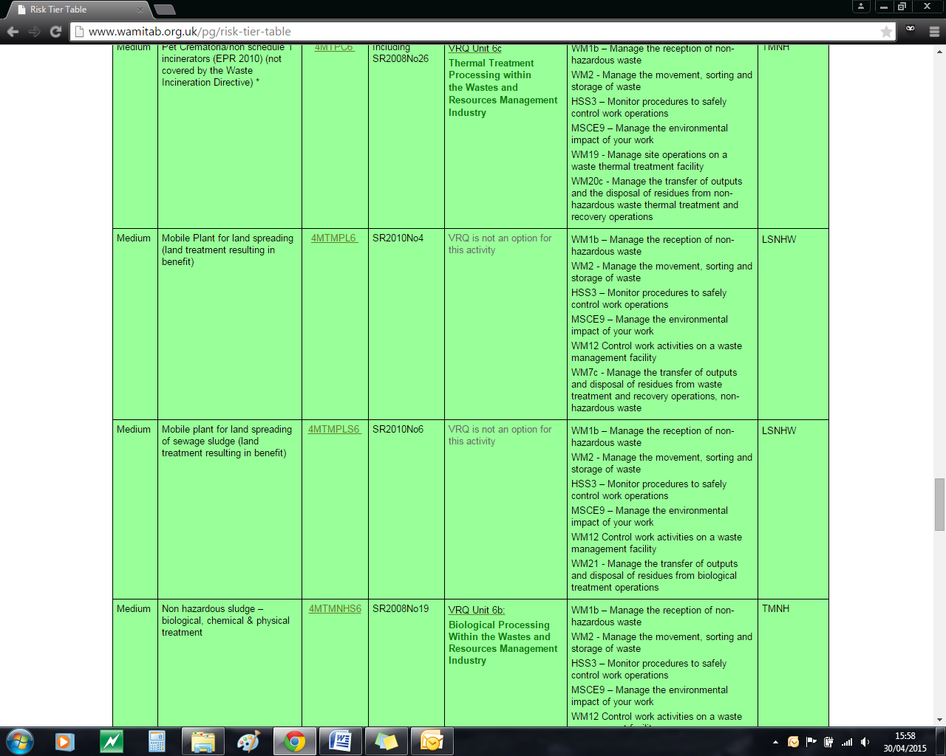http://ciwm-journal.co.uk/wordpress/wp-content/themes/ciwm-journal/hamish/CIWM_Journal_Logo.png

**CIWM/WAMITAB**

**Continuing Competence**

**Part of the CIWM/WAMITAB**

**Operator Competence Scheme**

Copyright ©2016 WAMITAB

Copyright in this document is owned by WAMITAB. Any person viewing, printing and distributing this document is subject to the following conditions:

* The document may be used for informational purposes only
* The document may be used for non-commercial purposes only (unless used by WAMITAB approved centres or partners)
* Anyone using information provided in this document should acknowledge WAMITAB

Changes are made periodically to the information contained within the document so for the latest version please refer to the website: [www.wamitab.org.uk](http://www.wamitab.org.uk).

For further information on Intellectual Property matters contact [info.admin@wamitab.org.uk](mailto:info.admin@wamitab.org.uk).

Please note that all word clouds are curtsey of Tagxedo.com and all images have been sourced from i-stock.

**Contents**

Introduction 4

About WAMITAB 4

What is Continuing Competence? 4

About this Revision Summary 4

1. Waste Acceptance 5

Learning Outcomes 5

Notes 5

Where do I find this information? 5

2. Storage of Materials 6

Learning Outcomes 6

Notes 6

Where do I find this information? 6

3. Quality Assurance 7

Learning Outcomes 7

Notes 7

Where do I find this information? 7

4. Vehicle Management 8

Learning Outcomes 8

Where do I find this information? 8

Notes 8

5. Site Infrastructure 9

Learning Outcomes 9

Where do I find this information? 9

Notes 9

6. Control of Emissions 10

Learning Outcomes 10

Where do I find this information? 10

Notes 10

Notes 11

7. Permit Compliance 12

Learning Outcomes 12

Where do I find this information? 12

Notes 12

# Introduction

## About WAMITAB

WAMITAB is an awarding organisation and charity that develops qualifications for those working in cleaning; street cleansing; facilities management; resource management and recycling and parking from operative through to management level.

Since it was formed in 1989, WAMITAB has evolved in line with the convergence between the sectors with a clear focus on promoting and supporting environmental sustainability.  With over 120 qualification pathways and 70 quality assured centres, WAMITAB offers an unrivalled specialist network to support staff development.

## What is Continuing Competence?

The CIWM/WAMITAB continuing competence scheme is designed to ensure that the technically competent person (holds a certificate of technical competence, units or a qualification that is part of the CIWM/WAMITAB Operator Competence Scheme) on a waste site has knowledge and skills that keep pace with changes made across the waste management industry, such as the introduction of new legislation, technologies and techniques.

The CIWM/WAMITAB continuing competence scheme requires technically competent people in England and Wales to pass an assessment that demonstrates individuals have kept their competence up to date.

Keeping competence up to date is becoming increasingly important across the UK as society starts to recognise the crucial role waste and resource management industry professionals play in ensuring that the 434 million tonnes of waste generated every year can be treated, reused and recycled to produce a product that will contribute to further economic growth.

## About this Revision Summary

WAMITAB recognise the diverse needs of learners within the sectors we represent. To support those individuals undertaking their Continuing Competence test, we have developed this revision summary.

This revision summary is designed to support you preparation by linking the learning outcomes with the areas that may come up during the Continuing Competence test.

# 1. Waste Acceptance

## Learning Outcomes

1.1 Know how to determine the suitability of waste for spreading in accordance with permit conditions.

1.2 Know the onsite waste acceptance procedures and checks.

1.3 Know the actions required when non-conforming wastes are identified.

1.4 Know the information required on a Waste Transfer Note.

1.5 Know who is responsible for characterising waste.

1.6 Know the actions to take if you need to spread waste that is not listed in the standard rules.





## Where do I find this information?

[How to Comply with Your Environmental Permit (V6.0, June 2013)](http://a0768b4a8a31e106d8b0-50dc802554eb38a24458b98ff72d550b.r19.cf3.rackcdn.com/LIT_7123_79744e.pdf)

[How to comply with your Landspreading Permit (v2 2013)](https://www.gov.uk/government/uploads/system/uploads/attachment_data/file/290130/LIT_5492_40c081.pdf)

[Duty of Care](https://www.gov.uk/managing-your-waste-an-overview/overview)

[Waste Transfer Notes](https://www.gov.uk/how-to-dispose-of-nonhazardous-waste)

[SRP 2010 No. 4 (v3) Mobile Plant for Landspreading (land treatment resulting in benefit to agriculture or ecological improvement)](https://www.gov.uk/government/publications/sr2010-no4-mobile-plant-for-land-spreading)

[SRP 2010 No. 6 (v2) Mobile Plant for Landspreading of sewage sludge (land treatment resulting in benefit)](https://www.gov.uk/government/publications/sr2010-no6-mobile-plant-for-land-spreading-of-sewage-sludge)

[LPD1 Application for Deployment](https://www.gov.uk/government/uploads/system/uploads/attachment_data/file/303882/LPD1_deployment_form.pdf)

[LPD1 Guidance notes – Application Deployment](https://www.gov.uk/government/uploads/system/uploads/attachment_data/file/303884/LPD1_form_guidance.pdf)

## Notes

|  |
| --- |
|  |
|  |
|  |
|  |
|  |
|  |
|  |
|  |
|  |
|  |
|  |
|  |
|  |
|  |
|  |
|  |
|  |
|  |
|  |
|  |
|  |
|  |
|  |
|  |

|  |
| --- |
|  |
|  |
|  |
|  |
|  |
|  |
|  |
|  |
|  |
|  |
|  |
|  |
|  |
|  |
|  |
|  |
|  |
|  |
|  |
|  |
|  |
|  |
|  |
|  |
|  |
|  |
|  |
|  |
|  |
|  |
|  |
|  |
|  |

# C:\Users\Helen\AppData\Local\Microsoft\Windows\Temporary Internet Files\Content.IE5\FJ1S42NY\MC900432680[1].png2. Storage Requirements for Waste Material

## Learning Outcomes

2.1 Know the storage requirements for waste materials which will be spread to land.

2.2 Know the procedures for minimising pollution during storage of waste materials to be spread to land.

2.3 Know the procedures for checking odour emissions from stored waste materials are within Permit limits.

2.4 Know the control measures to put in place if emissions exceed permitted limits or are not controlled by set limits.

2.5 Know the requirements for a sealed drainage system with an impermeable surface.

2.6 Know the requirements for a secondary containment systems for liquid waste.

2.7 Know how field drainage systems can affect the impact of watercourse contamination and how it can be controlled.

2.8 Know the maximum capacities and freeboard of lagoons and containers.



## Notes

|  |
| --- |
|  |
|  |
|  |
|  |
|  |
|  |
|  |
|  |
|  |
|  |
|  |
|  |
|  |
|  |
|  |
|  |
|  |
|  |
|  |
|  |
|  |
|  |
|  |
|  |

## Where do I find this information?

[EA Guidance - H4 – Odour Management](http://publications.environment-agency.gov.uk/PDF/GEHO0411BTQM-E-E.pdf)

[How to Comply with Your Environmental Permit (V6.0, June 2013)](http://a0768b4a8a31e106d8b0-50dc802554eb38a24458b98ff72d550b.r19.cf3.rackcdn.com/LIT_7123_79744e.pdf)

[How to comply with your Landspreading Permit (v2 2013)](https://www.gov.uk/government/uploads/system/uploads/attachment_data/file/290130/LIT_5492_40c081.pdf)

[SRP 2010 No. 4 (v3) Mobile Plant for Landspreading (land treatment resulting in benefit to agriculture or ecological improvement)](https://www.gov.uk/government/publications/sr2010-no4-mobile-plant-for-land-spreading)

[SRP 2010 No. 6 (v2) Mobile Plant for Landspreading of sewage sludge (land treatment resulting in benefit)](https://www.gov.uk/government/publications/sr2010-no6-mobile-plant-for-land-spreading-of-sewage-sludge)

[Environment Agency – PPG 2 Above ground oil storage tanks](http://publications.environment-agency.gov.uk/PDF/PMHO0811BUCR-E-E.pdf)

GOV.UK [Duty of Care – Store waste correctly](https://www.gov.uk/managing-your-waste-an-overview/overview)

|  |
| --- |
|  |
|  |
|  |
|  |
|  |
|  |
|  |
|  |
|  |
|  |
|  |
|  |
|  |
|  |
|  |
|  |
|  |
|  |
|  |
|  |
|  |
|  |
|  |
|  |
|  |
|  |
|  |
|  |
|  |
|  |
|  |
|  |
|  |

# C:\Users\Helen\AppData\Local\Microsoft\Windows\Temporary Internet Files\Content.IE5\FJ1S42NY\MC900432680[1].png3. Quality Assuring the Deployment Process

## Learning Outcomes

3.1 Know the procedure for gaining approval to enable deployment to spread waste to land.

3.2 Know the benefit associated with spreading waste to the land.

3.3 Know the requirements of an effective Environmental Management System (EMS).

3.4 Know why a site specific risk assessment may be required when spreading waste to land.

3.5 Know the control measures used to mitigate risks when spreading waste to land.

3.6 Know what information is required on a location plan.

3.7 Know what to do if any changes to the deployment are required.



## Notes

|  |
| --- |
|  |
|  |
|  |
|  |
|  |
|  |
|  |
|  |
|  |
|  |
|  |
|  |
|  |
|  |
|  |
|  |
|  |
|  |
|  |
|  |
|  |
|  |
|  |
|  |

## Where do I find this information?

[LPD1 Application for Deployment](https://www.gov.uk/government/uploads/system/uploads/attachment_data/file/303882/LPD1_deployment_form.pdf)

[LPD1 Guidance notes – Application Deployment](https://www.gov.uk/government/uploads/system/uploads/attachment_data/file/303884/LPD1_form_guidance.pdf)

[How to Comply with Your Environmental Permit (V6.0, June 2013)](http://a0768b4a8a31e106d8b0-50dc802554eb38a24458b98ff72d550b.r19.cf3.rackcdn.com/LIT_7123_79744e.pdf)

[How to comply with your Landspreading Permit (v2 2013)](https://www.gov.uk/government/uploads/system/uploads/attachment_data/file/290130/LIT_5492_40c081.pdf)

# C:\Users\Helen\AppData\Local\Microsoft\Windows\Temporary Internet Files\Content.IE5\FJ1S42NY\MC900432680[1].png4. Environmental Protection Requirements

## Learning Outcomes

4.1 Know the procedures for managing pests and scavengers during landspreading to minimise nuisance.

4.2 Know the procedures for managing odour during landspreading in accordance with an odour management plan.

4.3 Know the procedures for handling spillages on site.

4.4 Know the record keeping requirements for land spreading data.

4.5 Know the main features, benefits and risks of the different spreading techniques available.



## Where do I find this information?

[HSE Website – Provision and use of workplace equipment](http://www.hse.gov.uk/work-equipment-machinery/maintenance.htm)

## Notes

|  |
| --- |
|  |
|  |
|  |
|  |
|  |
|  |
|  |
|  |
|  |
|  |
|  |
|  |
|  |
|  |
|  |
|  |
|  |
|  |
|  |
|  |
|  |
|  |
|  |
|  |
|  |
|  |
|  |
|  |
|  |
|  |
|  |
|  |
|  |



WAMITAB

Peterbridge House

3 The Lakes

Northampton

NN4 7HE

Tel: 01604 231950

Email: [info.admin@wamitab.org.uk](mailto:info.admin@wamitab.org.uk)

Web: [www.wamitab.org.uk](http://www.wamitab.org.uk)

[](https://twitter.com/WAMITAB) [](http://www.linkedin.com/company/wamitab) [](https://www.facebook.com/pages/WAMITAB/218830928149483)