|  |
| --- |
| **Metal Recycling Sites (MRS)** |
| Revision Summary |
| Version 1, April 2016 |

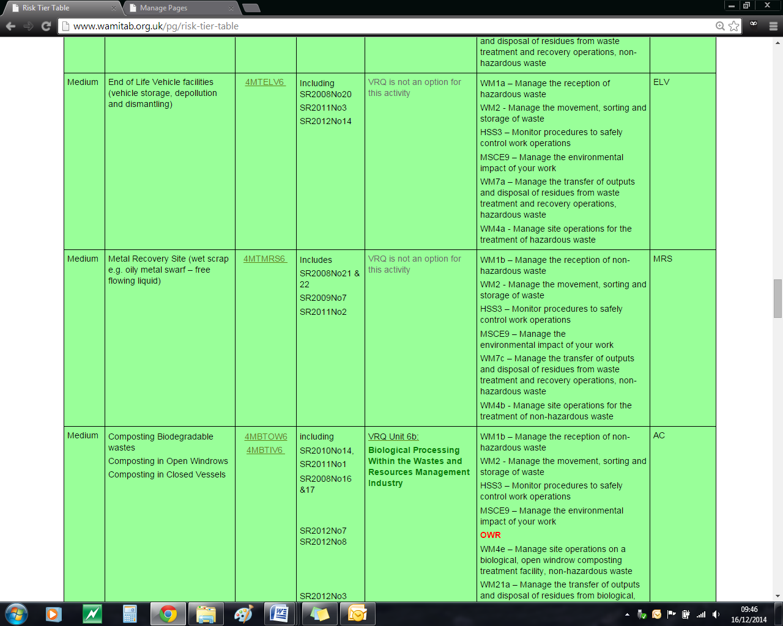http://ciwm-journal.co.uk/wordpress/wp-content/themes/ciwm-journal/hamish/CIWM_Journal_Logo.png

**CIWM/WAMITAB**

**Continuing Competence**

**Part of the CIWM/WAMITAB**

**Operator Competence Scheme**

Copyright ©2016 WAMITAB

Copyright in this document is owned by WAMITAB. Any person viewing, printing and distributing this document is subject to the following conditions:

* The document may be used for informational purposes only
* The document may be used for non-commercial purposes only (unless used by WAMITAB approved centres or partners)
* Anyone using information provided in this document should acknowledge WAMITAB

Changes are made periodically to the information contained within the document so for the latest version please refer to the website: [www.wamitab.org.uk](http://www.wamitab.org.uk).

For further information on Intellectual Property matters contact [info.admin@wamitab.org.uk](mailto:info.admin@wamitab.org.uk).

Please note that all word clouds are curtsey of Tagxedo.com and all images have been sourced from i-stock.

**Contents**

Introduction 4

About WAMITAB 4

What is Continuing Competence? 4

About this Revision Summary 4

1. Scrap Metal Dealers Act 2013 5

Learning Outcomes 5

Where do I find this information? 5

Notes 5

2. Management and Storage 7

Learning Outcomes 7

Where do I find this information? 7

Notes 7

3. Vehicle, Plant and Equipment 9

Learning Outcomes 9

Where do I find this information? 9

Notes 9

4. Hazardous Waste 10

Learning Outcomes 10

Where do I find this information? 10

Notes 10

# Introduction

## About WAMITAB

WAMITAB is an awarding organisation and charity that develops qualifications for those working in cleaning; street cleansing; facilities management; resource management and recycling and parking from operative through to management level.

Since it was formed in 1989, WAMITAB has evolved in line with the convergence between the sectors with a clear focus on promoting and supporting environmental sustainability.  With over 120 qualification pathways and 70 quality assured centres, WAMITAB offers an unrivalled specialist network to support staff development.

## What is Continuing Competence?

The CIWM/WAMITAB continuing competence scheme is designed to ensure that the technically competent person (holds a certificate of technical competence, units or a qualification that is part of the CIWM/WAMITAB Operator Competence Scheme) on a waste site has knowledge and skills that keep pace with changes made across the waste management industry, such as the introduction of new legislation, technologies and techniques.

The CIWM/WAMITAB continuing competence scheme requires technically competent people in England and Wales to pass an assessment that demonstrates individuals have kept their competence up to date.

Keeping competence up to date is becoming increasingly important across the UK as society starts to recognise the crucial role waste and resource management industry professionals play in ensuring that the 434 million tonnes of waste generated every year can be treated, reused and recycled to produce a product that will contribute to further economic growth.

## About this Revision Summary

WAMITAB recognise the diverse needs of learners within the sectors we represent. To support those individuals undertaking their Continuing Competence test, we have developed this revision summary.

This revision summary is designed to support you preparation by linking the learning outcomes with the areas that may come up during the Continuing Competence test.

# 1. Scrap Metal Dealers Act 2013C:\Users\Helen\AppData\Local\Microsoft\Windows\Temporary Internet Files\Content.IE5\FJ1S42NY\MC900432680[1].png

## Learning Outcomes

1.1 Know who is responsible for issuing scrap metal licences.

1.2 Know the difference between a site licence and a collector’s licence.

1.3 Know the definition of a ‘suitable person’ when applying for a site licence.

1.4 Know how long a licence is valid for.

1.5 Know under what circumstances a licence can be revoked or conditions imposed.

1.6 Know the conditions that may be imposed on a licence.

1.7 Know the information required for the Register of Licences.

1.8 Know who to notify when a licence is no longer required, and by when.

1.9 Know where site licences and collectors licences must be displayed.

1.10 Know what information is required to verify a supplier’s identity.

1.11 Know what forms of payment are acceptable when paying for scrap metal.

1.12 Know what records must be kept when receiving metal and disposing of metal.

1.13 Know how long records for receipt/disposal of metal should be kept for.

1.14 Know the offences under the Scrap Metal Dealers Act 2013.



## Where do I find this information?

[Scrap Metal Dealers Act 2013](http://www.legislation.gov.uk/ukpga/2013/10/contents/enacted)

[Scrap Metal Dealers Act 2013 – Explanatory Notes](http://www.legislation.gov.uk/ukpga/2013/10/pdfs/ukpgaen_20130010_en.pdf)

## Notes

|  |
| --- |
|  |
|  |
|  |
|  |
|  |
|  |
|  |
|  |
|  |
|  |
|  |
|  |
|  |
|  |
|  |
|  |
|  |
|  |
|  |
|  |
|  |
|  |
|  |
|  |

## Notes

|  |
| --- |
|  |
|  |
|  |
|  |
|  |
|  |
|  |
|  |
|  |
|  |
|  |
|  |
|  |
|  |
|  |
|  |
|  |
|  |
|  |
|  |
|  |
|  |
|  |
|  |
|  |
|  |
|  |
|  |
|  |
|  |
|  |
|  |
|  |

# 2. C:\Users\Helen\AppData\Local\Microsoft\Windows\Temporary Internet Files\Content.IE5\FJ1S42NY\MC900432680[1].pngManagement and Storage

## Learning Outcomes

2.1 Know under what circumstances water can be lawfully discharged from a metal recycling site.

2.2 Know how long waste can be stored under the Standard Rule Permit.

2.3 Know the steps for dealing with waste received which is not authorised by the site permit.

2.4 Know the infrastructure requirements for storage and treatment of different wastes on site, in accordance with Standard Rules and guidance.

2.5 Know which treatment activities are allowed under a Standard Rule Permit and any that are specifically prohibited.

2.6 Know the requirements for oil and fuel tank storage.

2.7 Know the checks and maintenance requirements for tanks and bunded areas.

2.8 Know how to deal with spillages of fuel and oils.

2.9 Know the requirement for safe storage of compressed gas cylinders.



## Where do I find this information?

Environment Agency – SR2008No21: Metal Recycling Site

[Environment Agency – SR2011No2: Metal Recycling Site](http://a0768b4a8a31e106d8b0-50dc802554eb38a24458b98ff72d550b.r19.cf3.rackcdn.com/LIT_6964_0de260.pdf)

[Environment Agency – How to comply with your environmental permit (V6, June 2013)](http://a0768b4a8a31e106d8b0-50dc802554eb38a24458b98ff72d550b.r19.cf3.rackcdn.com/LIT_7123_79744e.pdf)

[Environment Agency – Above Ground Oil Storage Tanks: PPG2 (August 2011)](http://a0768b4a8a31e106d8b0-50dc802554eb38a24458b98ff72d550b.r19.cf3.rackcdn.com/pmho0811bucr-e-e.pdf)

[HSE – Orphaned compressed gas cylinders in the waste and recycling industries (published 07/13)](http://www.hse.gov.uk/pubns/waste03.pdf)

[The Waste Batteries and Accumulators (Amendment) Regulations 2015](http://www.legislation.gov.uk/uksi/2015/1935/contents/made)

## Notes

|  |
| --- |
|  |
|  |
|  |
|  |
|  |
|  |
|  |
|  |
|  |
|  |
|  |
|  |
|  |
|  |
|  |
|  |
|  |
|  |
|  |
|  |
|  |
|  |
|  |
|  |

## Notes

|  |
| --- |
|  |
|  |
|  |
|  |
|  |
|  |
|  |
|  |
|  |
|  |
|  |
|  |
|  |
|  |
|  |
|  |
|  |
|  |
|  |
|  |
|  |
|  |
|  |
|  |
|  |
|  |
|  |
|  |
|  |
|  |
|  |
|  |
|  |

# 3. C:\Users\Helen\AppData\Local\Microsoft\Windows\Temporary Internet Files\Content.IE5\FJ1S42NY\MC900432680[1].pngVehicle, Plant and Equipment

## Learning Outcomes

3.1 Know when high visibility clothing should be worn and why.

3.2 Know how to reduce the effects of noise and vibration from the site.

3.3 Know when and how a banksman should be used.



## Where do I find this information?

[HSE – Section 5: Vehicle Movements](http://www.hse.gov.uk/workplacetransport/checklist/section5.htm)

[Environment Agency – How to comply with your environmental permit (V6, June 2013)](http://a0768b4a8a31e106d8b0-50dc802554eb38a24458b98ff72d550b.r19.cf3.rackcdn.com/LIT_7123_79744e.pdf)

[HSE - Controlling vibration](http://www.hse.gov.uk/vibration/wbv/risks.htm)

[HSE – noise](http://www.hse.gov.uk/noise/)

## Notes

|  |
| --- |
|  |
|  |
|  |
|  |
|  |
|  |
|  |
|  |
|  |
|  |
|  |
|  |
|  |
|  |
|  |
|  |
|  |
|  |
|  |
|  |
|  |
|  |
|  |
|  |

# 4. C:\Users\Helen\AppData\Local\Microsoft\Windows\Temporary Internet Files\Content.IE5\FJ1S42NY\MC900432680[1].pngHazardous Waste

## Learning Outcomes

4.1 Know what wastes resulting from metal recycling site treatment are classified as hazardous.

4.2 Know the correct List of Wastes (or EWC) codes for defining hazardous wastes.

4.3 Know how long to keep hazardous wastes consignment notes.

4.4 Know the paperwork needed for the disposal of hazardous waste.



## Where do I find this information?

[HSE (2014) Section 5: Vehicle Movements](http://www.hse.gov.uk/workplacetransport/checklist/section5.htm)

[Environment Agency (2013) How to comply with your environmental permit](https://www.gov.uk/government/uploads/system/uploads/attachment_data/file/298102/LIT_7123_79744e.pdf)

## Notes

|  |
| --- |
|  |
|  |
|  |
|  |
|  |
|  |
|  |
|  |
|  |
|  |
|  |
|  |
|  |
|  |
|  |
|  |
|  |
|  |
|  |
|  |
|  |
|  |
|  |
|  |





WAMITAB

Peterbridge House

3 The Lakes

Northampton

NN4 7HE

Tel: 01604 231950

Email: [info.admin@wamitab.org.uk](mailto:info.admin@wamitab.org.uk)

Web: [www.wamitab.org.uk](http://www.wamitab.org.uk)

[](https://twitter.com/WAMITAB) [](http://www.linkedin.com/company/wamitab) [](https://www.facebook.com/pages/WAMITAB/218830928149483)