|  |
| --- |
| **Treatment & Transfer Hazardous** |
| Revision Summary |
| Version 1, April 2016 |

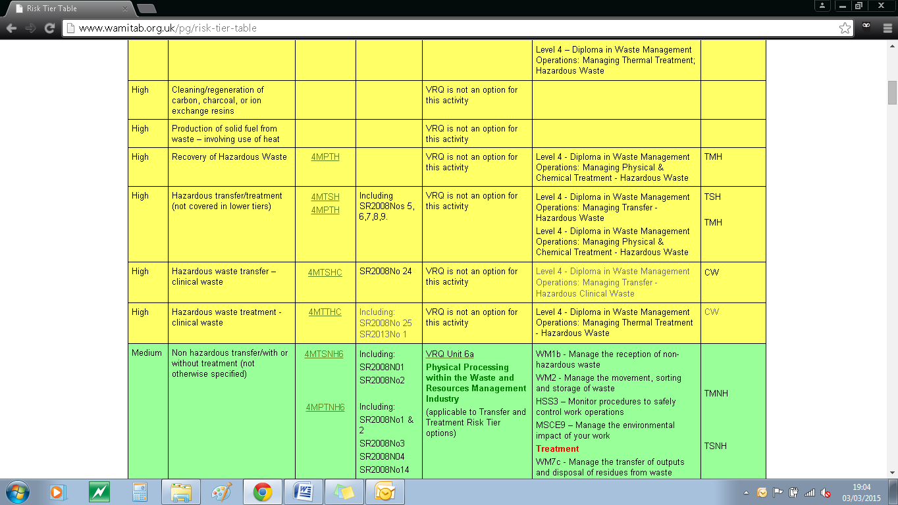http://ciwm-journal.co.uk/wordpress/wp-content/themes/ciwm-journal/hamish/CIWM_Journal_Logo.png

**CIWM/WAMITAB**

**Continuing Competence**

**Part of the CIWM/WAMITAB**

**Operator Competence Scheme**

Copyright ©2016 WAMITAB

Copyright in this document is owned by WAMITAB. Any person viewing, printing and distributing this document is subject to the following conditions:

* The document may be used for informational purposes only
* The document may be used for non-commercial purposes only (unless used by WAMITAB approved centres or partners)
* Anyone using information provided in this document should acknowledge WAMITAB

Changes are made periodically to the information contained within the document so for the latest version please refer to the website: [www.wamitab.org.uk](http://www.wamitab.org.uk).

For further information on Intellectual Property matters contact [info.admin@wamitab.org.uk](mailto:info.admin@wamitab.org.uk).

Please note that all word clouds are curtsey of Tagxedo.com and all images have been sourced from i-stock.

**Contents**

Introduction 4

About WAMITAB 4

What is Continuing Competence? 4

About this Revision Summary 4

1. Classifying Waste 5

Learning Outcomes 5

Where do I find this information? 5

Notes 5

2. Consignment Procedures 6

Learning Outcomes 6

Where do I find this information? 6

Notes 6

3. Waste Pre-acceptance 7

Learning Outcomes 7

Where do I find this information? 7

Notes 7

4. Waste Acceptance 8

Learning Outcomes 8

Where do I find this information? 8

Notes 8

5. Site Infrastructure 9

Learning Outcomes 9

Where do I find this information? 9

Notes 9

6. Incident and Accident Management 10

Learning Outcomes 10

Where do I find this information? 10

Notes 10

7. Health and Safety 11

Learning Outcomes 11

Where do I find this information? 11

Notes 11

# Introduction

## About WAMITAB

WAMITAB is an awarding organisation and charity that develops qualifications for those working in cleaning; street cleansing; facilities management; resource management and recycling and parking from operative through to management level.

Since it was formed in 1989, WAMITAB has evolved in line with the convergence between the sectors with a clear focus on promoting and supporting environmental sustainability.  With over 120 qualification pathways and 70 quality assured centres, WAMITAB offers an unrivalled specialist network to support staff development.

## What is Continuing Competence?

The CIWM/WAMITAB continuing competence scheme is designed to ensure that the technically competent person (holds a certificate of technical competence, units or a qualification that is part of the CIWM/WAMITAB Operator Competence Scheme) on a waste site has knowledge and skills that keep pace with changes made across the waste management industry, such as the introduction of new legislation, technologies and techniques.

The CIWM/WAMITAB continuing competence scheme requires technically competent people in England and Wales to pass an assessment that demonstrates individuals have kept their competence up to date.

Keeping competence up to date is becoming increasingly important across the UK as society starts to recognise the crucial role waste and resource management industry professionals play in ensuring that the 434 million tonnes of waste generated every year can be treated, reused and recycled to produce a product that will contribute to further economic growth.

## About this Revision Summary

WAMITAB recognise the diverse needs of learners within the sectors we represent. To support those individuals undertaking their Continuing Competence test, we have developed this revision summary.

This revision summary is designed to support you preparation by linking the learning outcomes with the areas that may come up during the Continuing Competence test.

# 1. Classifying Waste

## Learning Outcomes

1.1 Know how to determine if a mirror entry in the EWC is to be classified as non-hazardous or hazardous waste.

1.2 Know the information sources which may be needed to determine if a waste has any hazard properties.

1.3 Know how to apply the waste hierarchy to the management of any residues created from any hazardous waste treatment on site or any waste being transferred to another facility.

1.4 Know how to comply with the Waste Acceptance Criteria for waste generated by treatment processes prior to disposal in a hazardous waste landfill.



## Where do I find this information?

[GOV.UK Classify different types of waste](https://www.gov.uk/how-to-classify-different-types-of-waste)

[GOV.UK Hazardous Waste Classification Technical Guidance](https://www.gov.uk/government/publications/waste-classification-technical-guidance)

[GOV.UK Waste Acceptance at Landfill](https://www.gov.uk/government/publications/waste-acceptance-at-landfills)

[GOV.UK Waste legislation and Regulations](https://www.gov.uk/guidance/waste-legislation-and-regulations)

[GOV.UK Guidance on applying the waste hierarchy to hazardous waste](https://www.gov.uk/government/publications/guidance-on-applying-the-waste-hierarchy-to-hazardous-waste)

## Notes

|  |
| --- |
|  |
|  |
|  |
|  |
|  |
|  |
|  |
|  |
|  |
|  |
|  |
|  |
|  |
|  |
|  |
|  |
|  |
|  |
|  |
|  |
|  |
|  |
|  |
|  |

# C:\Users\Helen\AppData\Local\Microsoft\Windows\Temporary Internet Files\Content.IE5\FJ1S42NY\MC900432680[1].png2. Consignment Procedures

# 

## Learning Outcomes

2.1 Know the hazardous waste consignment process (including completion of consignment notes).

2.2 Know the actions required when hazardous waste is incorrectly consigned.

2.3 Know how to complete producer and consignee returns (including where and when to send them).

2.4 Know the requirements for keeping records of waste movements (including keeping an up to date site inventory).



## Where do I find this information?

[GOV.UK hazardous Waste- consignment notes](https://www.gov.uk/dispose-hazardous-waste/consignment-notes)

[GOV.UK Hazardous waste - carriers](https://www.gov.uk/dispose-hazardous-waste/carriers)

[GOV.UK Hazardous waste: rejected loads – supplementary guidance](https://www.gov.uk/guidance/hazardous-waste-rejected-loads-supplementary-guidance)

[GOV.UK hazardous waste consignee returns](https://www.gov.uk/dispose-hazardous-waste/consignee-returns)

[GOV.UK Hazardous waste consignees](https://www.gov.uk/dispose-hazardous-waste/consignees)

[GOV.UK Hazardous waste – producers and holders](https://www.gov.uk/dispose-hazardous-waste/producers-and-holders)

[GOV.UK: How to comply with your environmental permit.](https://www.gov.uk/government/publications/how-to-comply-with-your-environmental-permit)

## Notes

|  |
| --- |
|  |
|  |
|  |
|  |
|  |
|  |
|  |
|  |
|  |
|  |
|  |
|  |
|  |
|  |
|  |
|  |
|  |
|  |
|  |
|  |
|  |
|  |
|  |
|  |

# C:\Users\Helen\AppData\Local\Microsoft\Windows\Temporary Internet Files\Content.IE5\FJ1S42NY\MC900432680[1].png3. Waste Pre-acceptance

## Learning Outcomes

3.1 Know the requirements for characterising wastes in advance of their receipt and why it is important.

3.2 Know what information is required prior to accepting hazardous waste for treatment as part of the pre-acceptance process.



## Notes

|  |
| --- |
|  |
|  |
|  |
|  |
|  |
|  |
|  |
|  |
|  |
|  |
|  |
|  |
|  |
|  |
|  |
|  |
|  |
|  |
|  |
|  |
|  |
|  |
|  |
|  |

## Where do I find this information?

[GOV.UK Sector Guidance Note S5.06: recovery and disposal of hazardous and non-hazardous waste](https://www.gov.uk/government/publications/sector-guidance-note-s506-recovery-and-disposal-of-hazardous-and-non-hazardous-waste) - Section 2.1 .1

[GOV.UK Sector Guidance Note S5.06: recovery and disposal of hazardous and non-hazardous waste](https://www.gov.uk/government/publications/sector-guidance-note-s506-recovery-and-disposal-of-hazardous-and-non-hazardous-waste) - section 2.1.2

[GOV.UK Hazardous waste: rejected loads – supplementary guidance](https://www.gov.uk/guidance/hazardous-waste-rejected-loads-supplementary-guidance)

# C:\Users\Helen\AppData\Local\Microsoft\Windows\Temporary Internet Files\Content.IE5\FJ1S42NY\MC900432680[1].png4. Waste Acceptance

## Learning Outcomes

4.1 Know how to manage wastes as they are received on site.

4.2 Know the requirements for managing wastes which fail to meet the acceptance criteria and are to be rejected.

4.3 Know the requirements for keeping an audit trail of wastes from pre-acceptance to treatment and/or removal off site and why it is important.



## Where do I find this information?

[GOV.UK Sector Guidance Note S5.06: recovery and disposal of hazardous and non-hazardous waste](https://www.gov.uk/government/publications/sector-guidance-note-s506-recovery-and-disposal-of-hazardous-and-non-hazardous-waste) - Section 2.1 .1

[GOV.UK Sector Guidance Note S5.06: recovery and disposal of hazardous and non-hazardous waste](https://www.gov.uk/government/publications/sector-guidance-note-s506-recovery-and-disposal-of-hazardous-and-non-hazardous-waste) - section 2.1.2

[GOV.UK Hazardous waste: rejected loads – supplementary guidance](https://www.gov.uk/guidance/hazardous-waste-rejected-loads-supplementary-guidance)

## Notes

|  |
| --- |
|  |
|  |
|  |
|  |
|  |
|  |
|  |
|  |
|  |
|  |
|  |
|  |
|  |
|  |
|  |
|  |
|  |
|  |
|  |
|  |
|  |
|  |
|  |
|  |
|  |
|  |
|  |
|  |
|  |
|  |
|  |
|  |
|  |

# C:\Users\Helen\AppData\Local\Microsoft\Windows\Temporary Internet Files\Content.IE5\FJ1S42NY\MC900432680[1].png5. Site Infrastructure

## Learning Outcomes

5.1 Know the requirements for infrastructure on a treatment and transfer hazardous waste site.

5.2 Know the requirements for containers used to store and treat hazardous wastes.

5.3 Know the requirements for labelling, waste segregation and separation.

5.4 Know when compatibility testing would be required.

5.5 Know the potential safeguards for managing the storage of combustible waste in order to prevent fire or to mitigate its effects.

5.6 Know the information required regarding site drainage and its maintenance within a site management system.

## Where do I find this information?

[GOV.UK: How to comply with your environmental permit.](https://www.gov.uk/government/publications/how-to-comply-with-your-environmental-permit)

[GOV.UK Sector Guidance Note S5.06: recovery and disposal of hazardous and non-hazardous waste](https://www.gov.uk/government/publications/sector-guidance-note-s506-recovery-and-disposal-of-hazardous-and-non-hazardous-waste) Section 2.1.3

[HSE – HSG71 Chemical Warehousing (4th edition, 2009)](http://www.hse.gov.uk/pubns/priced/hsg71.pdf)

[CIRIA.org – containment systems for pollution prevention](https://www.ciria.org/Resources/Free_publications/c736.aspx)

[GOV.UK Hazardous Waste Classification Technical Guidance](https://www.gov.uk/government/publications/waste-classification-technical-guidance)

[GOV.UK: Hazardous waste segregation and mixing](https://www.gov.uk/guidance/hazardous-waste-segregation-and-mixing)

[GOV.UK Fire Prevention Plans](https://www.gov.uk/government/publications/permitted-sites-fire-prevention-plans)

[WISH: Reducing Fire Risk at Waste Management Sites](http://ciwm.org.uk/web/FILES/WISH/WISH_WASTE_28_Reducing_fire_risk_at_waste_management_sites_2015.pdf)



## Notes

|  |
| --- |
|  |
|  |
|  |
|  |
|  |
|  |
|  |
|  |
|  |
|  |
|  |
|  |
|  |
|  |
|  |
|  |
|  |
|  |
|  |
|  |
|  |
|  |
|  |

# C:\Users\Helen\AppData\Local\Microsoft\Windows\Temporary Internet Files\Content.IE5\FJ1S42NY\MC900432680[1].png6. Incident and Accident Management

## Learning Outcomes

6.1 Know the causes of incidents and accidents on a treatment and transfer hazardous site.

6.2 Know how to prevent incidents and accidents on a treatment and transfer hazardous site.

6.3 Know what to include in a formal accident management plan.

6.4 Know the actions an operator should take if staff or members of the public identify a potential non-compliance.



## Where do I find this information?

[GOV.UK Hazardous waste management facilities: review of incidents](https://www.gov.uk/government/publications/hazardous-waste-management-facilities-review-of-incidents)

[GOV.UK Sector Guidance Note S5.06: recovery and disposal of hazardous and non-hazardous waste](https://www.gov.uk/government/publications/sector-guidance-note-s506-recovery-and-disposal-of-hazardous-and-non-hazardous-waste)

[GOV.UK How to comply with your environmental permit.](https://www.gov.uk/government/publications/how-to-comply-with-your-environmental-permit)

## Notes

|  |
| --- |
|  |
|  |
|  |
|  |
|  |
|  |
|  |
|  |
|  |
|  |
|  |
|  |
|  |
|  |
|  |
|  |
|  |
|  |
|  |
|  |
|  |
|  |
|  |
|  |
|  |
|  |
|  |
|  |
|  |
|  |
|  |
|  |
|  |

# C:\Users\Helen\AppData\Local\Microsoft\Windows\Temporary Internet Files\Content.IE5\FJ1S42NY\MC900432680[1].png7. Health and Safety

## Learning Outcomes

7.1 Know how risk assessments can be used to identify training needs.

7.2 Know what training waste operatives working on a treatment and transfer hazardous site should have.

7.3 Know when health surveillance may be required for employees.

7.4 Know the hazard labels.

7.5 Know the health and safety implications for hazard label on waste materials.

7.6 Know the Hazard Properties (HP) codes are for potentially hazardous wastes and of the implications for staff safety.



## Where do I find this information?

[HSE – Health and Safety Training: a brief guide (published 11/12)](http://www.hse.gov.uk/pubns/indg345.pdf)

[HSE – Health and safety training in waste management and recycling (published 11/13)](http://www.hse.gov.uk/pubns/waste21.pdf)

[HSE – Health and hazardous substances in waste and recycling](http://www.hse.gov.uk/pubns/waste27.pdf)

[GOV.UK Hazardous Waste Classification Technical Guidance](https://www.gov.uk/government/publications/waste-classification-technical-guidance)

## Notes

|  |
| --- |
|  |
|  |
|  |
|  |
|  |
|  |
|  |
|  |
|  |
|  |
|  |
|  |
|  |
|  |
|  |
|  |
|  |
|  |
|  |
|  |
|  |
|  |
|  |
|  |
|  |
|  |
|  |
|  |
|  |
|  |
|  |
|  |
|  |



WAMITAB

Peterbridge House

3 The Lakes

Northampton

NN4 7HE

Tel: 01604 231950

Email: [info.admin@wamitab.org.uk](mailto:info.admin@wamitab.org.uk)

Web: [www.wamitab.org.uk](http://www.wamitab.org.uk)

[](https://twitter.com/WAMITAB) [](http://www.linkedin.com/company/wamitab) [](https://www.facebook.com/pages/WAMITAB/218830928149483)