|  |
| --- |
| **Treatment & Transfer Non-Hazardous** |
| Revision Summary |
| Version 1, April 2016 |

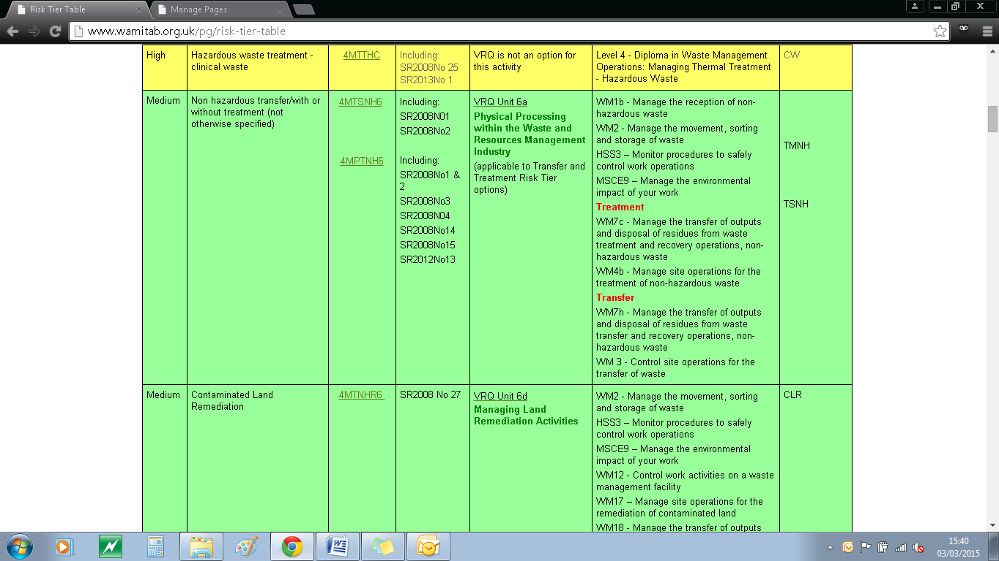http://ciwm-journal.co.uk/wordpress/wp-content/themes/ciwm-journal/hamish/CIWM_Journal_Logo.png

**CIWM/WAMITAB**

**Continuing Competence**

**Part of the CIWM/WAMITAB**

**Operator Competence Scheme**

Copyright ©2016 WAMITAB

Copyright in this document is owned by WAMITAB. Any person viewing, printing and distributing this document is subject to the following conditions:

* The document may be used for informational purposes only
* The document may be used for non-commercial purposes only (unless used by WAMITAB approved centres or partners)
* Anyone using information provided in this document should acknowledge WAMITAB

Changes are made periodically to the information contained within the document so for the latest version please refer to the website: [www.wamitab.org.uk](http://www.wamitab.org.uk).

For further information on Intellectual Property matters contact [info.admin@wamitab.org.uk](mailto:info.admin@wamitab.org.uk).

Please note that all word clouds are curtsey of Tagxedo.com and all images have been sourced from i-stock.

**Contents**

Introduction 4

About WAMITAB 4

What is Continuing Competence? 4

About this Revision Summary 4

1. Classifying Waste 5

Learning Outcomes 5

Where do I find this information? 5

Notes 5

2. Waste Acceptance 6

Learning Outcomes 6

Where do I find this information? 6

Notes 6

3. Site Infrastructure 7

Learning Outcomes 7

Where do I find this information? 7

Notes 7

4. Incident and Accident Management 8

Learning Outcomes 8

Where do I find this information? 8

Notes 8

5. Health and Safety 9

Learning Outcomes 9

Where do I find this information? 9

Notes 9

# Introduction

## About WAMITAB

WAMITAB is an awarding organisation and charity that develops qualifications for those working in cleaning; street cleansing; facilities management; resource management and recycling and parking from operative through to management level.

Since it was formed in 1989, WAMITAB has evolved in line with the convergence between the sectors with a clear focus on promoting and supporting environmental sustainability.  With over 120 qualification pathways and 70 quality assured centres, WAMITAB offers an unrivalled specialist network to support staff development.

## What is Continuing Competence?

The CIWM/WAMITAB continuing competence scheme is designed to ensure that the technically competent person (holds a certificate of technical competence, units or a qualification that is part of the CIWM/WAMITAB Operator Competence Scheme) on a waste site has knowledge and skills that keep pace with changes made across the waste management industry, such as the introduction of new legislation, technologies and techniques.

The CIWM/WAMITAB continuing competence scheme requires technically competent people in England and Wales to pass an assessment that demonstrates individuals have kept their competence up to date.

Keeping competence up to date is becoming increasingly important across the UK as society starts to recognise the crucial role waste and resource management industry professionals play in ensuring that the 434 million tonnes of waste generated every year can be treated, reused and recycled to produce a product that will contribute to further economic growth.

## About this Revision Summary

WAMITAB recognise the diverse needs of learners within the sectors we represent. To support those individuals undertaking their Continuing Competence test, we have developed this revision summary.

This revision summary is designed to support you preparation by linking the learning outcomes with the areas that may come up during the Continuing Competence test.

# 1. Classifying Waste

## Learning Outcomes

1.1 Know how to determine if a mirror entry in the EWC is to be classified as non-hazardous or hazardous waste.

1.2 Know how to apply the waste hierarchy to the management of any residues created from any waste treatment or any waste to be transferred to another facility.

1.3 Know how to comply with the Waste Acceptance Criteria for waste generated by treatment processes which is to be transferred to landfill.



## Notes

|  |
| --- |
|  |
|  |
|  |
|  |
|  |
|  |
|  |
|  |
|  |
|  |
|  |
|  |
|  |
|  |
|  |
|  |
|  |
|  |
|  |
|  |
|  |
|  |
|  |
|  |

## Where do I find this information?

[GOV.UK Classify different types of waste](https://www.gov.uk/how-to-classify-different-types-of-waste)

[GOV.UK Hazardous Waste Classification Technical Guidance](https://www.gov.uk/government/publications/waste-classification-technical-guidance)

[GOV.UK Waste Acceptance at Landfill](https://www.gov.uk/government/publications/waste-acceptance-at-landfills)

[GOV.UK Waste legislation and Regulations](https://www.gov.uk/guidance/waste-legislation-and-regulations)

[DEFRA: Waste Hierarchy Guidance](https://www.gov.uk/government/uploads/system/uploads/attachment_data/file/69403/pb13530-waste-hierarchy-guidance.pdf)

[GOV.UK SR2008 No3](https://www.gov.uk/government/publications/sr2008-no3-75kte-household-commercial-and-industrial-waste-transfer-station-with-treatment)

[GOV.UK SR2015 No 6](https://www.gov.uk/government/publications/sr2015-no6-75kte-household-commercial-and-industrial-waste-transfer-station-with-treatment)

# C:\Users\Helen\AppData\Local\Microsoft\Windows\Temporary Internet Files\Content.IE5\FJ1S42NY\MC900432680[1].png2. Waste Acceptance

# 

## Learning Outcomes

2.1 Know how to manage wastes as they are received on site.

2.2 Know the checks required before wastes can be accepted on site.

2.3 Know how to handle waste streams which contain non-compliant waste and are to be rejected.

2.4 Know who is responsible for describing and classifying the waste.

2.5 Know requirements for keeping an audit trail of wastes from pre-acceptance to treatment and/or removal off site.

2.6 Know when additional requirements for pre-acceptance checks should be applied.



## Notes

|  |
| --- |
|  |
|  |
|  |
|  |
|  |
|  |
|  |
|  |
|  |
|  |
|  |
|  |
|  |
|  |
|  |
|  |
|  |
|  |
|  |
|  |
|  |
|  |
|  |
|  |

## Where do I find this information?

[GOV.UK – How to comply with your environmental permit.](https://www.gov.uk/government/publications/how-to-comply-with-your-environmental-permit)

[GOV.UK Business and commercial waste – Duty of Care](https://www.gov.uk/managing-your-waste-an-overview/duty-of-care)

[GOV.UK Sector Guidance Note S5.06: recovery and disposal of hazardous and non-hazardous waste](https://www.gov.uk/government/publications/sector-guidance-note-s506-recovery-and-disposal-of-hazardous-and-non-hazardous-waste)

[GOV.UK SR2008 No3](https://www.gov.uk/government/publications/sr2008-no3-75kte-household-commercial-and-industrial-waste-transfer-station-with-treatment)

[GOV.UK SR2015 No 6](https://www.gov.uk/government/publications/sr2015-no6-75kte-household-commercial-and-industrial-waste-transfer-station-with-treatment)

# C:\Users\Helen\AppData\Local\Microsoft\Windows\Temporary Internet Files\Content.IE5\FJ1S42NY\MC900432680[1].png3. Site Infrastructure

## Learning Outcomes

3.1 Know the requirements for infrastructure in areas used to store non-hazardous wastes.

3.2 Know the requirements for infrastructure in areas where treatment of non-hazardous wastes takes place.

3.3 Know the requirements for containers used to store non-hazardous wastes.

3.4 Know the storage requirements for liquids in secondary containment systems.

3.5 Know the potential safeguards for managing the storage of combustible waste in order to prevent fire or to mitigate its effects.

3.6 Know the information required regarding site drainage and its maintenance within a site management system.



## Notes

|  |
| --- |
|  |
|  |
|  |
|  |
|  |
|  |
|  |
|  |
|  |
|  |
|  |
|  |
|  |
|  |
|  |
|  |
|  |
|  |
|  |
|  |
|  |
|  |
|  |
|  |

## Where do I find this information?

[GOV.UK How to comply with your environmental permit](http://a0768b4a8a31e106d8b0-50dc802554eb38a24458b98ff72d550b.r19.cf3.rackcdn.com/LIT_7123_79744e.pdf)

[Understanding permeable and impermeable surfaces: Technical report on surfacing options and cost benefit analysis](http://webarchive.nationalarchives.gov.uk/20120919132719/http:/www.communities.gov.uk/documents/planningandbuilding/pdf/permeablesufacesreport.pdf)

[Above Ground Oil Storage Tanks: PPG 2 – August 2011 – Environment Agency](http://a0768b4a8a31e106d8b0-50dc802554eb38a24458b98ff72d550b.r19.cf3.rackcdn.com/pmho0811bucr-e-e.pdf)

[GOV.UK SR2008 No3](https://www.gov.uk/government/publications/sr2008-no3-75kte-household-commercial-and-industrial-waste-transfer-station-with-treatment)

[GOV.UK SR2015 No 6](https://www.gov.uk/government/publications/sr2015-no6-75kte-household-commercial-and-industrial-waste-transfer-station-with-treatment)

[WISH: Reducing Fire Risk at Waste Management Sites](http://ciwm.org.uk/web/FILES/WISH/WISH_WASTE_28_Reducing_fire_risk_at_waste_management_sites_2015.pdf)

[GOV.UK Sector Guidance Note S5.06: recovery and disposal of hazardous and non-hazardous waste](https://www.gov.uk/government/publications/sector-guidance-note-s506-recovery-and-disposal-of-hazardous-and-non-hazardous-waste)

# C:\Users\Helen\AppData\Local\Microsoft\Windows\Temporary Internet Files\Content.IE5\FJ1S42NY\MC900432680[1].png4. Incident and Accident Management

## Learning Outcomes

4.1 Know the causes of incidents and accidents on a non-hazardous treatment and transfer site.

4.2 Know how to prevent incidents and accidents on a non-hazardous treatment and transfer site.

4.3 Know what to include in a formal accident management plan.

4.4 Know actions an operator should take if staff or members of the public identify a potential area of non-compliance.



## Where do I find this information?

[GOV.UK How to comply with your environmental permit](http://a0768b4a8a31e106d8b0-50dc802554eb38a24458b98ff72d550b.r19.cf3.rackcdn.com/LIT_7123_79744e.pdf)

## Notes

|  |
| --- |
|  |
|  |
|  |
|  |
|  |
|  |
|  |
|  |
|  |
|  |
|  |
|  |
|  |
|  |
|  |
|  |
|  |
|  |
|  |
|  |
|  |
|  |
|  |
|  |
|  |
|  |
|  |
|  |
|  |
|  |
|  |
|  |
|  |

# C:\Users\Helen\AppData\Local\Microsoft\Windows\Temporary Internet Files\Content.IE5\FJ1S42NY\MC900432680[1].png5. Health and Safety

## Learning Outcomes

5.1 Know how risk assessments can be used to identify training needs.

5.2 Know what training waste operatives working on non-hazardous treatment and transfer sites should have.

5.3 Know when health surveillance may be required for employees.



## Notes

|  |
| --- |
|  |
|  |
|  |
|  |
|  |
|  |
|  |
|  |
|  |
|  |
|  |
|  |
|  |
|  |
|  |
|  |
|  |
|  |
|  |
|  |
|  |
|  |
|  |

## Where do I find this information?

[HSE – Health and Safety Training: a brief guide (published 11/12)](http://www.hse.gov.uk/pubns/indg345.pdf)

[HSE – Health and safety training in waste management and recycling (published 11/13)](http://www.hse.gov.uk/pubns/waste21.pdf)



WAMITAB

Peterbridge House

3 The Lakes

Northampton

NN4 7HE

Tel: 01604 231950

Email: [info.admin@wamitab.org.uk](mailto:info.admin@wamitab.org.uk)

Web: [www.wamitab.org.uk](http://www.wamitab.org.uk)

[](https://twitter.com/WAMITAB) [](http://www.linkedin.com/company/wamitab) [](https://www.facebook.com/pages/WAMITAB/218830928149483)