|  |
| --- |
| **Waste Electrical & Electronic Equipment** |
| Revision Summary |
| Version 1, April 2016 |

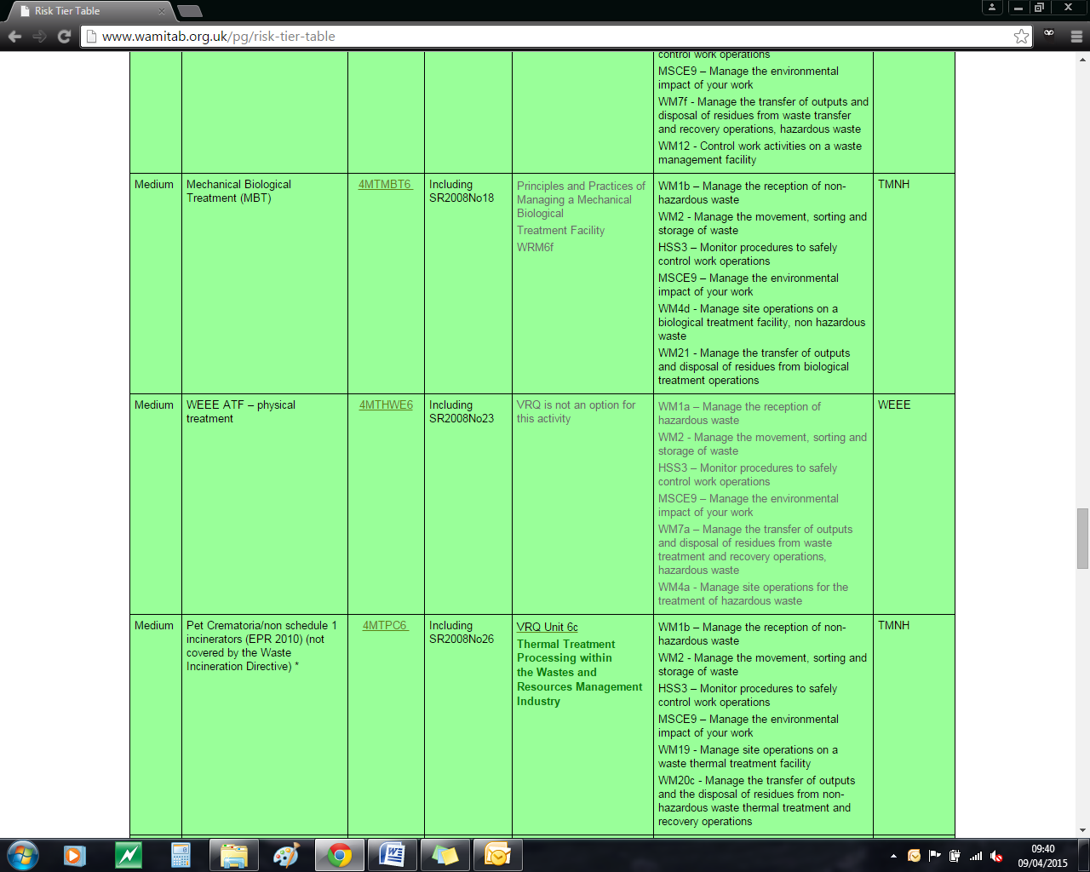http://ciwm-journal.co.uk/wordpress/wp-content/themes/ciwm-journal/hamish/CIWM_Journal_Logo.png

**CIWM/WAMITAB**

**Continuing Competence**

**Part of the CIWM/WAMITAB**

**Operator Competence Scheme**

Copyright ©2016 WAMITAB

Copyright in this document is owned by WAMITAB. Any person viewing, printing and distributing this document is subject to the following conditions:

* The document may be used for informational purposes only
* The document may be used for non-commercial purposes only (unless used by WAMITAB approved centres or partners)
* Anyone using information provided in this document should acknowledge WAMITAB

Changes are made periodically to the information contained within the document so for the latest version please refer to the website: [www.wamitab.org.uk](http://www.wamitab.org.uk).

For further information on Intellectual Property matters contact [info.admin@wamitab.org.uk](mailto:info.admin@wamitab.org.uk).

Please note that all word clouds are curtsey of Tagxedo.com and all images have been sourced from i-stock.

**Contents**

Introduction 5

About WAMITAB 5

What is Continuing Competence? 5

About this Revision Summary 5

1. Site Infrastructure 6

Learning Outcomes 6

Where do I find this information? 6

Notes 6

2. Managing fluids in WEEE materials 7

Learning Outcomes 7

Where do I find this information? 7

Notes 7

3. Handling Hazardous WEEE 8

Learning Outcomes 8

Where do I find this information? 8

Notes 8

4. WEEE Treatment 9

Learning Outcomes 9

Where do I find this information? 9

Notes 9

5. WEEE Items for Reuse 11

Learning Outcomes 11

Where do I find this information? 11

Notes 11

6. Exporting WEEE 12

Learning Outcomes 12

Where do I find this information? 12

Notes 12

7. Handle WEEE Safely 13

Learning Outcomes 13

Where do I find this information? 13

Notes 13

8. WEEE Evidence 14

Learning Outcomes 14

Where do I find this information? 14

Notes 14

# Introduction

## About WAMITAB

WAMITAB is an awarding organisation and charity that develops qualifications for those working in cleaning; street cleansing; facilities management; resource management and recycling and parking from operative through to management level.

Since it was formed in 1989, WAMITAB has evolved in line with the convergence between the sectors with a clear focus on promoting and supporting environmental sustainability.  With over 120 qualification pathways and 70 quality assured centres, WAMITAB offers an unrivalled specialist network to support staff development.

## What is Continuing Competence?

The CIWM/WAMITAB continuing competence scheme is designed to ensure that the technically competent person (holds a certificate of technical competence, units or a qualification that is part of the CIWM/WAMITAB Operator Competence Scheme) on a waste site has knowledge and skills that keep pace with changes made across the waste management industry, such as the introduction of new legislation, technologies and techniques.

The CIWM/WAMITAB continuing competence scheme requires technically competent people in England and Wales to pass an assessment that demonstrates individuals have kept their competence up to date.

Keeping competence up to date is becoming increasingly important across the UK as society starts to recognise the crucial role waste and resource management industry professionals play in ensuring that the 434 million tonnes of waste generated every year can be treated, reused and recycled to produce a product that will contribute to further economic growth.

## About this Revision Summary

WAMITAB recognise the diverse needs of learners within the sectors we represent. To support those individuals undertaking their Continuing Competence test, we have developed this revision summary.

This revision summary is designed to support you preparation by linking the learning outcomes with the areas that may come up during the Continuing Competence test.

# 1. Site Infrastructure

## Learning Outcomes

1.1 Know the storage requirements for WEEE prior to treatment.

1.2 Know the technical requirements for sites undertaking WEEE treatment operations.

1.3 Know the characteristics of impermeable surfaces used in WEEE treatment facilities.

1.4 Know why weatherproof coverings are used by WEEE treatment facilities.



## Notes

|  |
| --- |
|  |
|  |
|  |
|  |
|  |
|  |
|  |
|  |
|  |
|  |
|  |
|  |
|  |
|  |
|  |
|  |
|  |
|  |
|  |
|  |
|  |
|  |
|  |
|  |

## Where do I find this information?

[Defra – Guidance on Best Available Treatment Recovery and Recycling Techniques (BATRRT) and Treatment of Waste Electrical and Electronic Equipment (WEEE)(November 2006)](http://webarchive.nationalarchives.gov.uk/20130402151656/http:/archive.defra.gov.uk/environment/waste/producer/electrical/documents/weee-batrrt-guidance.pdf)

To access this document cut and paste into a search engine directly!

<http://webarchive.nationalarchives.gov.uk/20130402151656/http://archive.defra.gov.uk/environment/waste/producer/electrical/documents/weee-batrrt-guidance.pdf>

# C:\Users\Helen\AppData\Local\Microsoft\Windows\Temporary Internet Files\Content.IE5\FJ1S42NY\MC900432680[1].png2. Managing fluids in WEEE materials

# 

## Learning Outcomes

2.1 Know the requirements for treating and storing WEEE materials that contain fluids.



## Notes

|  |
| --- |
|  |
|  |
|  |
|  |
|  |
|  |
|  |
|  |
|  |
|  |
|  |
|  |
|  |
|  |
|  |
|  |
|  |
|  |
|  |
|  |
|  |
|  |
|  |
|  |

## Where do I find this information?

[Defra – Guidance on Best Available Treatment Recovery and Recycling Techniques (BATRRT) and Treatment of Waste Electrical and Electronic Equipment (WEEE)](http://archive.defra.gov.uk/environment/waste/producer/electrical/documents/weee-batrrt-guidance.pdf) [(November 2006)](http://archive.defra.gov.uk/environment/waste/producer/electrical/documents/weee-batrrt-guidance.pdf)

# C:\Users\Helen\AppData\Local\Microsoft\Windows\Temporary Internet Files\Content.IE5\FJ1S42NY\MC900432680[1].png3. Handling Hazardous WEEE

## Learning Outcomes

* 1. Know the WEEE components classified as hazardous waste.
  2. Know the consignment procedures for hazardous WEEE.



## Notes

|  |
| --- |
|  |
|  |
|  |
|  |
|  |
|  |
|  |
|  |
|  |
|  |
|  |
|  |
|  |
|  |
|  |
|  |
|  |
|  |
|  |
|  |
|  |
|  |
|  |
|  |

## Where do I find this information?

[Environment Agency – Technical Guidance WM3: Interpretation of the definition and classification of hazardous waste (1st edition, August 2015)](http://a0768b4a8a31e106d8b0-50dc802554eb38a24458b98ff72d550b.r19.cf3.rackcdn.com/LIT_5426_acd22f.pdf)

[Classification of Different Types of Waste](https://www.gov.uk/how-to-classify-different-types-of-waste)

[Hazardous waste - GOV.UK](https://www.gov.uk/dispose-hazardous-waste/consignment-notes)

[Environment Agency - Consignee Returns – records](https://www.gov.uk/guidance/hazardous-waste-returns-supplementary-guidance)

[Environment Agency – Consignment notes](https://www.gov.uk/dispose-hazardous-waste/consignment-notes)

[Hazardous Waste (England and Wales) Regulations 2005](http://www.legislation.gov.uk/uksi/2005/894/contents/made)

[Hazardous Waste (England and Wales) (Amendment) Regulations 2009](http://www.legislation.gov.uk/uksi/2009/507/pdfs/uksi_20090507_en.pdf)

# C:\Users\Helen\AppData\Local\Microsoft\Windows\Temporary Internet Files\Content.IE5\FJ1S42NY\MC900432680[1].png4. WEEE Treatment

## Learning Outcomes

4.1 Know the permitting arrangements for a facility treating WEEE.

4.2 Know the items that must be removed from WEEE during treatment.

4.3 Know the items that must be safely removed as whole items from any separately collected WEEE.

4.4 Know the requirements for weighing WEEE prior to and after treatment.

4.5 Know good practice for maximising the quality of WEEE derived materials.

4.6 Know good practice for identifying and removing contaminated/non-conforming wastes from the WEEE.



## Where do I find this information?

[Defra – Guidance on Best Available Treatment Recovery and Recycling Techniques (BATRRT) and Treatment of Waste Electrical and Electronic Equipment (WEEE)(November 2006)](http://archive.defra.gov.uk/environment/waste/producer/electrical/documents/weee-batrrt-guidance.pdf)

[BIS – WEEE Regulations 2013: Government Guidance Notes(March 2014)](https://www.gov.uk/government/uploads/system/uploads/attachment_data/file/254118/bis-13-1256-interim-government-guidance-notes-new-weee-regulations.pdf)

[WRAP – Treatment of WEEE](http://www.wrap.org.uk/sites/files/wrap/6.0%20Treatment%20of%20WEEE%20-%20Online.pdf)

[WRAP – Waste Treatment](http://www.wrap.org.uk/sites/files/wrap/7.0%20Waste%20Treatment%20-%20Online.pdf)

## Notes

|  |
| --- |
|  |
|  |
|  |
|  |
|  |
|  |
|  |
|  |
|  |
|  |
|  |
|  |
|  |
|  |
|  |
|  |
|  |
|  |
|  |
|  |
|  |
|  |
|  |
|  |
|  |
|  |
|  |
|  |
|  |
|  |
|  |
|  |
|  |

## Notes

|  |
| --- |
|  |
|  |
|  |
|  |
|  |
|  |
|  |
|  |
|  |
|  |
|  |
|  |
|  |
|  |
|  |
|  |
|  |
|  |
|  |
|  |
|  |
|  |
|  |
|  |
|  |
|  |
|  |
|  |
|  |
|  |
|  |
|  |
|  |
|  |
|  |

# C:\Users\Helen\AppData\Local\Microsoft\Windows\Temporary Internet Files\Content.IE5\FJ1S42NY\MC900432680[1].png5. WEEE Items for Reuse

## Learning Outcomes

5.1 Know the items which can be separated for reuse.

5.2 Know the quality standards for the reuse of WEEE.

5.3 Know good practice for the disassembly and storage of WEEE to increase potential for reuse.

5.4 Know good practice for testing WEEE items for reuse.



## Notes

|  |
| --- |
|  |
|  |
|  |
|  |
|  |
|  |
|  |
|  |
|  |
|  |
|  |
|  |
|  |
|  |
|  |
|  |
|  |
|  |
|  |
|  |
|  |
|  |
|  |
|  |

## Where do I find this information?

[WRAP – The benefits of PAS 141](http://www.wrap.org.uk/content/benefits-pas-141)

[Defra – Guidance on Best Available Treatment Recovery and Recycling Techniques (BATRRT) and Treatment of Waste Electrical and Electronic Equipment (WEEE)](http://archive.defra.gov.uk/environment/waste/producer/electrical/documents/weee-batrrt-guidance.pdf)

[(November 2006)](http://archive.defra.gov.uk/environment/waste/producer/electrical/documents/weee-batrrt-guidance.pdf)

[WRAP – Treatment for Reuse](http://www.wrap.org.uk/sites/files/wrap/5.0%20Treatment%20for%20Reuse%20-%20Online.pdf)

# C:\Users\Helen\AppData\Local\Microsoft\Windows\Temporary Internet Files\Content.IE5\FJ1S42NY\MC900432680[1].png6. Exporting WEEE

## Learning Outcomes

6.1 Know the circumstances where approval for exporting obligated WEEE is required.

6.2 Know the permits, approvals and information required to export WEEE.

6.3 Know legislation and regulations applicable to exporting WEEE.



## Where do I find this information?

[Environment Agency - Guidance note for approval as an approved authorised treatment facility (AATF) or approved exporter (AE) for waste electrical and electronic equipment (WEEE) (WMP7)(V6, July 2012)](http://a0768b4a8a31e106d8b0-50dc802554eb38a24458b98ff72d550b.r19.cf3.rackcdn.com/geho0812busu-e-e.pdf)

[GOV. UK – Waste electrical and electronic equipment (WEEE): Exporting](https://www.gov.uk/guidance/waste-electrical-and-electronic-equipment-weee-exporting)

## Notes

|  |
| --- |
|  |
|  |
|  |
|  |
|  |
|  |
|  |
|  |
|  |
|  |
|  |
|  |
|  |
|  |
|  |
|  |
|  |
|  |
|  |
|  |
|  |
|  |
|  |
|  |

# C:\Users\Helen\AppData\Local\Microsoft\Windows\Temporary Internet Files\Content.IE5\FJ1S42NY\MC900432680[1].png7. Handle WEEE Safely

## Learning Outcomes

7.1 Know the hazards associated with handling hazardous WEEE items.



## Where do I find this information?

[HSE Guidance – Waste Electrical and Electronic Equipment Recycling](http://www.hse.gov.uk/waste/waste-electrical.htm)

## Notes

|  |
| --- |
|  |
|  |
|  |
|  |
|  |
|  |
|  |
|  |
|  |
|  |
|  |
|  |
|  |
|  |
|  |
|  |
|  |
|  |
|  |
|  |
|  |
|  |
|  |
|  |

# C:\Users\Helen\AppData\Local\Microsoft\Windows\Temporary Internet Files\Content.IE5\FJ1S42NY\MC900432680[1].png8. WEEE Evidence

## Learning Outcomes

8.1 Know the type of facility that can issue WEEE evidence.



## Where do I find this information?

[Waste electrical and electronic equipment (WEEE): reuse and treatment - Detailed guidance - GOV.UK](https://www.gov.uk/guidance/waste-electrical-and-electronic-equipment-weee-reuse-and-treat)

## Notes

|  |
| --- |
|  |
|  |
|  |
|  |
|  |
|  |
|  |
|  |
|  |
|  |
|  |
|  |
|  |
|  |
|  |
|  |
|  |
|  |
|  |
|  |
|  |
|  |
|  |
|  |



WAMITAB

Peterbridge House

3 The Lakes

Northampton

NN4 7HE

Tel: 01604 231950

Email: [info.admin@wamitab.org.uk](mailto:info.admin@wamitab.org.uk)

Web: [www.wamitab.org.uk](http://www.wamitab.org.uk)

[](https://twitter.com/WAMITAB) [](http://www.linkedin.com/company/wamitab) [](https://www.facebook.com/pages/WAMITAB/218830928149483)