Anaerobic Digestion
Content Changes 2016-2018 Revision Guide
All page numbers refer to the 2016-2018 Revision Guides with red covers.

Syllabus Structure Amendments
Please note that the syllabus for anaerobic digestion has been restructured:
- Section 8: Health and Safety is now Section 9.
- A new Section 8: Biogas Treatment and Storage has been added.
- The following learning outcomes have been removed: 3.3, 3.4, 7.2 and 6.9.
- The following learning outcomes have been moved: 6.8 is now 6.3, 6.11 is now 6.9, 6.12 is now 6.10 and 6.10 is now 8.4.
- The wording of the following learning outcomes has been changed: 3.2, 5.8 and 7.1.
- The following learning outcomes are new:
- 1.5 Know how to manage food waste packaging on site.
- 4.13 Know what maintenance and checks should be undertaken to prevent emissions.
- 8.1 Know where to find the specification for biomethane for injection to the grid or use in appliances.
- 8.2 Know the options for disposal of biogas condensate.
- 8.3 Know which regulations must be complied with in relation to Gas Quality requirements for injection to the gas grid.
- 8.5 Know the requirements for biogas treatment.
- 8.6 Know the requirements for biogas storage.

- 9.4 Know the standard all equipment in contact with biogas should be certified to and what this certification means.
Section 1: Information, Checks and Records, page 14
Pre-acceptance information should be stored on a waste tracking system with a record being opened. This record should “follow” the waste during acceptance, checking, storage, treatment or removal from site.
An operator must review and update their management system:
- When they make changes to the site, operations or equipment affecting permitted waste activities.
- Whenever an application is made to change/vary their permit.
- After an accident, complaint or permit breach.
- If a new environmental problem or issue arises.
Section 1: Procedures, page 15
Waste should only be accepted if it is of a type and quality listed in the site permit and if it matches the description in the documentation accompanying the load.
A representative sample of the waste should be taken for compliance testing and analysed in accordance with the sampling plan. Samples should be kept on site for at least two days after waste treatment.
Section 1: Waste Reception and Rejection, page 16
Storage and process tanks: located on an impermeable surface (with a hydraulic permeability of no greater than 1 x 10-9 m/s) with sealed construction joints within a bunded area. There should be appropriate secondary containment that can accommodate a volume at least 110% of the total capacity of the tank.
Section 1: Food Waste Packaging, new page
One of the objectives for pre-treating feedstock typically involves removing packaging material from food waste (sometimes known as de-packaging).
Food waste de-packaging equipment is designed to remove non-biodegradable packaging material from delivered food waste prior to digestion. This type of equipment can use mechanical pre-treatment technologies such as a bag splitter, a feeding conveyor and a unit with blades, screws, breaker bars or crushers to shred and break the packaging material. There would then be a screening stage to remove the broken packaging.
Section 2: Non-Source Segregated Feedstocks, page 19
Manual sorting at an anaerobic digestion facility is normally reserved for the removal of large contaminants and/or oversized materials at the reception stage.
Once removed by hand, these residual wastes are stored on site until they can be sent for reprocessing at an appropriate site.
Section 3: Handling Materials, page 22
An anaerobic digestion facility can operate to UK standards if it only treats category 3 catering waste and the following category 2 Animal By-Products:
- Manure.
- Digestive tract and its contents.
- Dairy products or colostrum.
- Eggs or egg products.
To meet UK standards the following time and temperature requirements must be followed for treating Animal By-Products:

- Composting (closed reactor) must meet a minimum temperature of 60°C for 2 days for a maximum particle size of 400mm.
- Biogas systems must meet a minimum temperature of 57°C for 5 hours for a maximum particle size of 50mm.
- Composting (closed reactor) or biogas must meet a minimum temperature of 70°C for 1 hour for a maximum particle size of 60mm.
- Composting (housed windrow) must meet a minimum temperature of 60°C for 8 days (during which the windrow must be turned at least 3 times, at no less than 2 day intervals) for a maximum particle size of 400mm.
If your anaerobic digestion facility is operating under UK standards, the way catering waste is treated depends on whether it is meat-excluded or non-meat-excluded.
Meat-excluded waste must have specific measures employed to keep it away from meat at source, after collection and at all stages of transport.
Non-meat excluded waste can only be stored for 18 days after treatment on an anaerobic digestion site.
Section 3: Pathogens, new page
The new learning outcome wording for 3.2 is Know what is required for sampling and testing pathogens.
A pathogen is bacterium, virus, or other microorganism that can cause disease.
During validation, operators must send samples of compost or digestate to a lab for testing to check that treatment is removing bacteria.
During normal operating, operators must still take samples. For each bacterium, operators need to take either:
- A sample from 1 in every 4 batches
- 1 sample of compost or digestate a month.
Section 4: Emissions to Air, page 27
To prevent emissions on an anaerobic digestion site, operators will normally carry out regular scheduled checks and maintenance, including leak detection.
Section 4: Monitoring Odour, page 28
Sniff testing is a common form of odour monitoring, although measures need to be taken to minimise inconsistencies, such as the use of a field dilution olfactometer.
Section 4: Bioaerosols, page 30
Enclosed buildings should have an appropriate air management system that maintains negative pressure and discharges via an emissions abatement system.
Section 4: Noise and Vibration, page 33
Maintenance and Checks: an operator’s management system should implement effective maintenance programme on all aspects of the anaerobic digestion process to prevent emissions to the environment, including regular inspection of major ‘non-productive items’ (e.g. tanks, pipework, retaining walls, bunds, ducts and filters).
Section 6: Anaerobic Digestion Process, page 43
Anaerobic digestion is “a natural process in which microorganisms break down organic matter, in the absence of oxygen, into biogas and digestate. The biogas can be used directly in engines for Combined Heat and Power (CHP).”

Section 6: Issues and Organic Loading Rates (OLR), page 48
Monitoring the OLR can indicate if:
- There is over-feeding causing an accumulation of volatile fatty acids in the digester and a decline in methane production.
- The feed rate is too low and therefore causing low plant productivity.
Section 7: Sampling, Testing and Treatment, page 53
Examples of equipment used to separate digestate include rotary screens, flat belt separators, roller presses, vibrating screens, screw or ram presses and centrifuges.

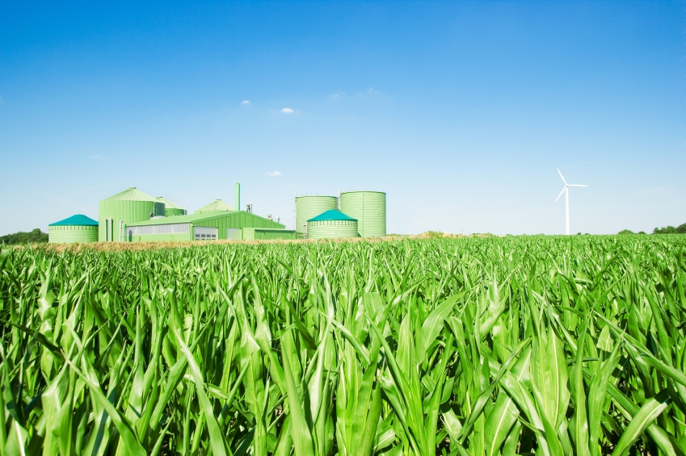

Section 8: Biogas for the Grid or Use in Appliances, new page
The biomethane quality protocol sets out end of waste criteria for the production and use of biomethane arising from the degradation of organic wastes in an anaerobic digestion plant for injection into the gas grid or use in an appliance suitably designed and operated for natural gas. If the criteria are met, the biomethane will be regarded as fully recovered and will no longer be considered waste.
The gas quality requirements for injection into the gas grid are defined within the Gas Safety Management regulations implemented by the Health and Safety Executive.
Section 8: Biogas Treatment and Storage, new page
The composition of biogas generated from anaerobic digestion will vary depending on the feedstock and process used.
However, it will normally be composed of methane and carbon dioxide with small amounts of hydrogen sulphide and ammonia. The requirements for biogas treatment depend on the gas quality requirements for the intended end use of the biogas. Biogas treatment techniques include:
- Dewatering (to prevent condensate forming in pipes and causing corrosion)
- Removal of H₂S (potentially corrosive to engines)
- Removal of oxygen and nitrogen (where present)
- Removal of ammonia
- Removal of siloxanes (if treating sewage sludge)
- Removal of particulates
- Removal of CO₂ (for upgrading biomethane)

Small scale anaerobic digestion facilities should monitor:
- Gas production rates continuously.
- Test the composition of the gas periodically using portable gas monitoring equipment.
Biogas storage is required to maintain a relatively constant reaction volume and pressure.
All biogas storage facilities must be gas tight and pressure-resistant. Where storage facilities are not protected by buildings, they must be UV, temperature and weather proof.
Storage vessels should be sealed for biogas collection and fitted with over/under pressure relief valves. Isolating valves should also be incorporated to enable inspection and maintenance.
Section 9: Hazards and Risks, page 56
Equipment in Contact with Biogas
All equipment should be ATEX certified as it will be operating in an explosive environment.
ATEX refers to a European Directive by which all electrical equipment used in potentially explosive environments must be certified by the supplier as safe to use according to specific risk categories.
Potentially hazardous areas should be considered in accident management plans e.g. biogas storage, internal transfer procedures and waste segregation.

Revised List of Sources
Page | Source
14,15,16,17,20,21,28,29,30,31,32,33,34,44,45,46,47,48,49,52,53,56,57,58,61 | Environment Agency (2013) How to comply with your environmental permit. Additional guidance for anaerobic digestion.
14 | GOV.UK (2019) Develop a Management System
15 | SR2010No15, SR2010No16, SR2012No9, SR2012No10, SR2012No11, SR2012No12
24,25 | GOV.UK (2014) Using animal by-products at compost and biogas sites
29,30 | Environment Agency (2011) H4: Odour Management
29,30 | Natural Resources Wales (2014) H4: Odour Management
37,41,52 | PAS 110 (2014)
38 | WRAP (2009) Anaerobic Digestion Quality Protocol
39,40,56 | Environment Agency (2014) Quality protocol: anaerobic digestate
48 | ADBA (2016) Best practice checklist operational performance
61 | Health and Safety Executive (2013) Confined Spaces
61 | Health and Safety Executive (2013) Fire and Explosion
Please note: this information was correct at the time of publishing. If you find these links are broken, type the document title into a search engine.

About this sheet
The Continuing Competence Free Update Sheet is designed to be used by purchasers of the Continuing Competence Revision Guides for the 2016-2018 period.

It will highlight any changes in technical guidance and sources used as a basis for the Continuing Competence question bank to support the revision of users.

Frequently Asked Questions (FAQs)
How much does the test cost?
Each test costs £139 irrespective of the number of Activity Specific Tests chosen (a maximum of three activity specific tests can be taken at one time).
What form of personal identification can I use at the test centre?
- A valid signed passport of any country with your photograph and signature.
- A valid signed UK photo card driving licence (full or provisional).
- If you have none of these, you may present a Citizen’s ID Card.
How can I find out if I have passed the test?
At the end of the test you will receive your score report which provides the scores for each component of the Generic Knowledge Test and the score for each Activity Specific Test you have taken.
There is an example on the back of your score report showing how to work out if you’ve passed. Alternatively, you can go to https://wamitab.org.uk/competence/continuing-competence/test-score-calculator/ and type in your scores.

