Waste Electrical & Electronic Equipment (WEEE)
About this sheet
The Continuing Competence Free Update Sheet is designed to be used by purchasers of the Continuing Competence Revision Guides for the 2016-2018 period.

It will highlight any changes in technical guidance and sources used as a basis for the Continuing Competence question bank to support the revision of users.

Frequently Asked Questions (FAQs)
How much does the test cost?
Each test costs £139 irrespective of the number of Activity Specific Tests chosen (a maximum of three activity specific tests can be taken at one time).
What form of personal identification can I use at the test centre?
- A valid signed passport of any country with your photograph and signature.
- A valid signed UK photo card driving licence (full or provisional).
- If you have none of these, you may present a Citizen’s ID Card.
How can I find out if I have passed the test?
At the end of the test you will receive your score report which provides the scores for each component of the Generic Knowledge Test and the score for each Activity Specific Test you have taken.
There is an example on the back of your score report showing how to work out if you’ve passed. Alternatively, you can go to https://wamitab.org.uk/competence/continuing-competence/test-score-calculator/ and type in your scores.

Content Changes 2016-2018 Revision Guide
All page numbers refer to the 2016-2018 Revision Guides with red covers.
Section 4: Permitting Arrangements, page 25
The learning outcome ‘4.1 Know the permitting arrangements for a facility treating WEEE’ was removed from the syllabus this year.
Section 4: Persistent Organic Pollutants (NEW)
The learning outcome ‘4.6 Know the requirements for disposal of waste containing persistent organic pollutants (POPs) such as flame retarded plastic’ was added to the syllabus this year.

Persistent organic pollutants are organic compounds that are resistant to environmental degradation and can therefore accumulate having a negative impact on human health and/or the environment. Before waste can be disposed of, you need to know if it contains POPs. You can do this by:
- Asking the suppliers or manufacturers of the material.
- Testing the material yourself to find out the concentrations of any POPs.
- Getting the material analysed by a laboratory.
Waste that contains POPs can be sent to a disposal site capable of completely destroying POPs or irreversibly transforming them using one of the following methods:
- Physico-chemical treatment.
- Incineration on land.
- Using the waste as a fuel or other means to generate energy.
For more information visit:
- GOV.UK - Dispose of waste containing persistent organic pollutants (POPs)
- NRW - Permits and permissions WEEE
Section 5: Items, page 31
The learning outcome ‘5.1 Know the items which can be separated for reuse’.

Item | Example Reuse Criteria
Refrigeration | No CFC refrigerant.  No faded appliance.  No warped appliance.  No severe front damage and maximum of ‘x’ missing internal trays or bins.
Cookers | No gas appliances.  No smashed ceramic hobs.  Minimal front damage.  No warped appliances.  No smashed door glass.
Washing machine /washer dryer | Minimal front damage.  Specific models only.
Tumble dryers | Minimal front damage.  No warped appliances.  No compact ones.
Dishwasher | Minimal front damage.  No warped appliances.  Must contain all trays.  Door catch must work.
Source: WRAP - Treatment for Reuse

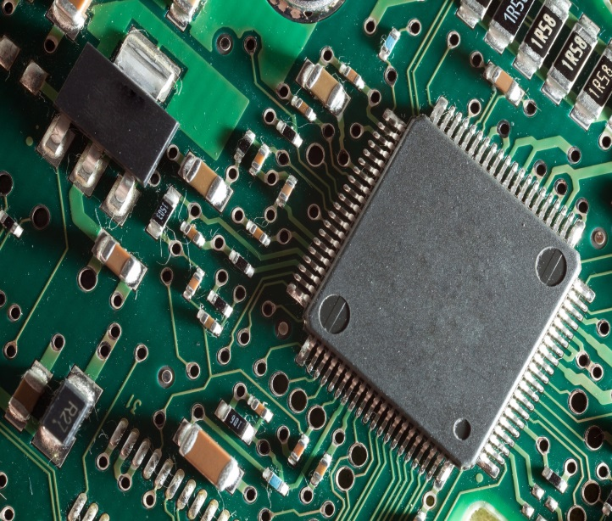

Revised List of Sources
Page | Source
25 | BIS - WEEE Regulations 2013: Government Guidance Notes (March 2014)
13, 14, 15, 18, 25, 27 | Defra - Guidance on Best Available Treatment Recovery and Recycling Techniques (BATRRT) and treatment of Waste Electrical and Electronic Equipment (WEEE)
22 | Environment Agency Guidance - HWR05: Record Keeping
22 | GOV.UK - WM3 v1.1 Technical Guidance and List of Wastes
31 | Environment Agency - WEEE: reuse and treatment
22 | GOV.UK - Classify Different Types of Waste
New page | GOV.UK - Dispose of waste containing persistent organic pollutants (POPs)
22 | GOV.UK - Hazardous Waste
36 | GOV.UK - Guidance on WEEE exporting
43 | GOV.UK - Waste electrical and electronic equipment (WEEE): reuse and treatment - Detailed guidance
40 | Health and Safety Executive - Waste Electrical and Electronic Equipment (WEEE) recycling
22 | NRW - How to classify waste
New page, 36 | NRW - Permits and permissions WEEE
32 | WRAP - The benefits of PAS 141
31, 33 | WRAP - Treatment for reuse
28 | WRAP - 6.0 Treatment of WEEE
Please note: this information was correct at the time of publishing. If you find these links are broken, type the document title into a search engine.

